FCI GST User Manual



Tech Mahindra
May-2019
Contents
01- Account Payables 4
Reverse Charge Application to Registered vendors 17
Prepayment Application to Taxable Invoices 19
AP Validations 23
Third Party Payment Functionality 24
AP Reports 28
Supplier Master Report 28
FCI GST AP Self Addressed Invoice Report 29
FCI GST AP Payment Voucher- Reverse Charge 30
FCI GST AP ITC Report 31
FCI GST Reverse Charge Register Report 33
FCI GST Refund Voucher Report 34
FCI GST Inward Supply Register Report 35
02- Account Receivables 37
Invoice Creation 38
Customer Ship To 44
Credit Memo 48
Debit Memo 50
AR Validations 52
AR Reports 53
FCI GST AR Tax Invoice/Bill of Supply 53
FCI GST AR Credit Note/Debit Note Report 55
FCI GST AR Advance Receipt Voucher 57
FCI GST Outward Supply Register Report:- 59
03- General Ledger 60
Manual Journal Entry-Paddy Mill Rice In 64
Manual Journal Entry-Interco IOM Railroad 67
Manual Journal Entry-Transfer In Against Stocks Received 71
Asset Transfer 75
Unconn/Missing Wagon 78
GL Reports 79
GST- Tax Invoice/ Bill of Supply/ Delivery Challan Reports 79
FCI GST Job Work Register Report 82
FCI GST GL ITC Report 83
GST- Asset Tax Invoice/ Bill of Supply/ Delivery Challan Reports 84
GL Reversal – Credit Note Report 86
04-GST Reports (GSTR1 and GSTR2) 90
FCI GSTR2 Voucher 91
FCI GSTR2 Credit Debit Note 92
FCI GSTR2 B2B RCM 93
FCI GSTR1 Business To Business 94
FCI GSTR1 Credit/Debit Note 95
FCI GSTR Delivery Challan Summary Report 96
FCI GST Sequence Summary Report 97
Annexure-A Scheduled Programs 98
India- Period Ending Process 98
FCI AP GST Payment Sequence Generator 99
FCI Customer Third Party Registration 100
FCI GL GST Generate Sequence Program 100
GOODS AND SERVICES INCLUSION IN GENERAL LEDGER (AS PER PLAN B) 101

01- Account Payables

GST Tax impact on procurement:-
FCI would not incur any GST on the procurement of Food Grains, pulses and paddy from various sources such as state government agencies, farmers/arthias and private parties.
The applicability of GST on procurement of other goods purchased by FCI would depend on the respective HSN classification of the said goods.
FCI would be required to discharge GST under reverse charge mechanism on procurement of any taxable goods from unregistered and registered vendors.
Considering the above following provision have been made in the current FAP system for FCI to become GST compliant.
Flow of AP invoice:-Enter Third Party Information GSTIN & TDS Information of parties need to entered in Third Party Registrations.
Functional Path: Payables Responsibility >> Define Third Party Registration
NOTE: The check has been implemented in the system which will prevent the user to enter or update GSTIN details of another unit. Moreover, GSTIN information is mandatory to capture for the registered vendors.
Steps:
Select Party Type: Supplier
- Enter the Party name, Party Number and Party Site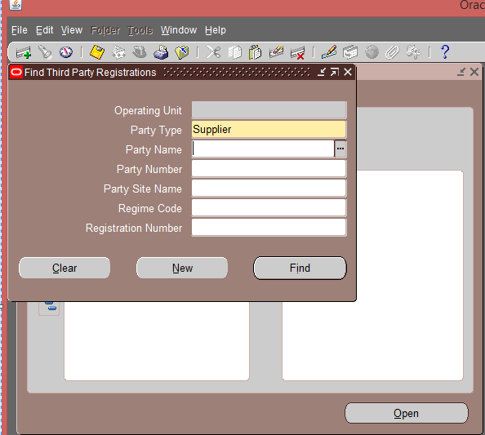
- Now, to enter the details about Supplier, Click on New and Third Party Registration form will open.
- Enter the Registration Details
- Regime Code- to enter GST details, choose GST-India from LOV. System will restrict the user to select the GST Regime at supplier level having null site.
- Primary Registration Name- always select GST Registration Number (Check in the system that user will be able to select the GST Registration Number against GST Regime only)
- Enter the Primary Registration Number. System will allow the user to enter the GST registration number, in the specified format otherwise following error message will appear.
ERROR: -Format for GSTIN Number (15 char). Correct Format – State Code (2 No) PAN No (10 char) (1 No/Char) (1No/Char) (1 No/Char)

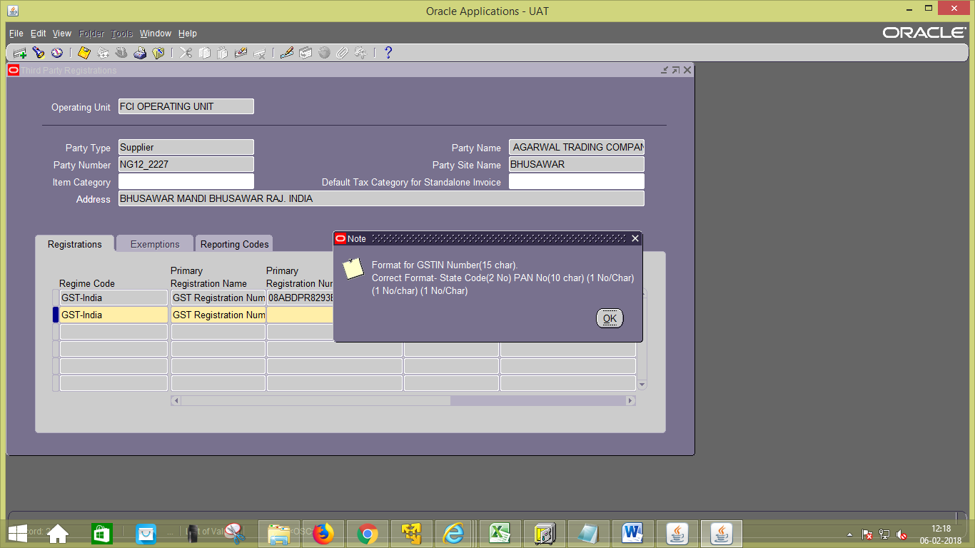
- Enter the Start date. The check on GST Registration Number will appear on click on start date, in case user wrongly entered the same.
- Save the record.
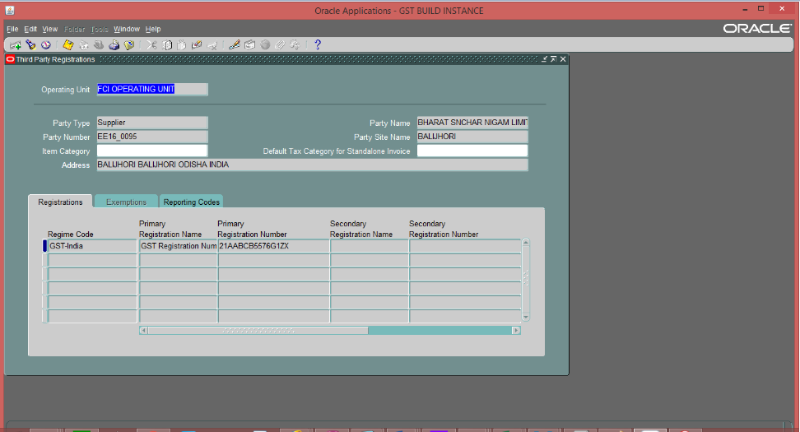
- To enter TDS details for Supplier, Choose TDS for Regime Code from LOV.
- Select the PAN Number for Primary Registration Name.
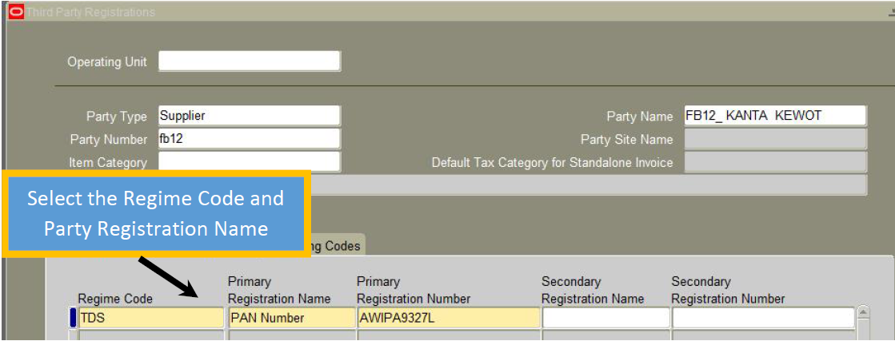
- Enter the value of the PAN Number in Primary Registration Number.
- Click on Save.
- For auto deduction of TDS, vendor type also needs to be attached to the vendor in the reporting codes section of third party registration form.
- Select Regime code as TDS, Reporting type Name as ‘Vendor Type’ and select the vendor type from reporting codes LOV.
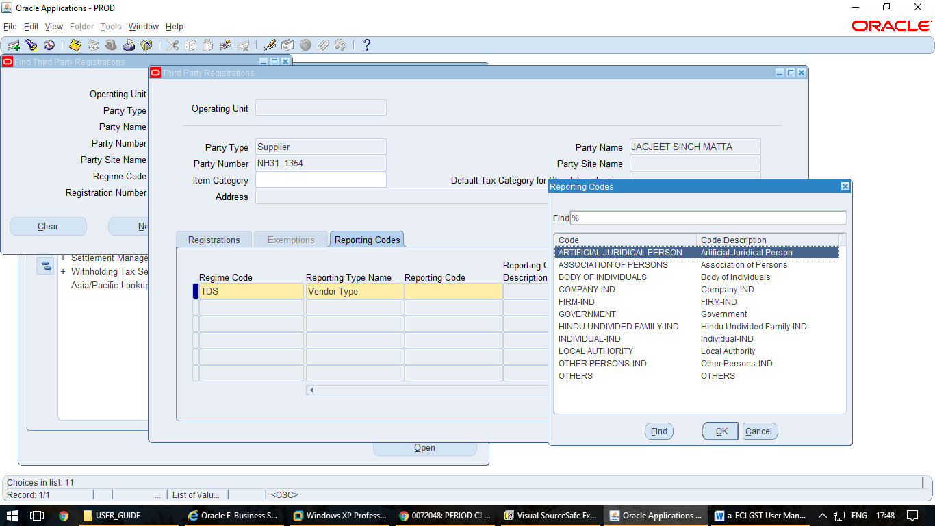

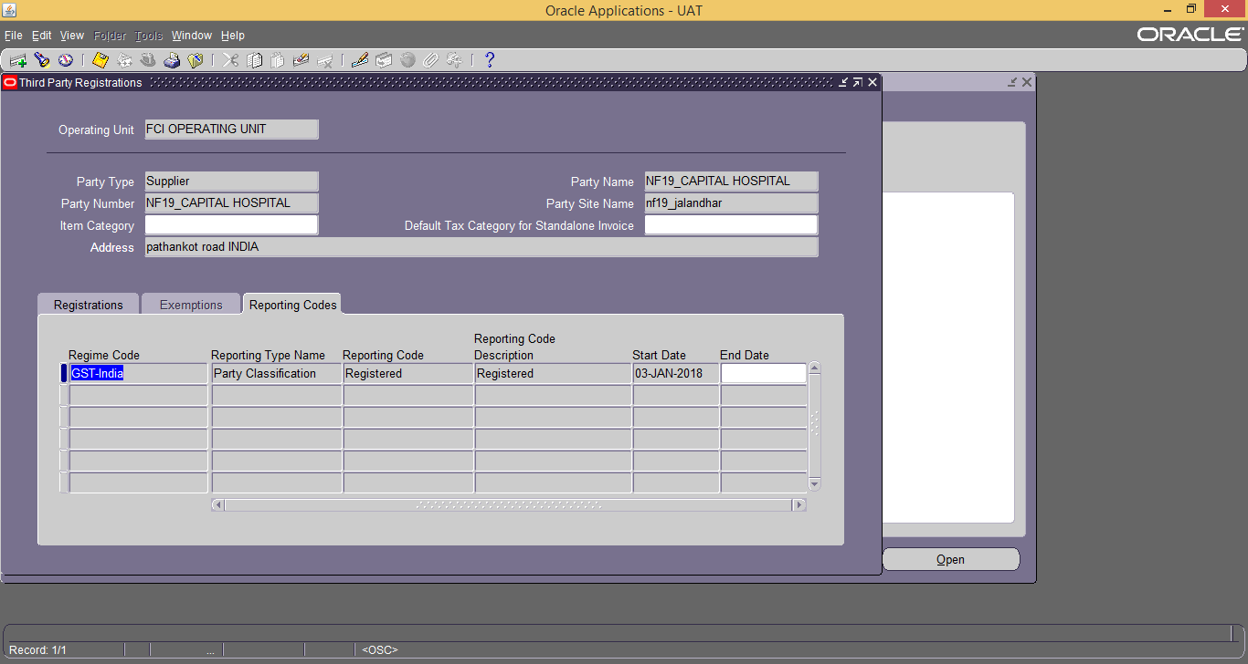
- For entering the GST Reporting Codes, select the Regime Code as GST- India, Reporting Type Name as Party Classification & select the Reporting Code from LOV. Enter the Start Date
- Save the details.
Note: TDS registration (PAN No) is mandatory incase TDS is to be applied on Supplier’s Invoice. Also user needs to specify the vendor type in reporting codes section only then system will start deducting the TDS.
To Find or Update GSTIN Number or PAN Number
Functional Path: Oracle Financials for India >>Party Registrations >> Define Third Party Registration
NOTE: The user can update the GSTIN or PAN details only after the next day i.e if the end date is taken as 06-nov-2017 of older GSTIN/PAN, the start date can only be taken as greater than 06-nov-2017.

- Updation of GSTIN :
- Select Party Type: Supplier
- Enter the Party name, Party Number and Party Site
- Click on Find
- Supplier Registration details appears.
- Scroll till end and enter the End Date.
- Click on Save.

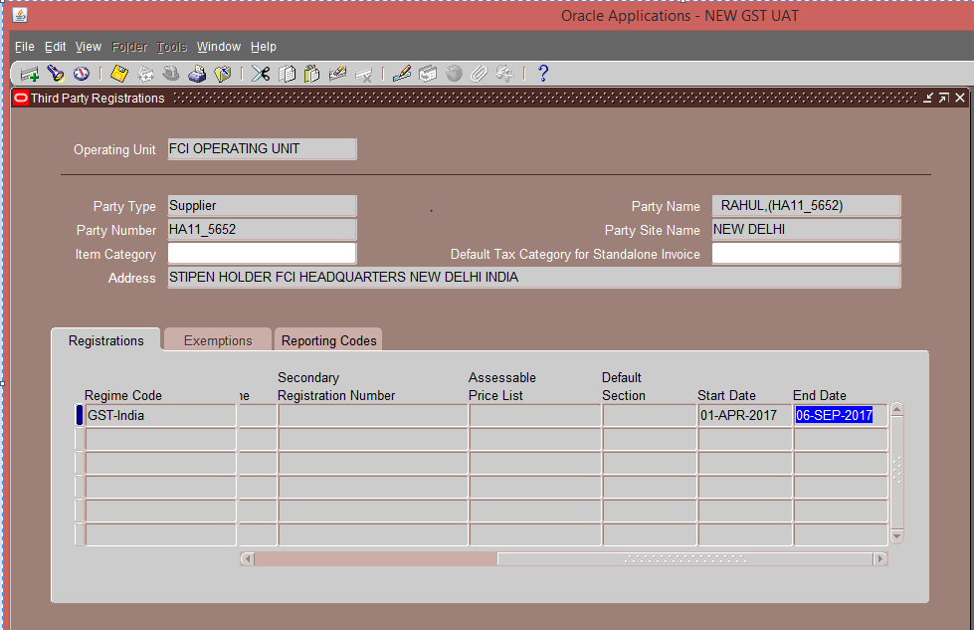

- Enter the new record in next line as per the steps mentioned above. Here also the, GSTIN registration number entered should be in Correct Format as mentioned above.
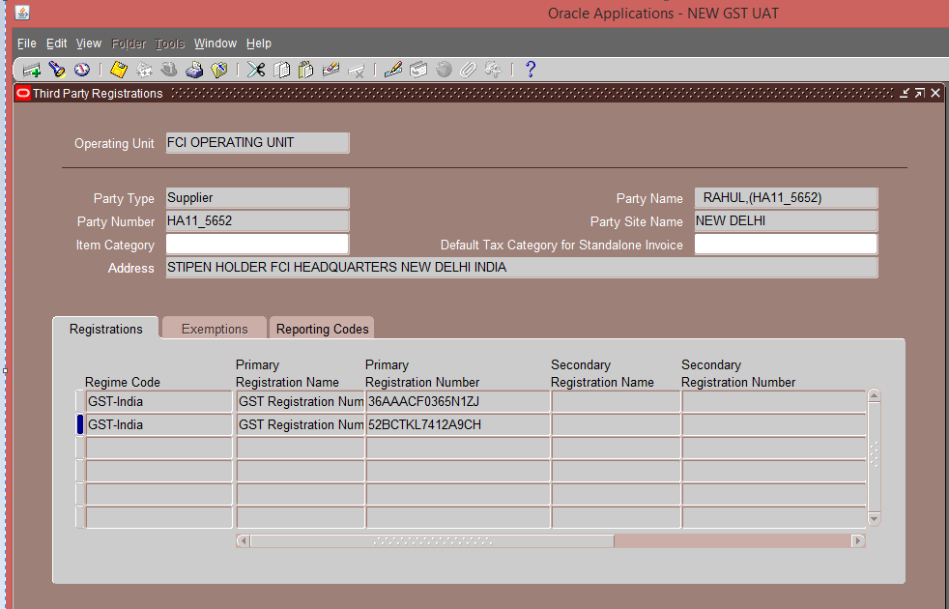

Notes:
- FCI Customer Third Party Registration is an scheduled program which will register the corresponding Customer’s Third Party Details. (Program is scheduled to run once a day in evening.)
- ItemCategory will be setup for Exempted items. So, End user needs not to select tax category on AR invoice. Unit wise item tax category with naming “Item_Category_<Unit>”. CGST and SGST/UTGST Recoverable zero rate taxes will be applied be assigned to all food grain items in these tax categories.
Details of Exempted Items is attached.

Mapping between Item Category and Customers will depend on their Unit defined as first four characters of Customer Number.
Eg- Customer No- NF19_BLS will have the Item_Category_NF19
- Updation of PAN :
Note: The check is implemented in the system which will prevent the user to enter PAN details at the site level .Therefore,PAN should be updated first at the supplier level otherwise the system will throw an error as shown below. The PAN details across the supplier site will automatically be updated corresponding to the supplier.
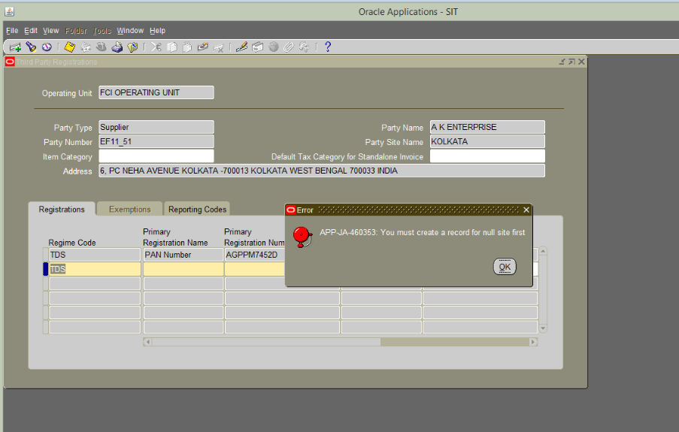
- Select Party Type: Supplier
- Enter the Party name, Party Number and Party Site
- Click on Find
- Supplier Registration details appears.
Note: Updation of PAN at the supplier level will automatically update the PAN across its corresponding sites as shown below.
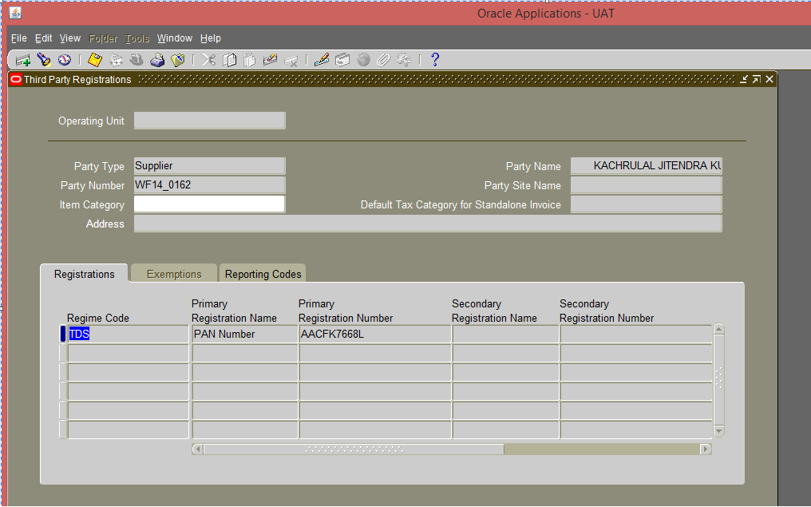
- Scroll till end and enter the End Date.
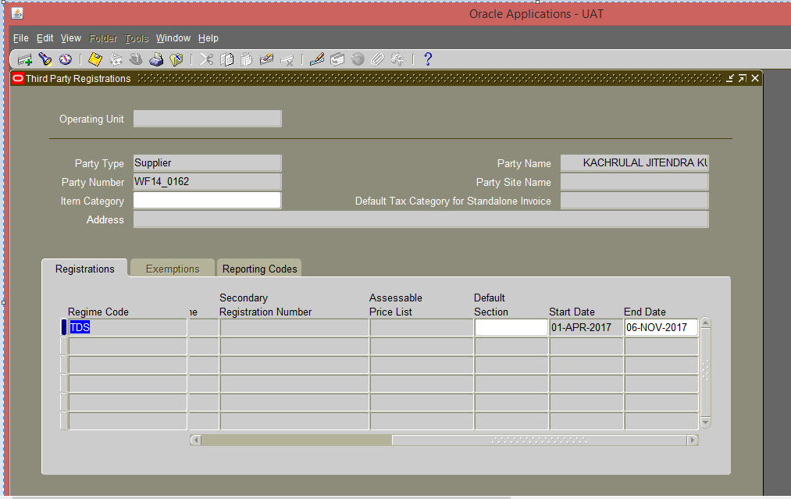
- Click on Save.
- Enter the new record in next line as per the steps mentioned above .Here also the , PAN registration number entered should be in Correct Format otherwise error will occur.
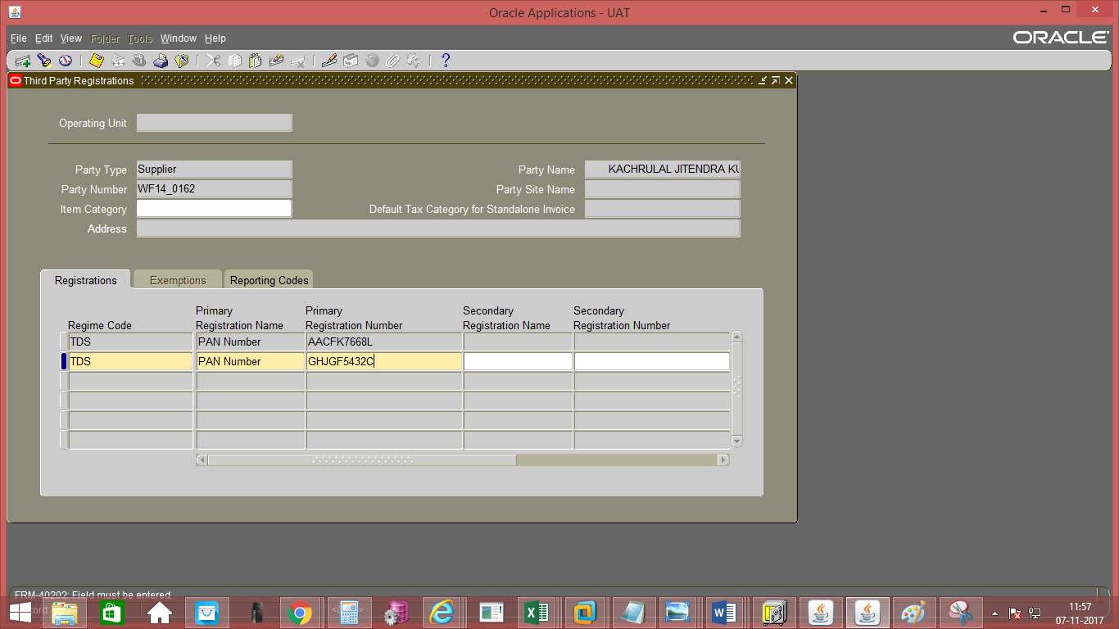
- Enter the start date of the next day
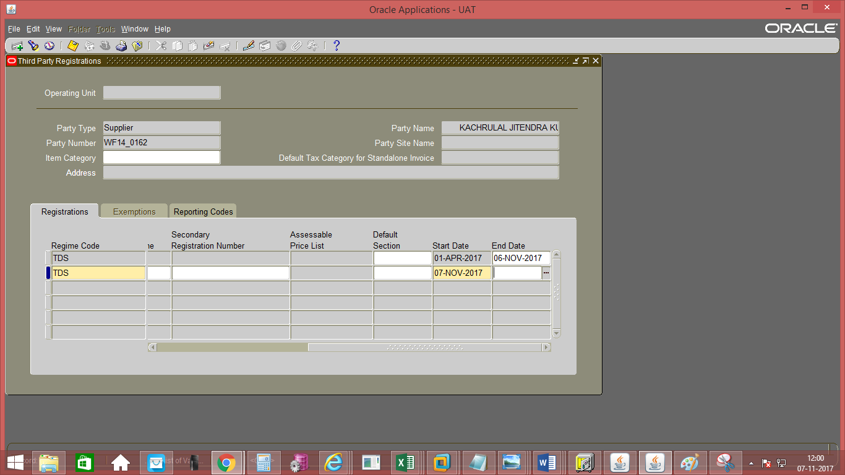

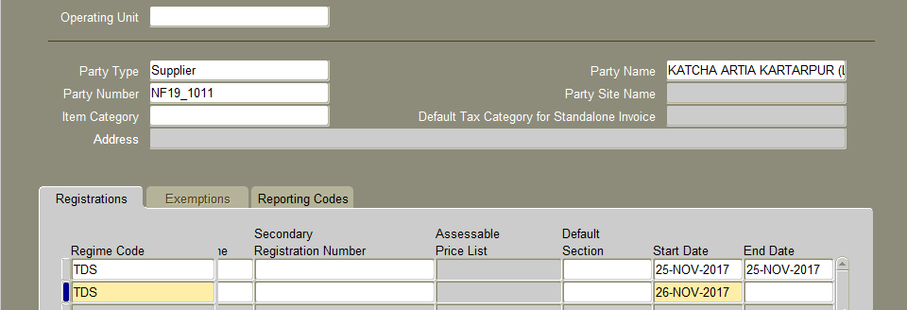

Note: - As per the standard functionality of Oracle PAN/GSTIN update cannot be done on the same date. It has to be done on the consecutive days only.
Non Reverse Charge GST Application
Functional Path: Invoice >> Entry >> Invoices
- Enter Invoice Header Details.
- Enter the Invoice Line Details. Description is made mandatory. In addition, User should enter the UOM & Quantity at Line Level & Place of Supply at Line DFF as these details are necessary for correct GST reporting.
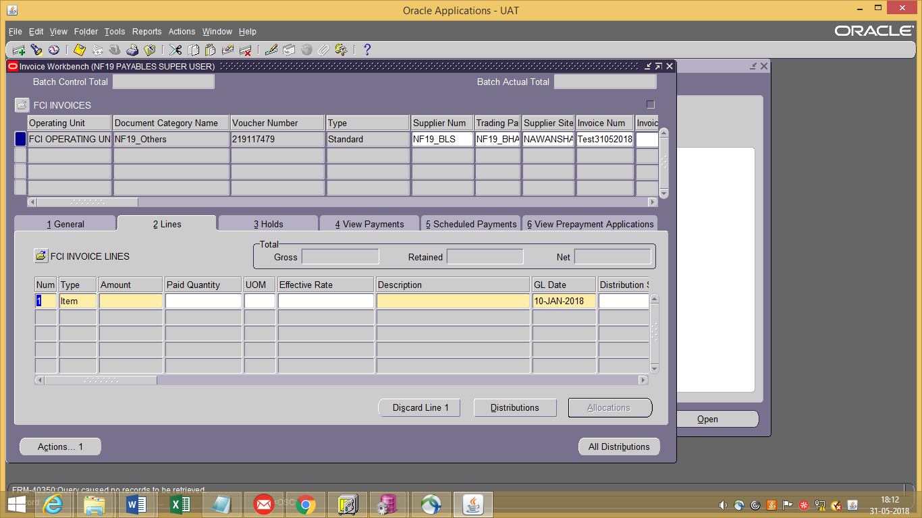
- Enter the Line Distributions.

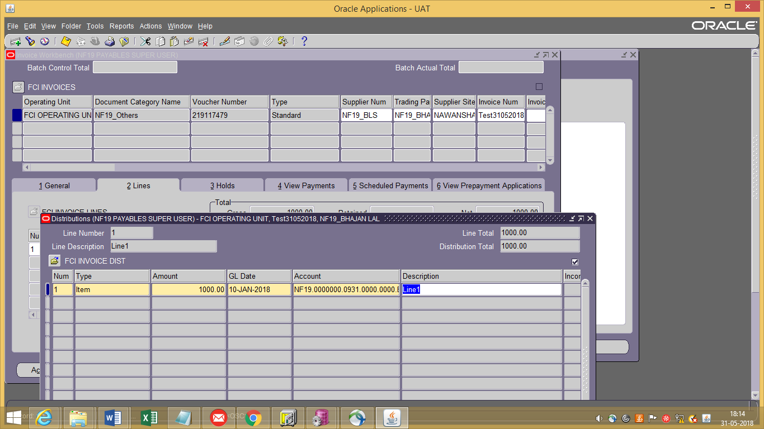

Save the Distribution and close the Distribution window.

- Now, to apply the GST on invoice, Navigate to: Invoice workbench >>Tools >> India Tax Details
- Enter the Organization and Location
Organization:-Select the name of the organization prefix with the unit code for which taxable invoice has to be created. The Location will automatically get populated.
- Enter the following details >>
Tax Category:- For each line on the basis of taxability. For example: FB_IGST_NREC_0%. Select the Tax Category prefix with the unit code for which taxable invoice has to be created.
HSN Code:-If the user is purchasing goods,then HSN Code has to be entered by the user.It should always be numeric otherwise system will throw an error.
SAC Code:-If the user is buying services, then SAC Code has to be entered by the user.It should always be numeric otherwise system will throw an error.
Intended Use:Always enter Non-manufacturing.
Note: The HSN/SAC entered should always be numeric otherwise system will throw an error upon validation as shown.
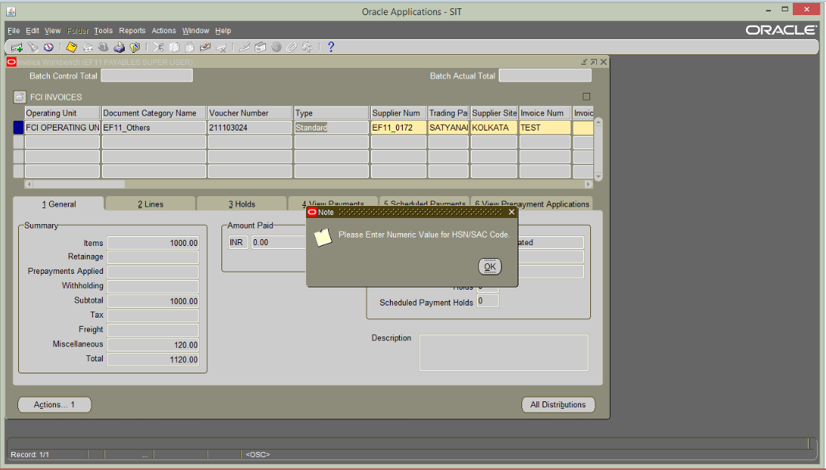

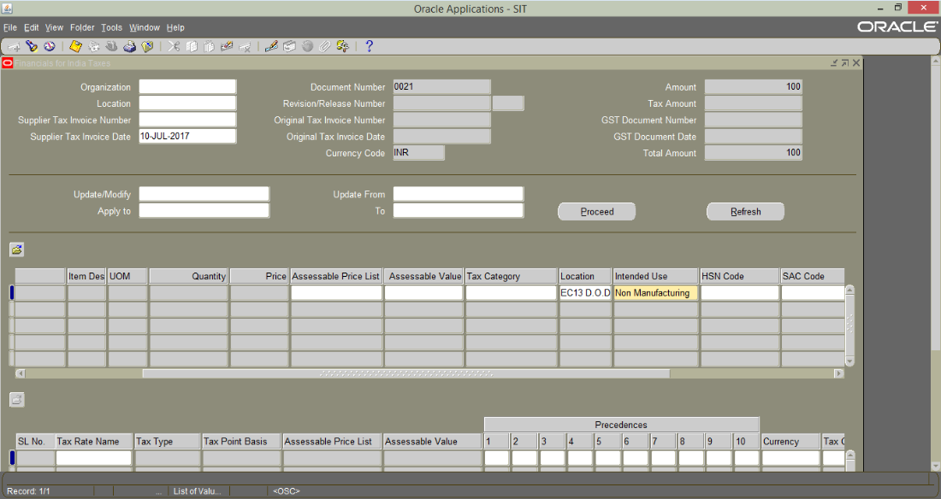
- Click Save and apply. The changes will be reflected on the invoice and the Total Tax Amount will be calculated.
- Close the India Tax Details Form and go to main Invoice form
- Validate the Invoice and submit for approval

Note: GST taxes will appear as miscellaneous as shown below.

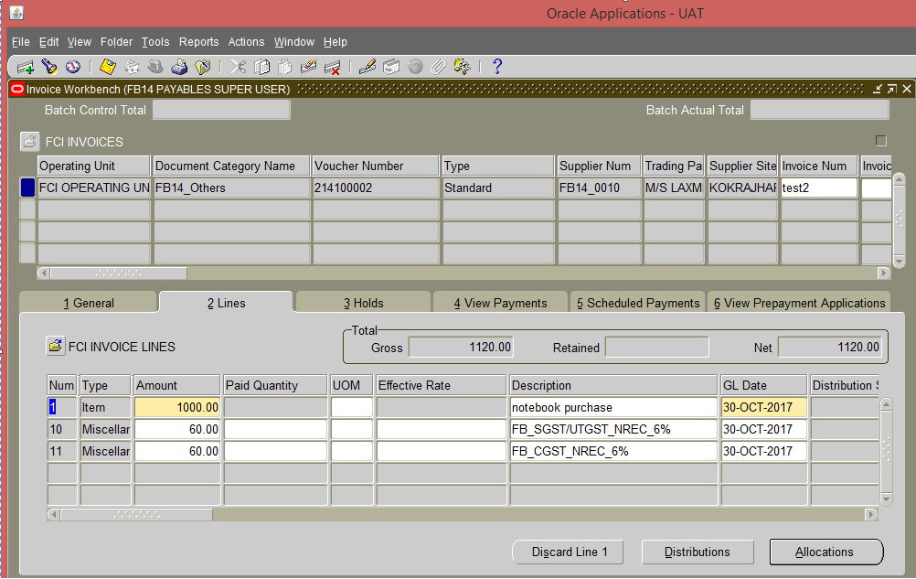

Note: - In case FCI is eligible for input tax credit, REC– Recoverable Tax category to be selected. Eg- Tax Category NB12_IGST_REC_18% is applied, then accounting will be as follows: -

Goods a/c debit 10000
IGST Credit a/c debit 1800
Supplier Liability a/c 11800

For Non Recoverable NREC- Tax Category to be selected.Eg- Tax Category NB12_IGST_NREC_18% is applied, then accounting will be as follows: -

Goods a/c debit 10000
Goods a/c debit 1800
Supplier Liability a/c 11800

Reverse Charge Application to Registered vendors
Functional Path: Invoice >> Entry >> Invoices
Steps to create Reverse Charge invoice -
- Enter all the relevant details of Invoice as explained in above section.
- Now, while applying GST the Tax Category selected should be of ‘REVERSE’ type.
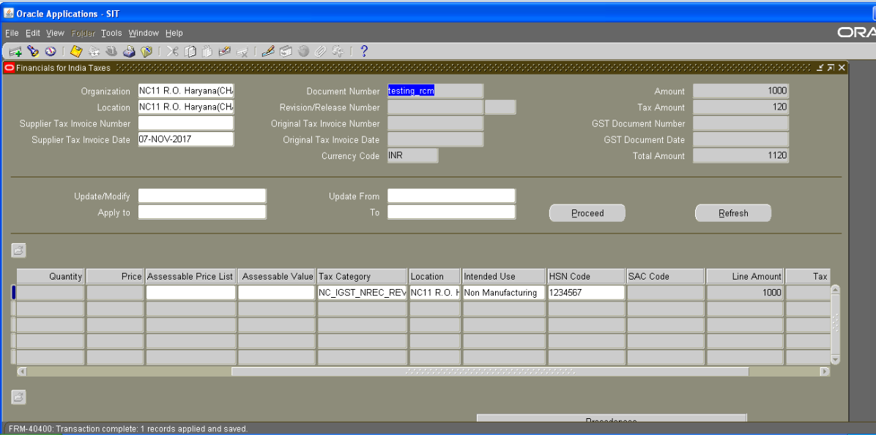

- Save the changes and click on apply
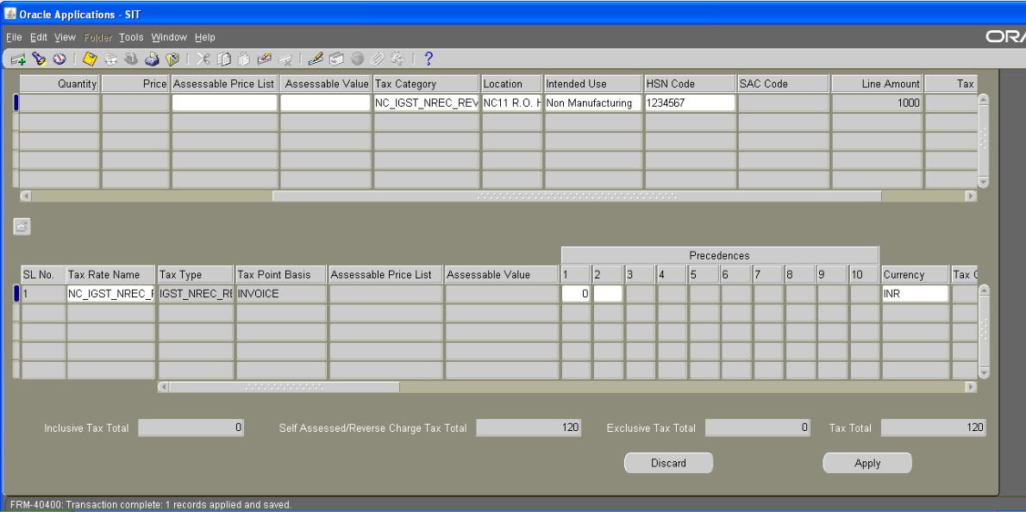

NOTE: - Creating Reverse Charge Tax Invoice will not add any Tax lines at Distribution Level

- Close the India Tax Details Form and go to main Invoice form.
- Now, validate and approve the invoice.
- Create Accounting.
- Now, Reverse charge Invoice will be processed when “India-Period Ending Process”is completed for the said Period.
- After that Reverse Charge sequence will be generated for the Invoice & GST accounting will flow in General Ledger under Journal Category- “AP Validate”.
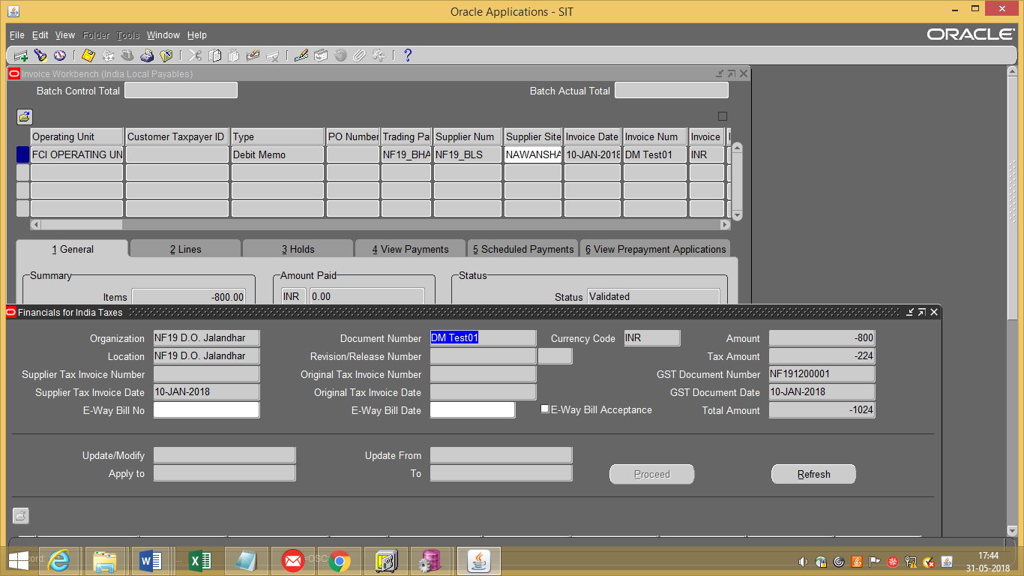

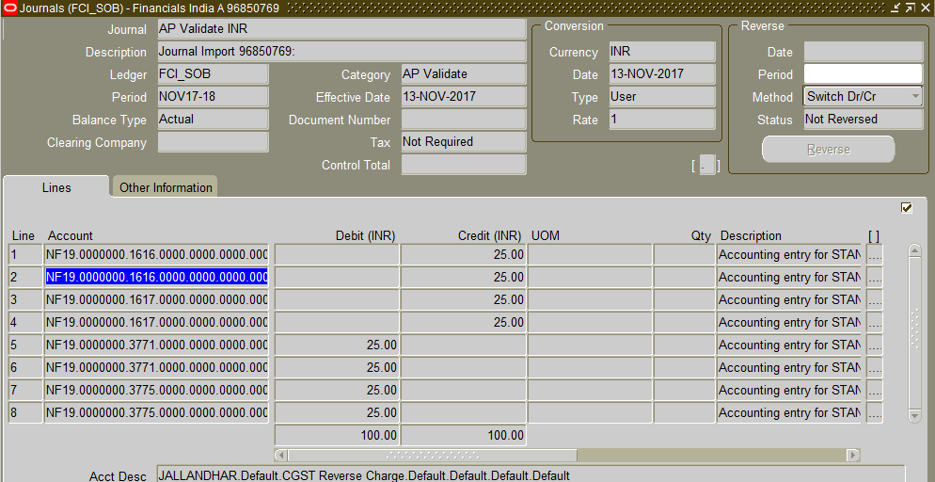

Prepayment Application to Taxable Invoices
Functional Path: Invoice >> Entry >> Invoices
Steps to create Prepayment invoice -
- Enter all mandatory requirements in the standard Invoice form for header and line level where invoice type is Prepayment.
- Now, to apply the GST on invoice, Navigate to : Invoice workbench >> tools >> India Tax Details
- Enter the Organization and Location
- Enter the Organization, HSN/ SAC Code and location.
- Select the Tax Category.
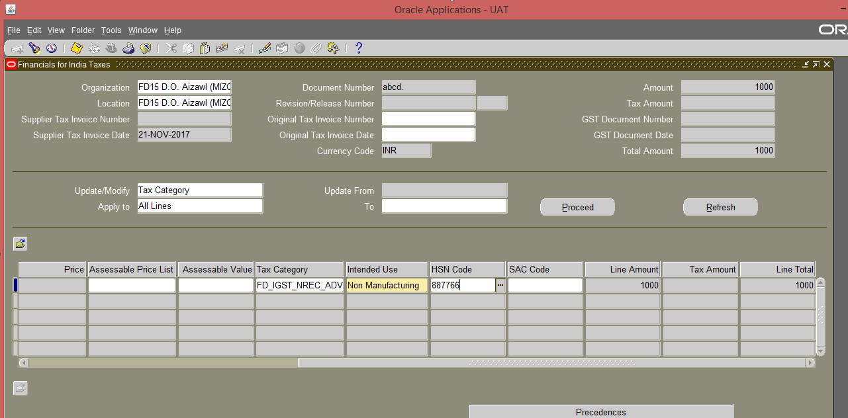
- Save the changes and click on apply
- Now, validate and approve the prepayment invoice
- Create Accounting
- Pay in full
- Now,apply this prepayment to the standard invoice. Here, taxes applied to both the invoices should be same with same HSN Code.
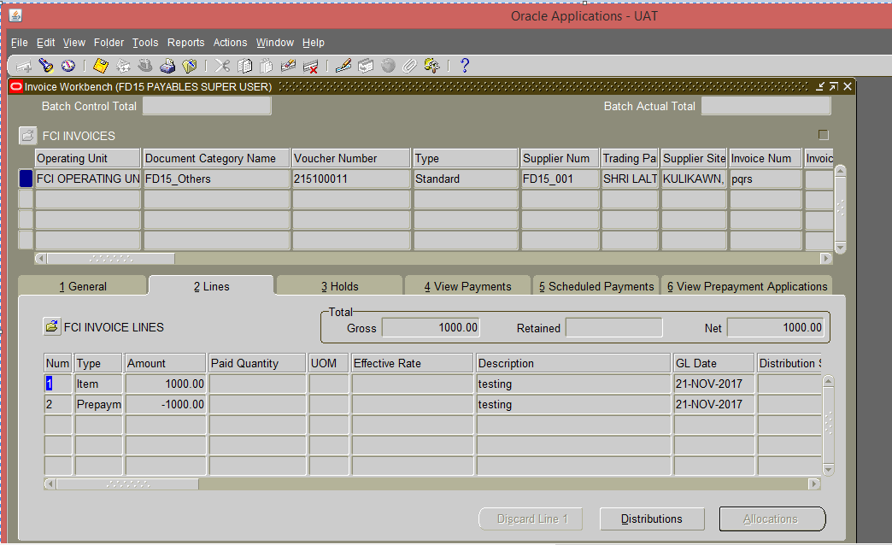
TDS application to Standard Invoices
Functional Path: Invoice >> Entry >> Invoices
Steps:
- Create an Invoice for a Supplier on whom TDS is applicable (TDS can be deducted for suppliers for which supplier additional information is entered). TDS will automatically be deducted for the specified section, which is attached as the default section to the supplier.
- Once all the mandatory fields are entered while invoice creation, click on Tools>TDS Tax Details
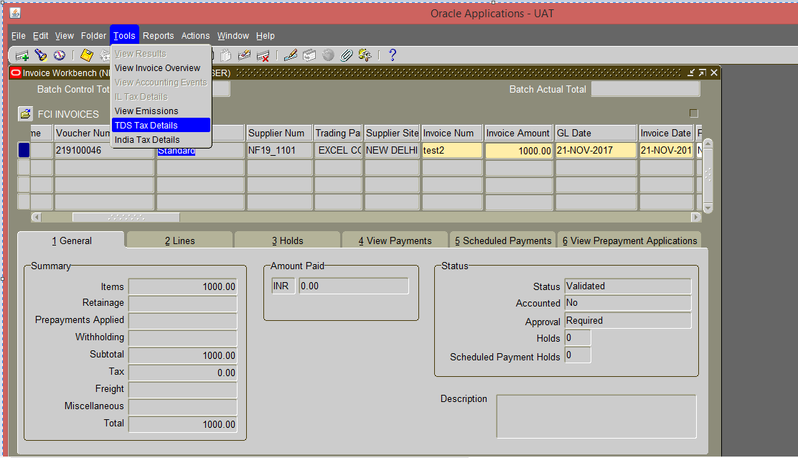

Note : The TDS can only be applied to the third party registered vendors otherwise system will throw an error as shown below.
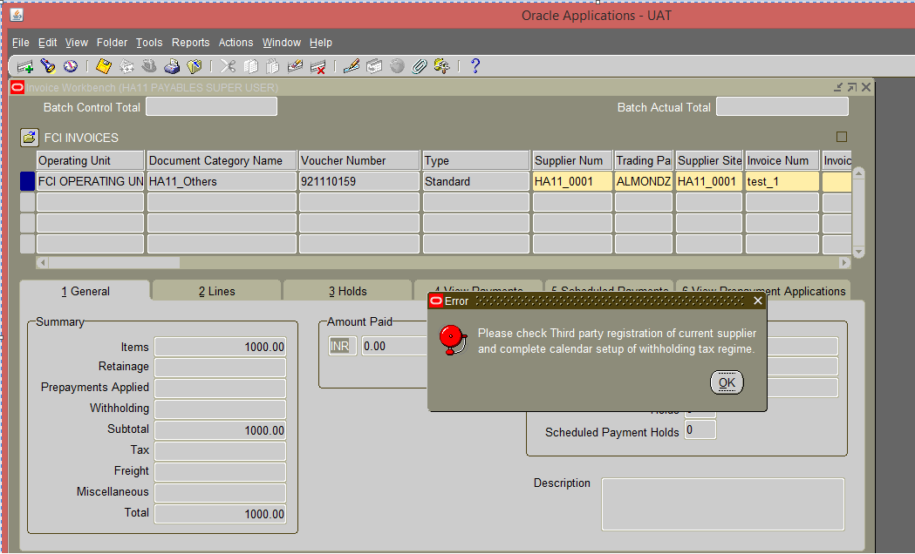

- Enter the section code and the Tax category and Save.Section Code and Tax category populated will always be of the logged in user unit
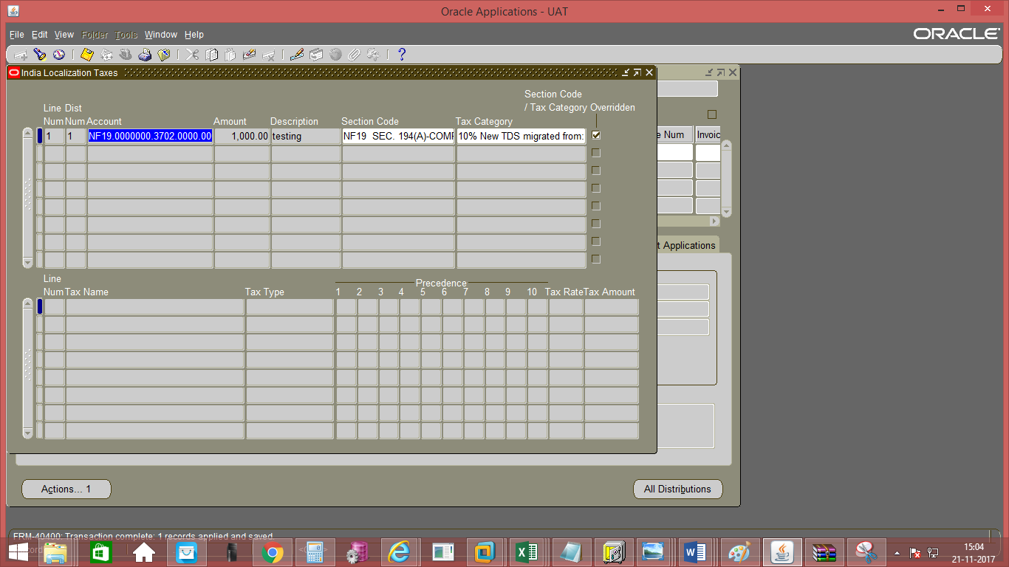

4. Click on Actions and Validate the Invoice
5.Once invoices are validated “India TDS Processing (India - TDS Processing Concurrent)” will fire. Which will generate the TDS Invoices

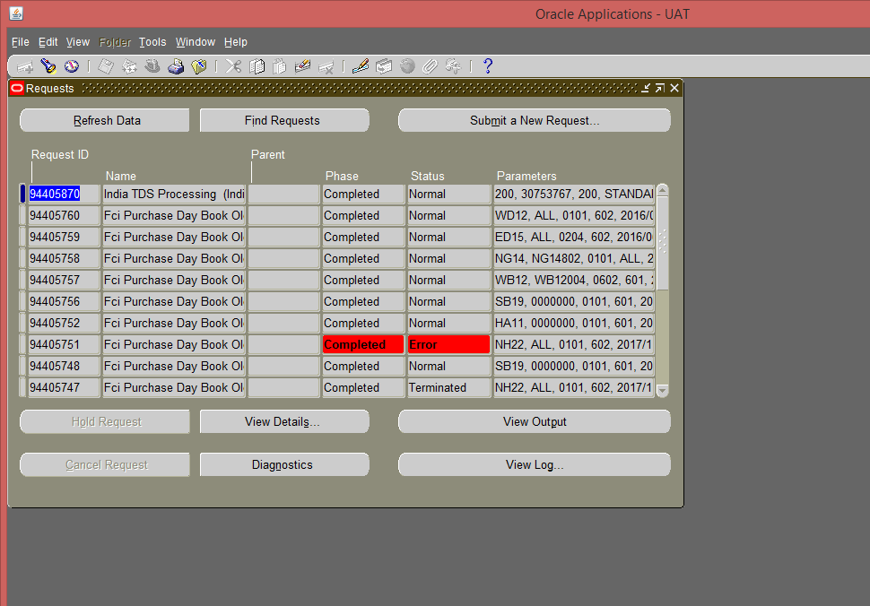

6. Search for invoices created for the supplier. The system will automatically make a credit memo on supplier for the amount of TDS to be deducted from the Invoice, also a Standard Invoice will be created by the system on Income Tax Authority for the amount of TDS that is deducted and hence becomes payable to Income Tax Authority. Create accounting and approve the invoice for payment.
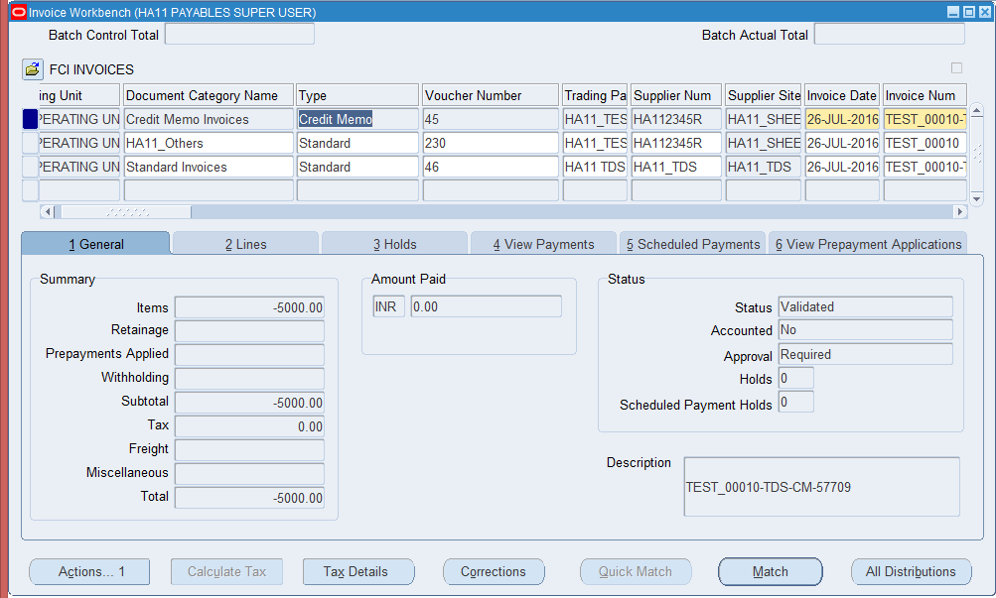
7. The TDS invoices get generated with pay group same as that of the original invoice, in TDS invoice.

AP Validations
Invoice Form
- Tax category LOV will contain categories starting with first 2 characters of unit.
- Organization and Location LOV will contain self-unit entry only.
- Tax Rate LOV will contain rates starting with first 2 characters of unit.
- Intended Use LOV restrict to Non- manufacturing only.
- Validate option in Invoice Actions will be available only after following checks-
  - Tax Application is mandatory for Goods Purchase Invoice Categories.
  - Tax Category/Organisation and Location must belong to same unit.
  - User must Enter Numeric Value for HSN/SAC Code.
- The Tax Rates in the detail section must be in sync with Tax Category selected.

Third Party Payment Functionality
Navigate to the Supplier page and query the supplier with which relationship is required to be created.
Third Party Payment
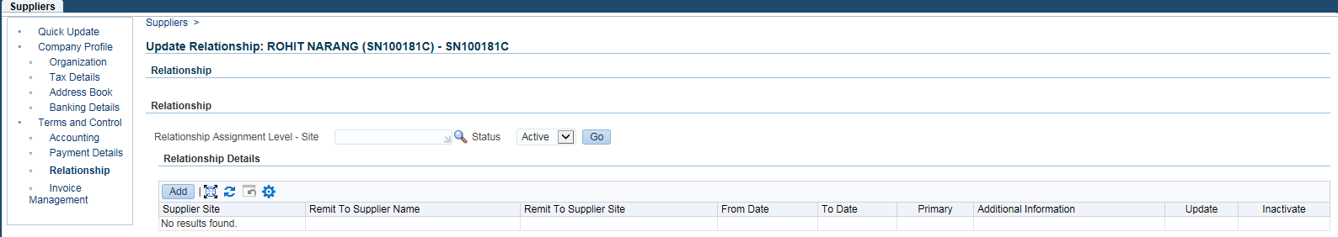
Added Relationship:-
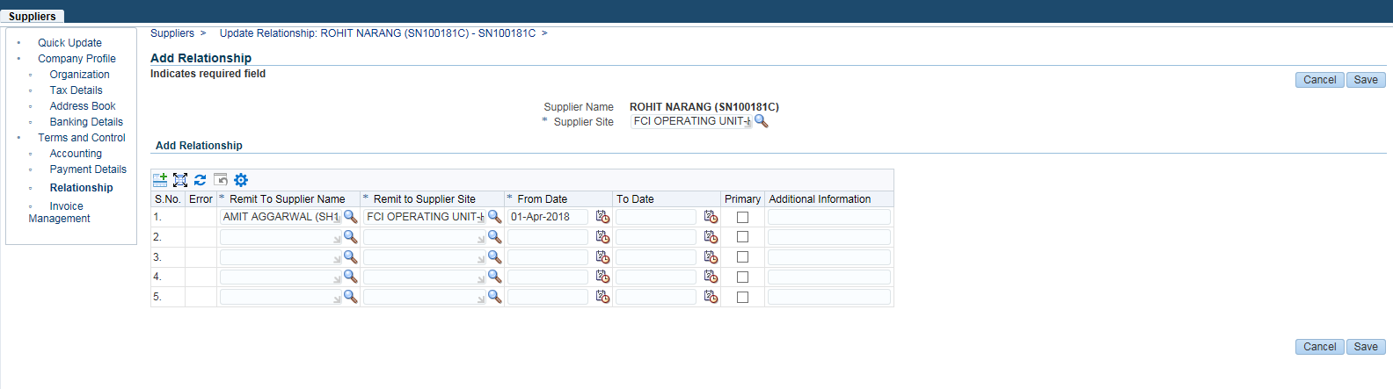
Click on Save
Step 2:-
Navigate to the invoice screen:-
Enter the Invoice Details:-
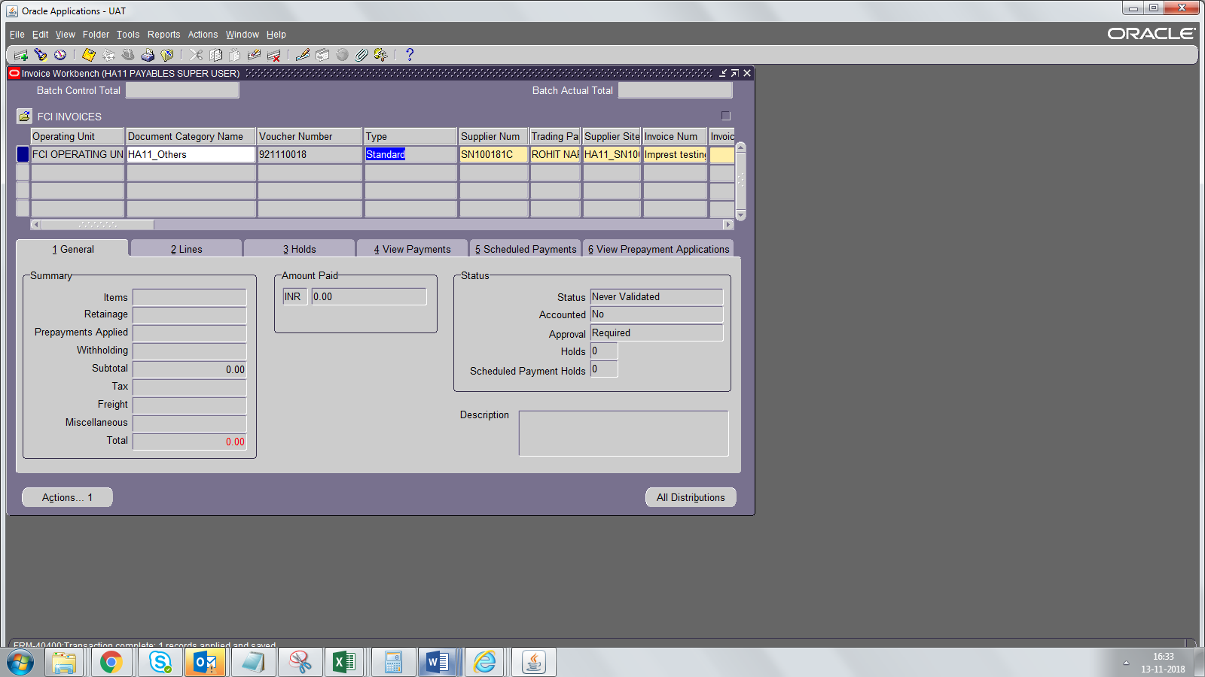
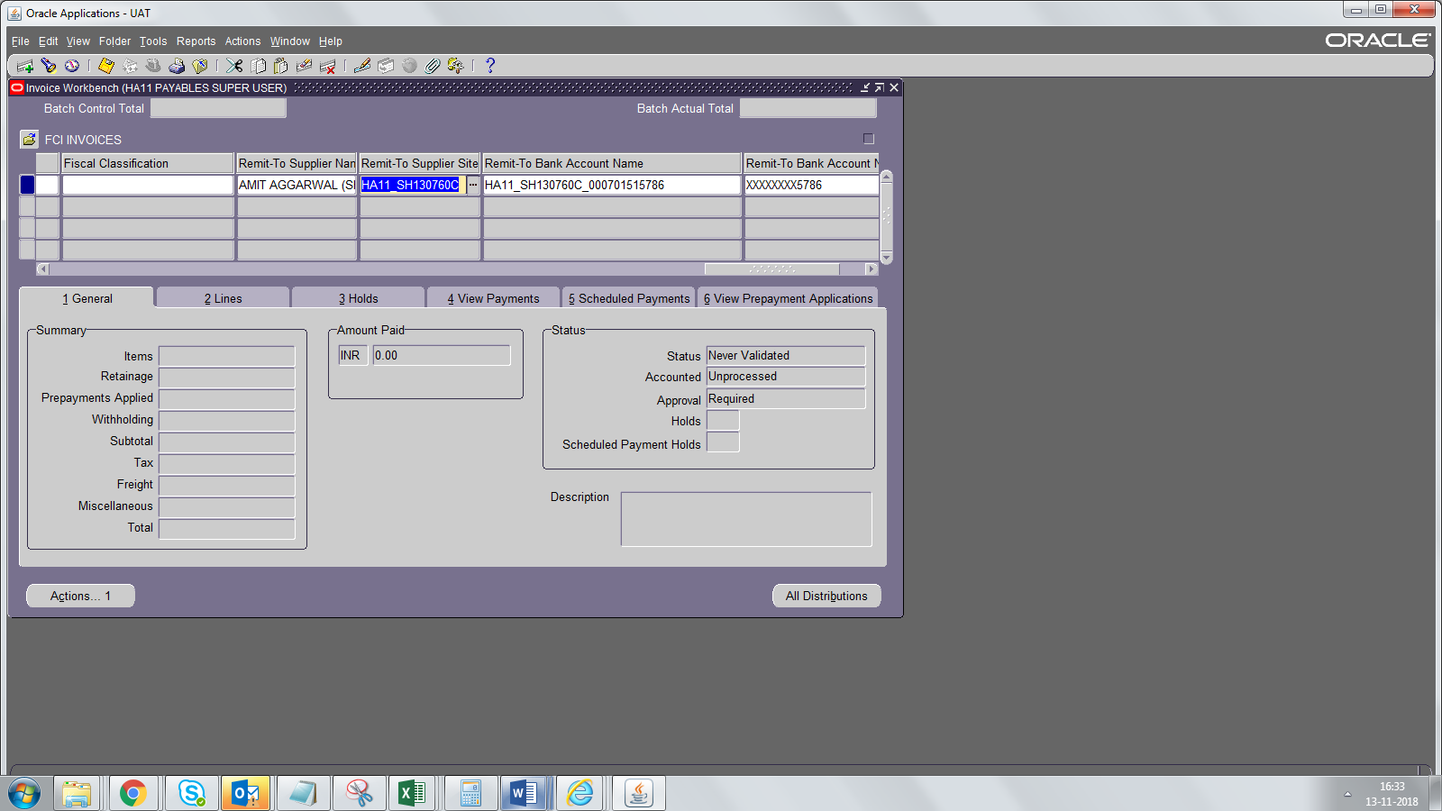
Select Remit To Supplier Name from the LOV
Enter the lines details:-
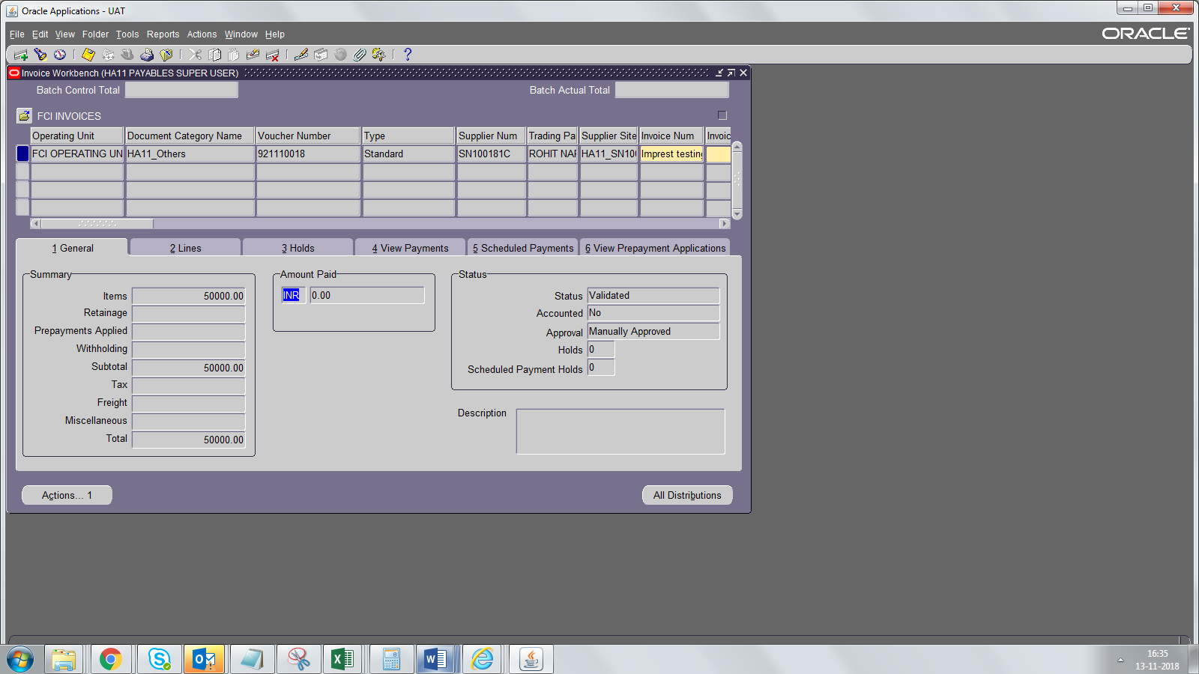

Scheduled Payments- Remit to supplier details are auto-populated
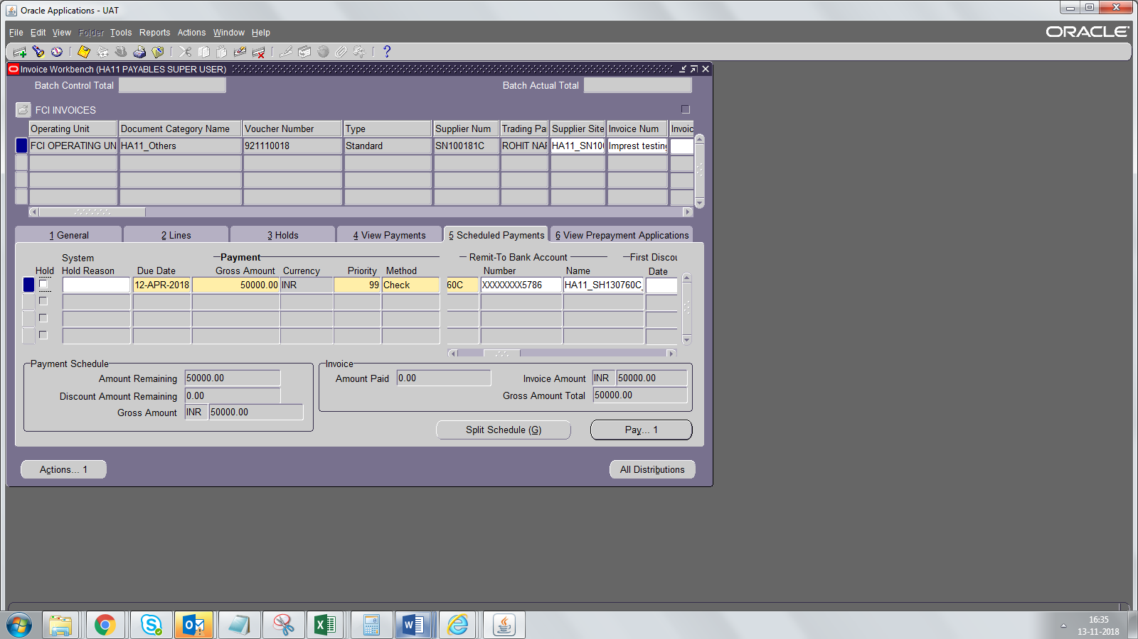Step 3:-
Payment
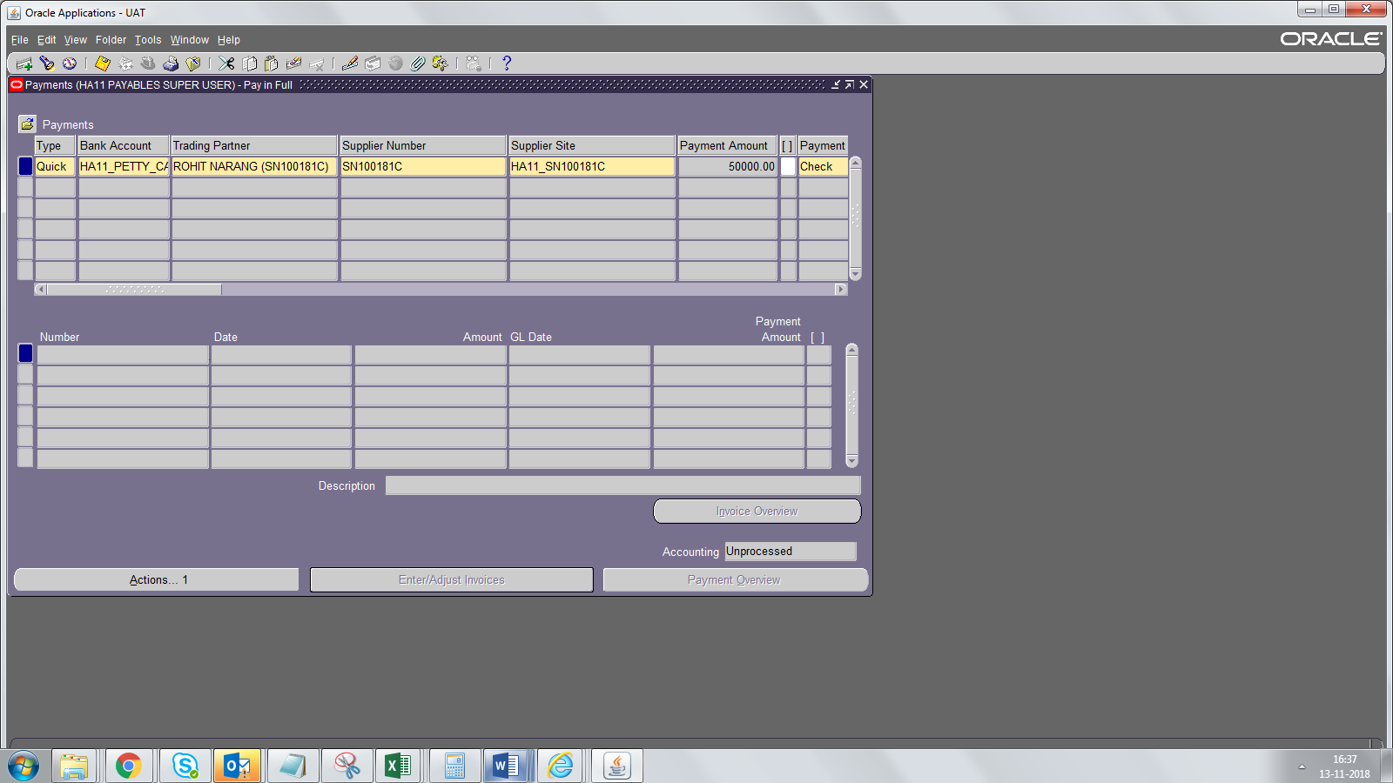
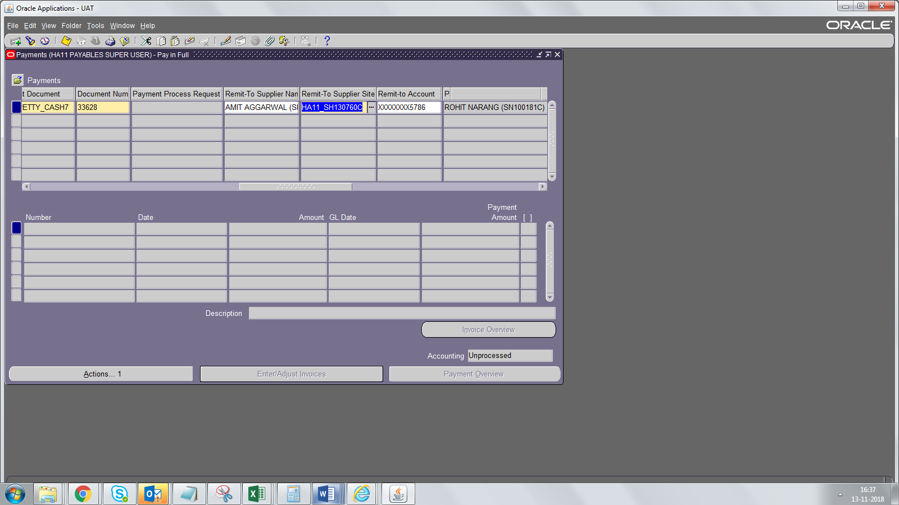
Payment is done to the correct Account.
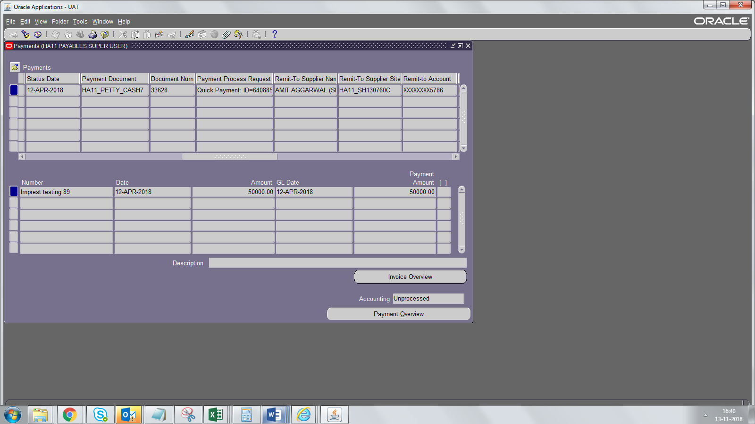

AP Reports

Supplier Master Report
The Report shows all the details related to a supplier.Additionally ,"FCI Supplier Details Report" is enabled to run on hierarchy. i.e if run for a parent unit it will display the details of underlying units also.

Report Parameter is Unit. If run for H000, ZO Level or RO level- all records with valid GSTIN will be displayed.
If run unit wise, then all details irrespective of GSTIN will be displayed.

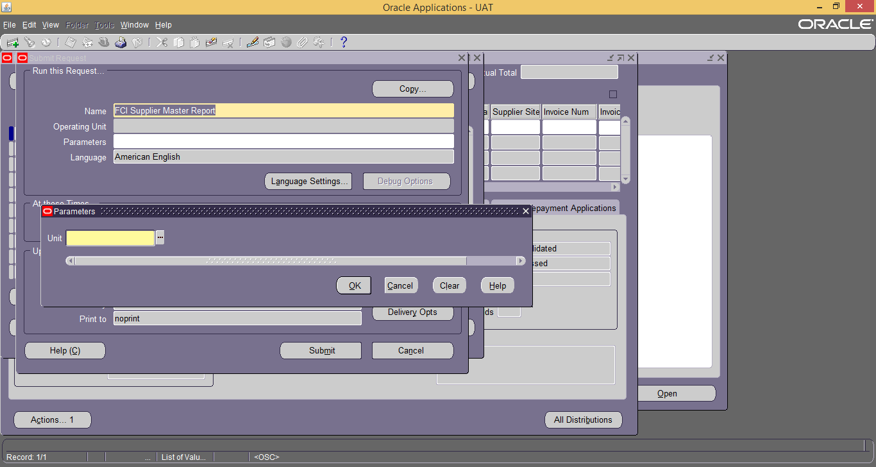

Report should be generated in Excel format.

FCI GST AP Self Addressed Invoice Report
Self-Addressed Invoice needs to be issued by FCI incase Goods/Services are availed from UN registered vendor.
So, in all cases where Reverse Charge Tax category with rate >0 on an Invoice is applied and vendor is unregistered it will be reported as Self Addressed Invoice.
Report will be generated for only those AP documents on which Reverse charge sequence at India Tax Detail Form is generated.
Reverse charge sequence is generated on competion of India- Period Ending Processwhich is scheduled daily once a day.

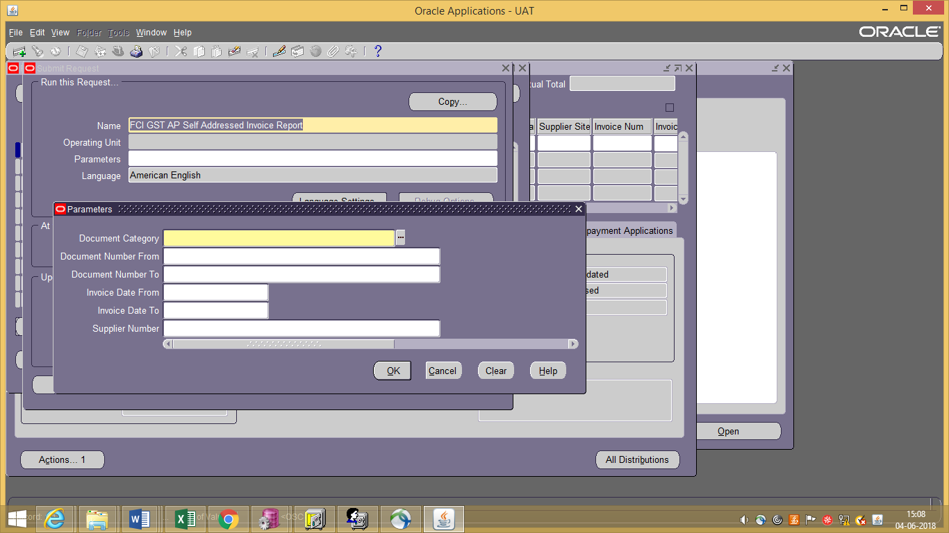

Report Parameters-

- Document Category (Mandatory)- AP Document Category List
- Document Number From (Optional)- From Range of Voucher No
- Document Number To (Optional)- To Range of Voucher No
- Invoice Date From (Mandatory)- GL Date Range From
- Invoice Date To (Mandatory)- GL Date Range To
- Supplier Number (Optional) - List of Values displaying the Suppliers
Output of the report should be generated in PDF format.

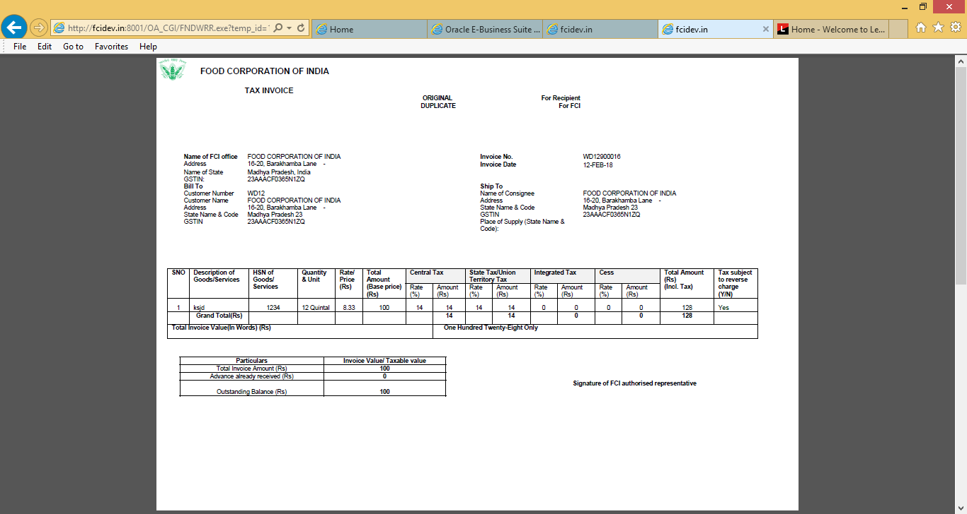

FCI GST AP Payment Voucher- Reverse Charge

FCI purchases goods or services from registered vendor and some of the services falls under Reverse Charge Category as per law.
FCI purchases goods/ services from unregistered vendor and Reverse Charge is applicable as per law.Therefore for ensuring GST compliance, FCI is required to issue Payment voucher- Reverse Charge to both Registered and unregistered vendor as the case be.
Report will be generated for only those AP documents on which Payment voucher Sequence is generated.
Payment Voucher sequence will be generated on completion of FCI AP GST Payment Sequence Generator program which is scheduled daily once a day.
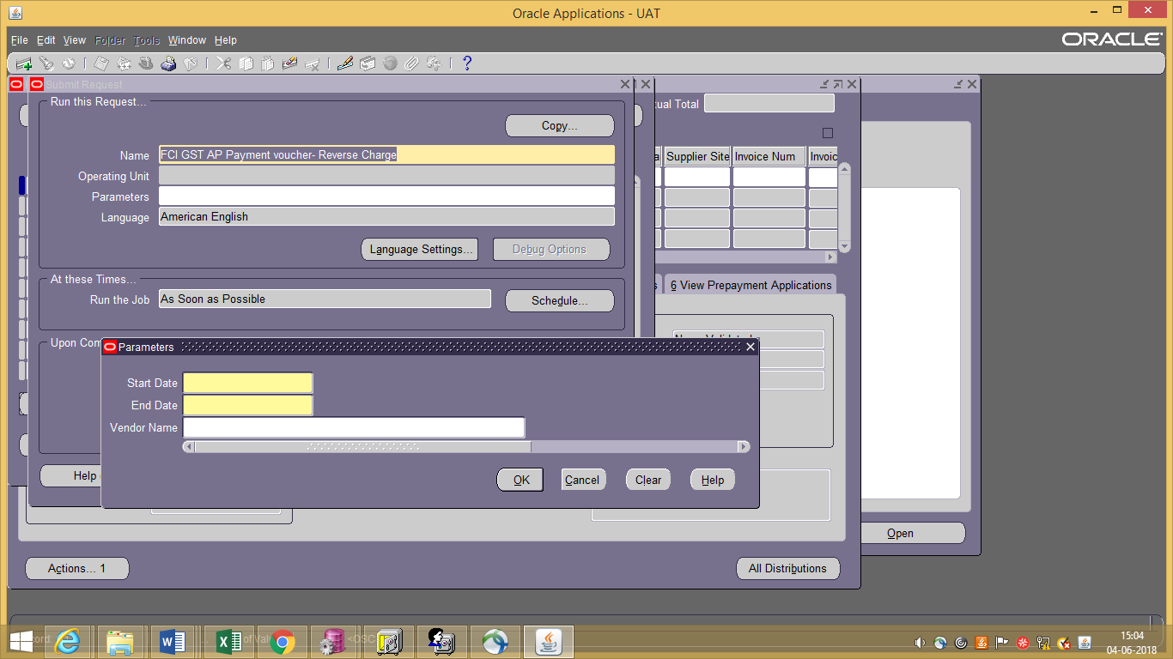
Report Parameters-

- Unit (Mandatory)-Hidden- Will be auto selected based on user responsibility first 4 characters
- Start Date (Mandatory)- Payment GL Date From
- End Date (Mandatory)- Payment GL Date To
- Vendor Name (Optional) - List of Values displaying the Suppliers
Output of the report should be generated in PDF format.
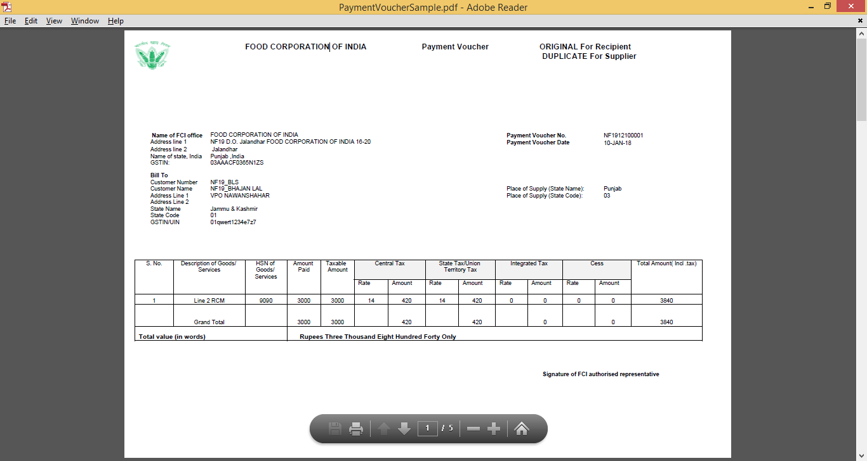

FCI GST AP ITC Report

This report brings out the details of all the applicable Account Payables documents (Standard Invoice, Prepayment, Credit Memo and Debit Memo) on which GST taxes (Except Reverse Charge) are applied. The report reflects only invoice lines of the above invoices on which GST taxes (Except Reverse Charge) are applied. This report runs on hirarchy basis too.

Note:
- The report brings data only if that particular invoice is accounted and having GL date on or after ’01-Nov-2017’.
- The ‘GL Date From’ and ‘GL Date To’ parameters should be in the date range of same month (or Say Period). The cross month dates parameters value in above two input parameters will compell program to get completed with Error. The message will be reflected in the Log file.

Parameter’s Screenshot:-

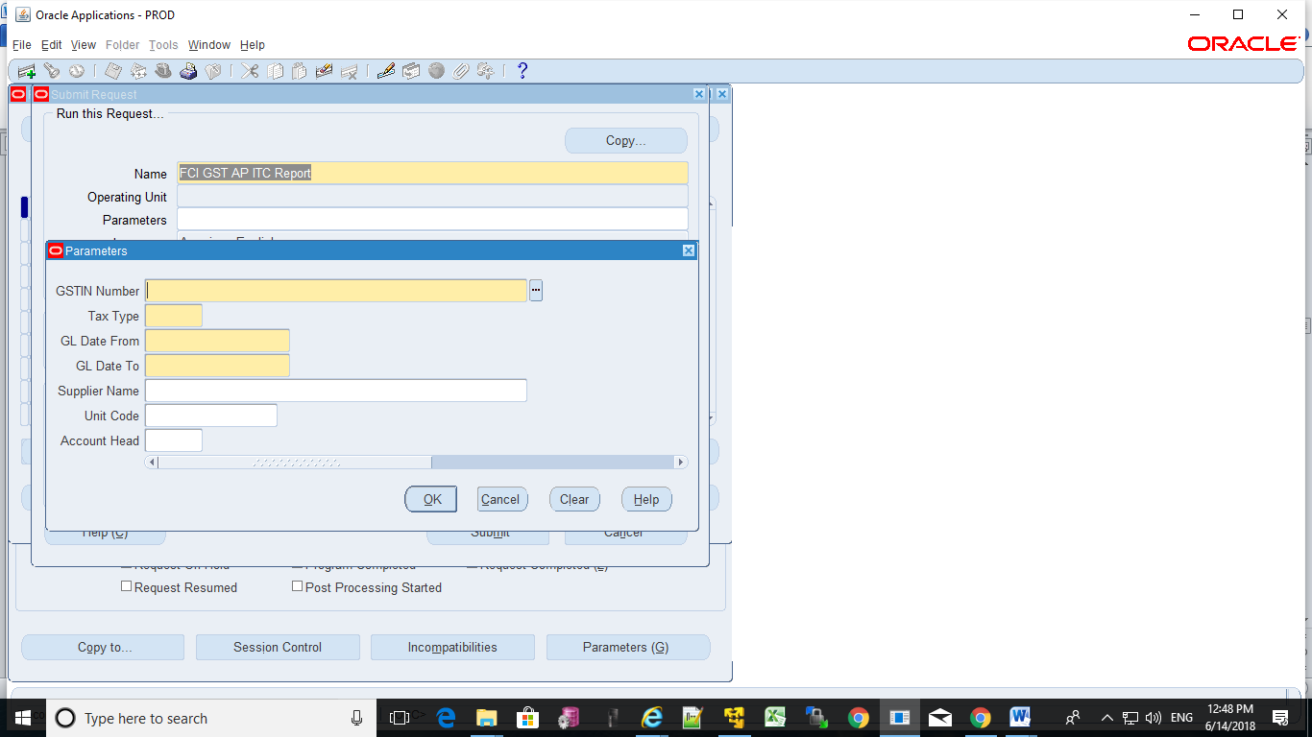

Report Parameters-
GSTIN Number (Mandatory) – It gets auto selected based on the registered GSTIN number of the responsibility’s first four character (i.e. Unit).
- Tax Type (Mandatory) – It gives LOV ‘REC’ and ‘NREC’ as two values.
- GL Date From (Mandatory) – It is invoice’s starting date range of GL date.
- GL Date To (Mandatory) - It is invoice’s ending date range of GL date.
- Supplier Name (Optional) - It fetches the LOV of supplier’s name pertaining to that particular Unit.
- Unit Code (Optional)–It fetches LOV of all the Units.
- Account Head (Optional) – It fetches LOV of Account codes. This account code is pertaining to the account code at the invoice line level .
Output of the report should be generated in Excel format.

- Sample Output

FCI GST Reverse Charge Register Report
This report brings out the lines of all the applicable Account Payables documents (Standard Invoice, Prepayment, Credit Memo and Debit Memo) on which GST Reverse Charge tax is applied.
User needs to run this report only for the gl_date>=’01-Nov-2017’.

Parameter’s Screenshot:-

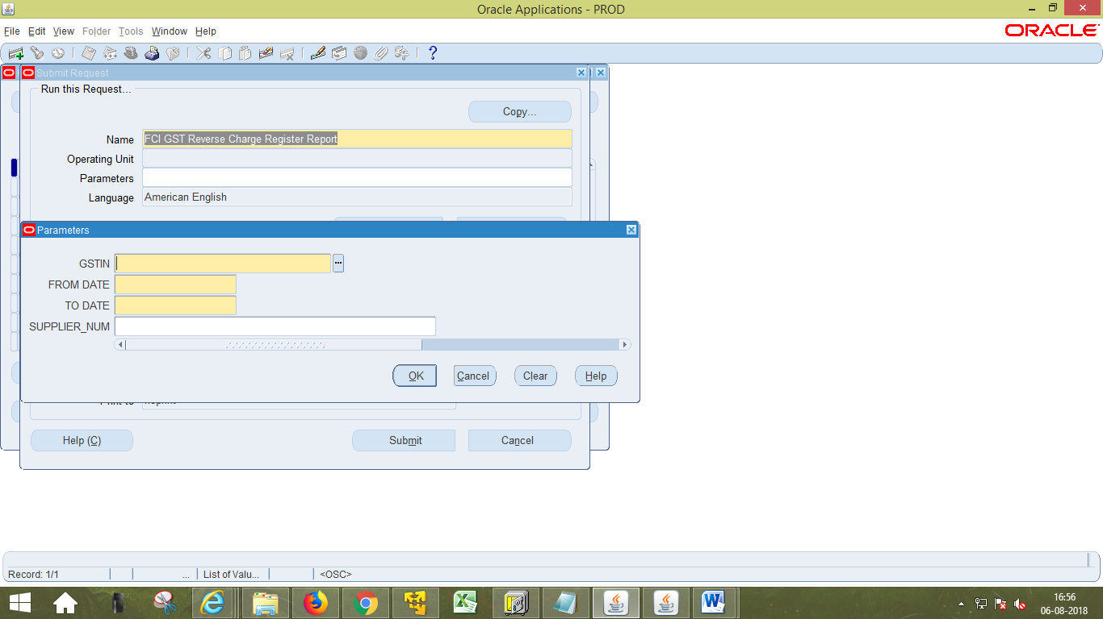

Report Parameters-

- GSTIN Number (Mandatory) – It gets auto selected based on the registered GSTIN number of the responsibility’s first four character (i.e. Unit).
- GL Date From (Mandatory) – It is invoice’s starting date range of GL date.
- GL Date To (Mandatory) - It is invoice’s ending date range of GL date.
- Supplier Num (Optional) - It fetches the LOV of supplier’s number along with name.
Output of the report should be generated in Excel format.

- Sample Output

FCI GST Refund Voucher Report
- As per GST law, refund voucher needs to be issued to Customer incase we have accepted the Advance amount & haven’t submitted the Bill of Supply/Tax Invoice i.e actual supply of goods/services is not being made or partially made.
Therefore for ensuring GST compliance, FCI is required to issue the Refund Voucher.
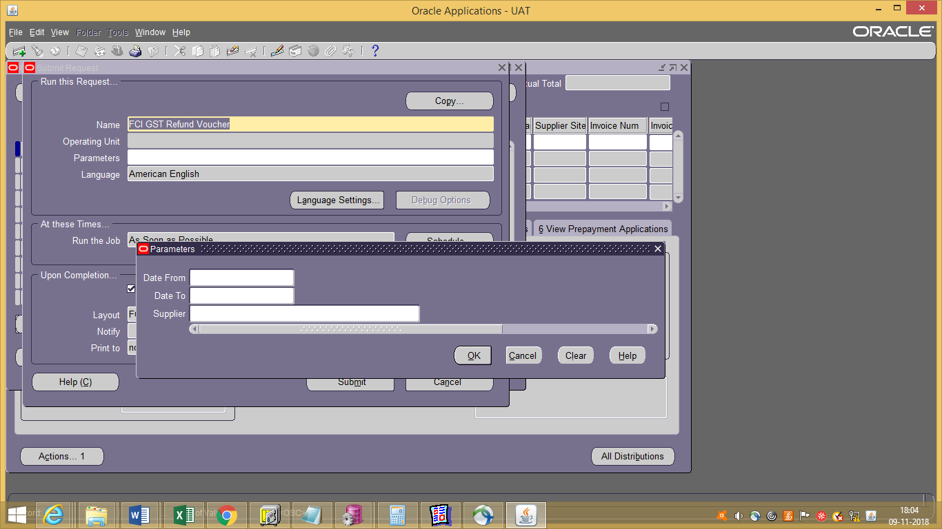
Report Parameters-
- Date From :- Date Range From
- Date To:-Date Range To
- Supplier Name :-List of Values Displaying the Suppliers
- 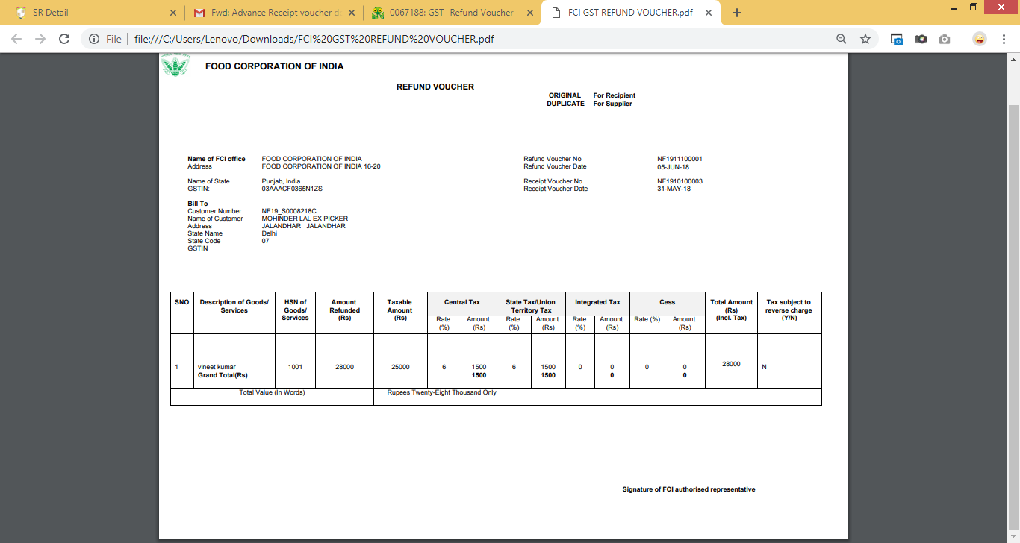

FCI GST Inward Supply Register Report

The Report Parameters for “FCI GST Inward Supply Register” will be as Follows:
- Region (GSTIN)- (Mandatory)- List of Values
- GL Date From (Mandatory)- GL Date From
- GL Date To (Mandatory)- GL Date To
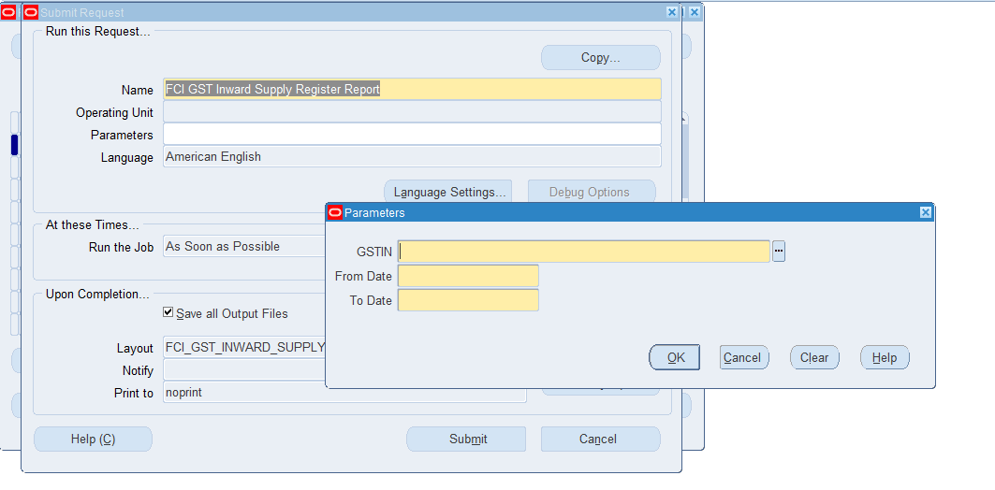

- For AP- All Transactions will be picked on which GST Tax Category is applied.
- For GL- ALL JE’s with category TrfIn Stocks Recvd & Asset Transfer IN will be picked.
- Credit Note will be pulled only when GST is applied.
- Report is assign in unit wise responsibility (eg NF11 GST USER,EE11 GST USER) , FCI Support User and General user Responsibility(eg NF11 GENERAL LEDGER USER).

02- Account Receivables
FCI would need to issue bill of supply (in case of exempted goods) to external customers.
FCI also supplies Gunnies and other taxable items, accordingly FCI will require to discharge the applicable GST liability arising in sale of said goods. Thus FCI will require to issue a Tax invoice. The tax rate will based on the HSN classification.
With respect to services, FCI is also receiving some miscellaneous income which is in nature of service revenues. Hence items of the Non Sales category are opened in the FAP system.

Invoice Creation
Navigate To: | Receivables Responsibility of respective Unit>Transaction > Transaction

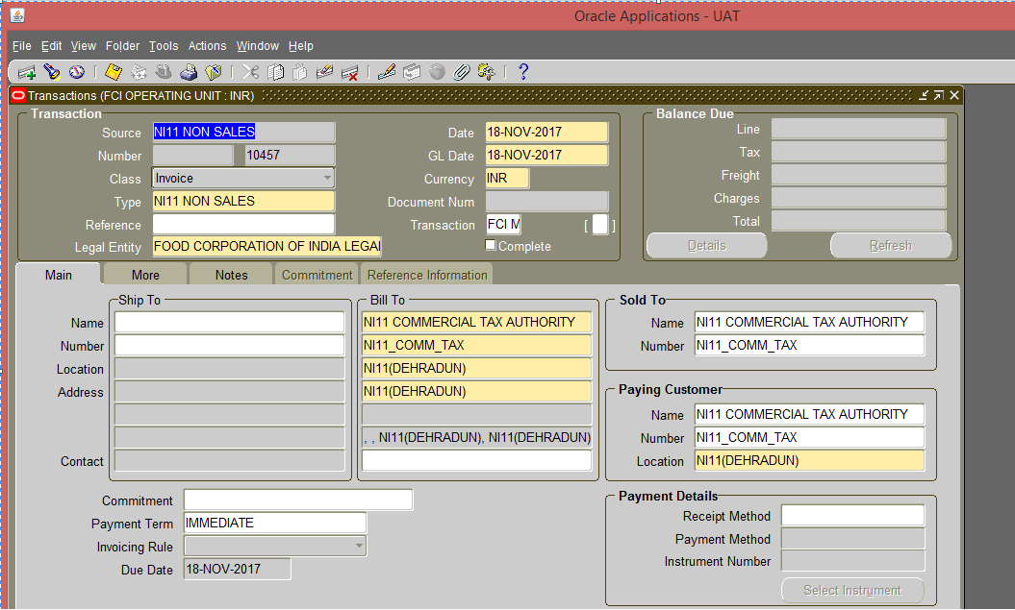
Fig 3.2 – Transactions

Note: For all Receivables Responsibility, in Accounts Receivables, customization is added on Transaction and Transaction Summary form which will prevent the user from selecting customer belonging to another unit.

While entering the distributions, the user cannot use a code combination which is in the process of being disabled and will get the error that “The code combination is obsolete”.If the code combination is already disabled then also the user cannot make the entry.

While creating the distributions, user will not be able to pick any account pertaining to some other unit.

Fields | Description
Source | Make sure that a batch source, which is defined for each unit by prefixing the unit code, is selected in the Source field.  While creating a new transaction the transaction source and transaction type should be User’s unit‘s only.  The invoice number will be generated by the system based on transaction source value. There are two types of source created for each unit and their naming convention is given below  - UNITCODE SALES – For sales invoices  - UNITCODE NON SALES – For non-sales invoices.
Class | Enter Invoice as the Transaction Class
Type | Enter Invoice or the transaction type created for each unit as the Transaction Type.
Invoice Date | Default is current date; it can be changed as per requirement.
GL Date | Default is current date; it can be changed as per requirement.
Customer Ship to and Bill to Address | If a customer is already created, then Ship to and bill to address can be selected from the LOV. Otherwise first create the customer. The bill to address is mandatory.

When you save the invoice header, Oracle will assign an invoice number.
There is restriction on the forms Transaction and Transaction summary which will prevent deletion / completion / incompletion/ changes in line items by another unit’s user. Changes will be allowed only in case when first four characters of the responsibility being used and compare first four characters of the Source of the Transaction are same. The user will not be able to view the transaction otherwise.
Enter Line Items
In the Main alternate region, click on the Line Items button to enter invoice lines.
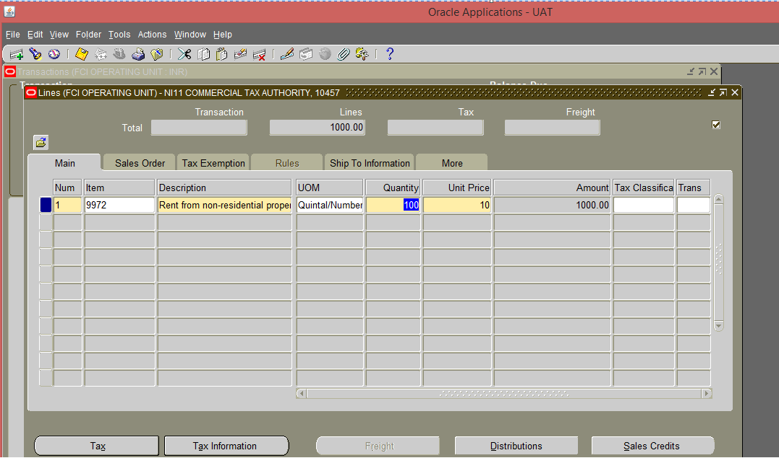
Fig 3.5 – Lines

To enter invoice lines using Items from the Item Master, enter the following:

Field | Description
Item Field | Enter the item number in the Item Field (The description and unit of measure will default in from the Item Master).  It is Mandatory for SALES transaction & optional for NON-SALES
Quantity | Manually enter the quantity
Unit Price | Manually enter the unit price. Oracle will calculate the extended amount. (Note: Oracle validates items against the Item Master set-up in Oracle Inventory).

Notes:
- For Sales transaction item is mandatory and default product cannot be selected for Sales.
- Place of Supply in Invoice Line Level DFF is made mandatory (available under MORE tab).
- To enter the Market fees- Please select the Item Code ‘9999’ (Statutory Charges for Exempted Items), Enter the quantity as 1 and enter the amount in Unit Price field. Navigate to India Tax Details form- Enter the HSN of the base product under Market Fee Line. Eg- If Market Fee is to applied to Wheat Item (0101), then the HSN at the Market Fee Line should also be entered as 0101.
- UOM- Quintal/Number automatically gets populated while selecting the Item. User needs to erase the same if it’s not required. Eg- For Non-Sales Item 9972 (Rent from non-Residential property) it will not be required.

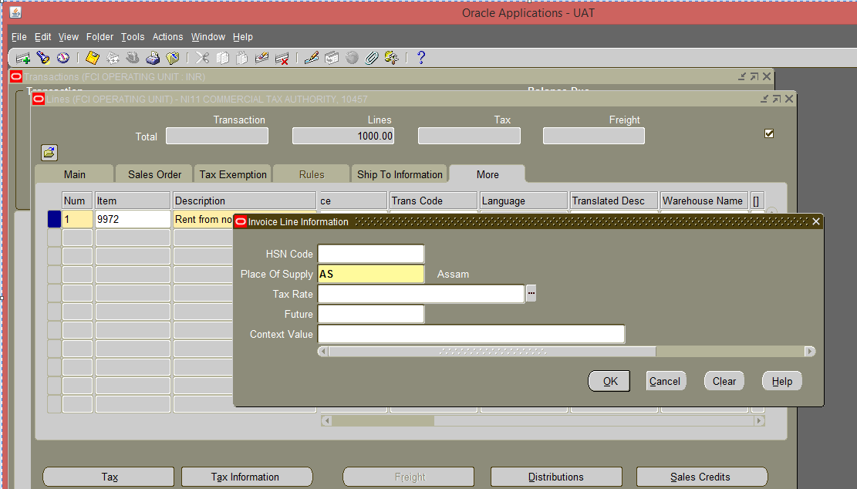
Entering the Quantity and Unit Price, may result in an amount in decimal point. However, the total amount of the invoice has to be in a rounded figure. Line showing the difference (positive or negative) is automatically generated against the rounding off account number 4206.
For the auto generated revenue line, quantity is 1 and unit price is the Rounding off amount.
Rounding off line is generated before transaction is completed.

GST Application
Tools India Tax details

To complete a Transaction, GST information should be entered.

Prerequisite- No entry should be made in Reference field on the main transaction form, otherwise system will not allow to enter the taxes.
From the toolbar above the screen navigate to Tools India Tax details

India Tax Details screen will open.

Details entered at Transaction Lines will be displayed. HSN/SACcode mapped with the Product will also be displayed.

Incase HSN/SAC code is not getting populated for a transaction, user is required to manually enter the same referring to the below table-
User can now apply GST taxes for each available Line.
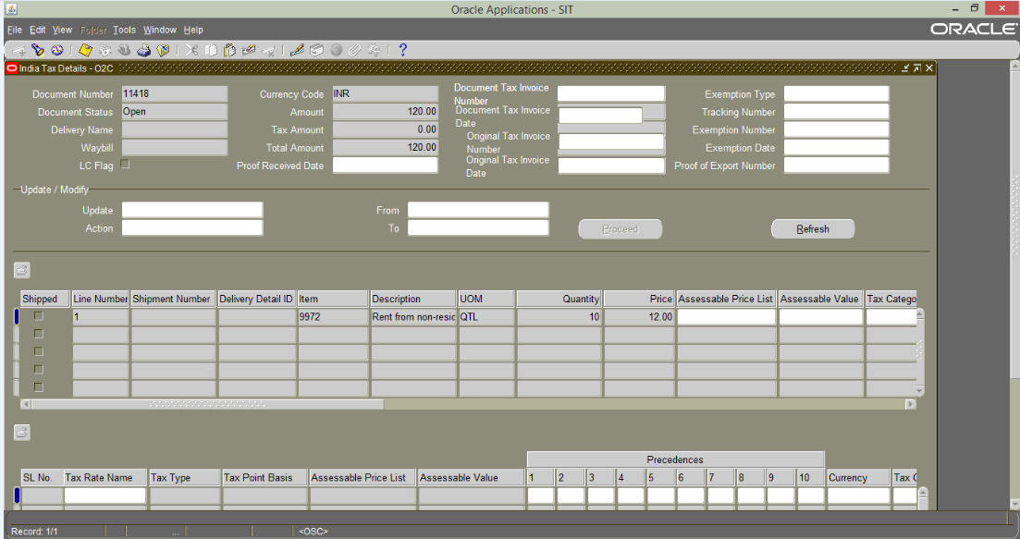

- Select the Organization from the LOV. (This should be prefix with the unit for which the user is entering the transaction)
- Select the Location of the Organization from the LOV. (This should be prefix with the unit for which the user is entering the transaction)
- Select the Tax Category. (This should be prefix with the unit for which the user is entering the transaction). Restriction is applied to display only Recoverable (REC)Tax Categories.

Note: Organization selected should match with the Transaction Type. Eg- For Transaction Type - “NF13 SALES” the Organization should be “NF13 D.O. Bhatinda”.
Tax Category selected, should match with the Organization. Eg- For Organization “NF13 D.O. Bhatinda” the Tax Category should start with “NF”.
Naming of Tax category is designed based on the GST taxes applicable.
Sample- “NF_CGST_REC_2.5%_SGST/UTGST_REC_2.5%”.
NF- NF Units.
CGST_REC_2.5% - CGST Tax, Recoverable with rate 2.5%
SGST/UTGST_REC_2.5%- SGST/UTGST,Recoverable with rate 2.5%
Below table defines the Naming Conventions Used-

Code | Description
CGST | Central Goods and Service Tax
SGST | State Gods and Service Tax
UTGST | Union Territory Goods and Service Tax
CESS | Cess
ADV | Advance
REC | Recoverable
NREC | Non- recoverable
RC | Reverse Charge

Save the transaction and click on apply. GST Tax Lines will be auto generated.

Close the India Tax details Screen.

The GST Tax lines will be generated at distribution level.

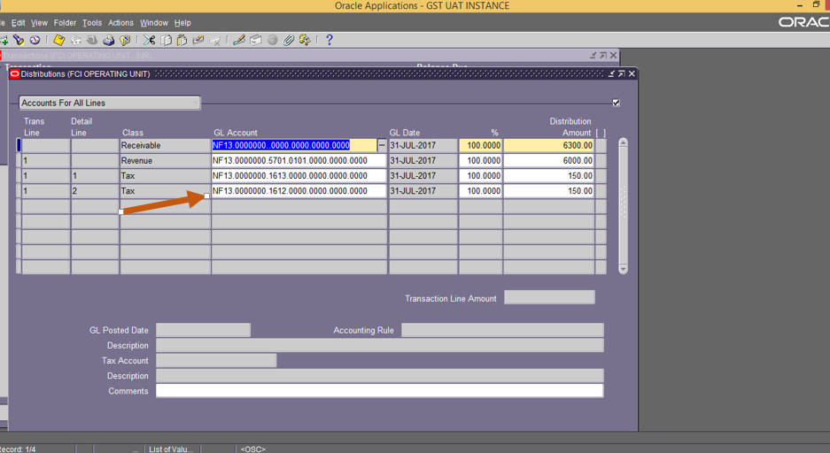

Complete the Transaction.

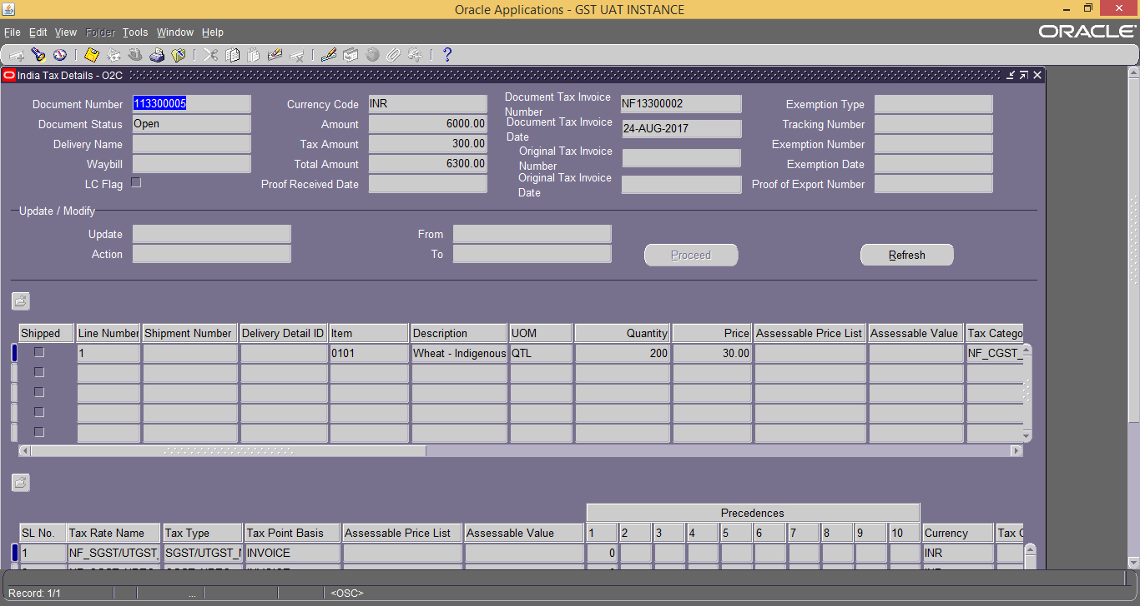

In case, user selects the tax category/ Organization/ Location for the unit other than the unit for which transaction is entered, Complete button will get disabled. It will get enabled only when the user select the correct details.

Oracle provided the separate document sequencing for GST related invoices in addition to the standard document sequence for audit purpose. GST document sequence will be created for GSTIN wise and Item classification as per taxability. Items will be classified as exempted and taxable as per current GST laws for generating unique consecutive sequence in AR. For this purpose personalization will be done for non-sales category, so that user will be able to select the item list also along with description field user enterable for other than GST transactions.
New sequence will be generated for the GST related transactions in addition to the existing sequence.

Note: Item Category Setup is defined for Exempted Items (Food grains, pulses).
If Item Category is defined for the Customer, then on entering the applicable Item- GST tax rates will be auto entered in India Tax details form. User needs to just select the Organization & Location in India Tax details form.

Tax Defaulting at AR Level :The default taxes has beenapplied in the setup for the exempted item category(i.e the items having 0% taxable amount) so that tax will automatically be applied to such items .The list of exempted items has been attached

Customer Ship To
Navigate to receivables responsibility> Customers
An oracle web page will open
Navigation:-
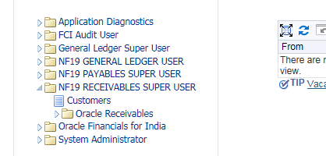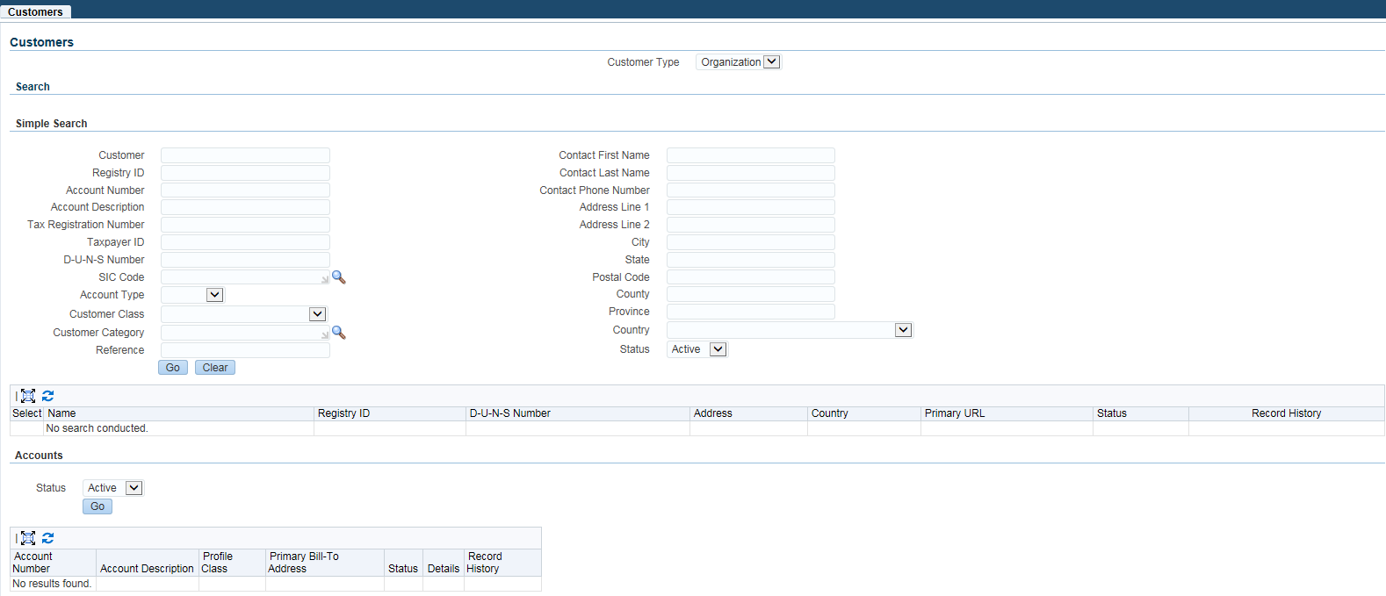

Query the customer and click on details:-
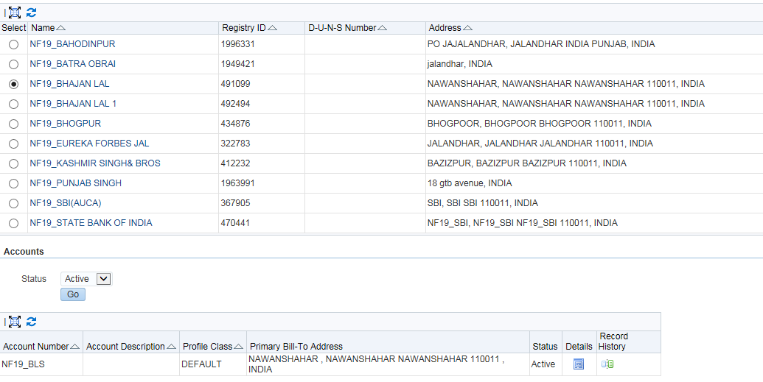
Click on detail Button
Click on Create Site
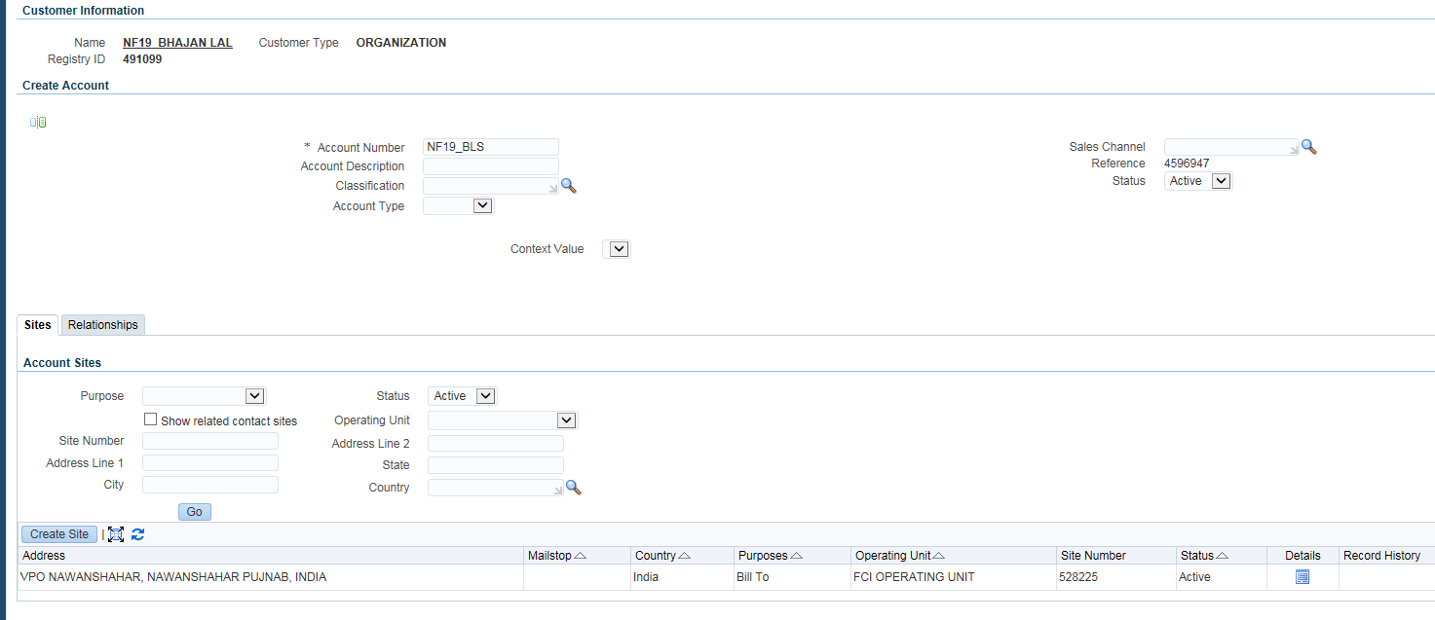

Enter the address and under the business process as Ship To as displayed in the below screenshot.
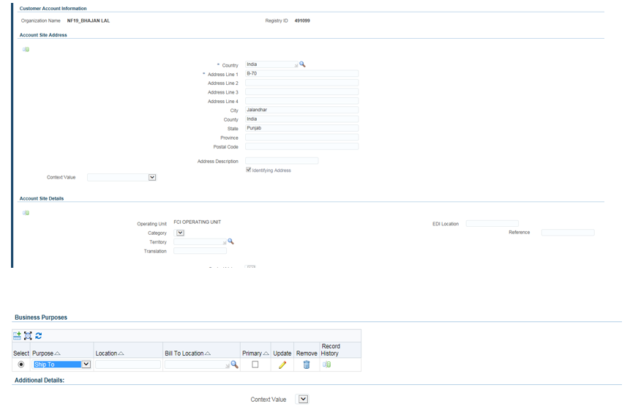

Click on Finish.
Click on Apply.
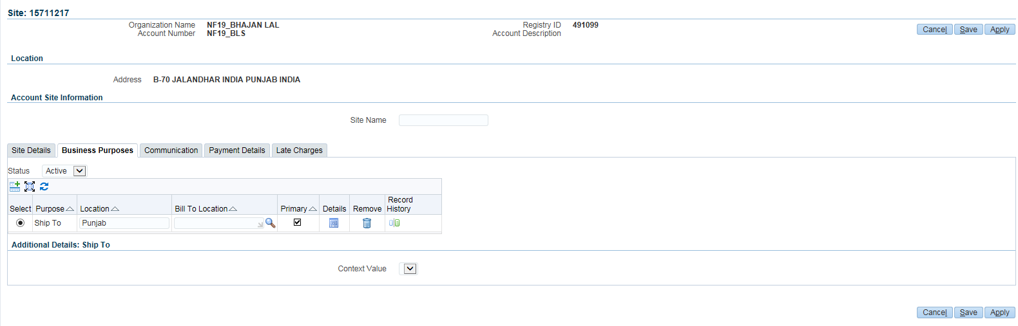
An Additional Site will be created as shown below:-

This ship to detail is to be selected at the transaction header. This ship to details to be mapped in Bill of Supply/ tax Invoice and Outward register.

Transaction Entry:-
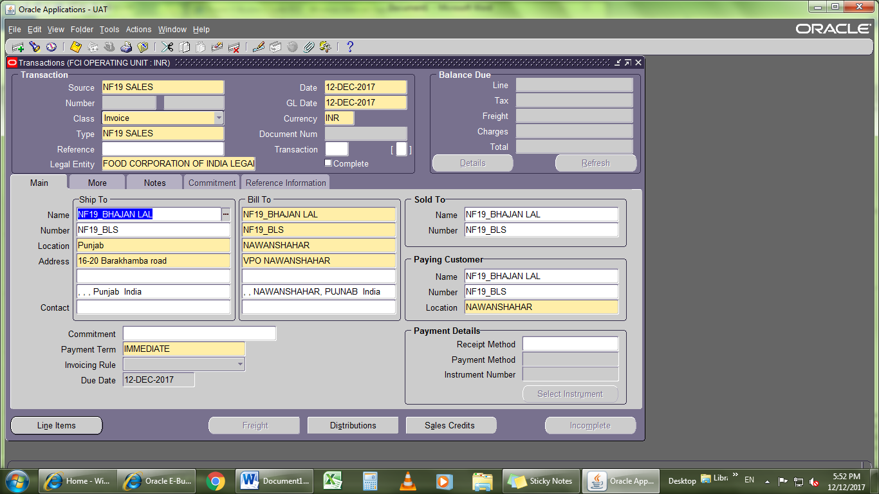
Ship To is populated on the transaction. User will have to select the Ship to from the LOV.

Credit Memo
Auto Credit Memo is revoked from Account Receivables. In case, user selects Actions Credit from the toolbar, then message- ‘This form access is revoked’ will be displayed.
When manually creating a credit memo, the first decision to make is whether or not the credit memo will be applied to a specific invoice or whether the credit memo will go on the customer’s account. On-Account Credit Memos can be applied against customer invoices at some future time. The process of creating On-Account Credit Memos is similar to that of creating a manual invoice.
GST Sequence on Credit Memo will be generated only in case GST is applied on the Credit Memo.

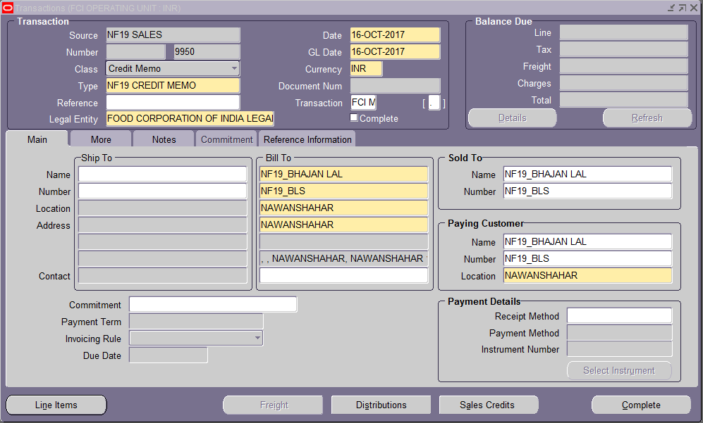
Accounting Entries for Debit memo
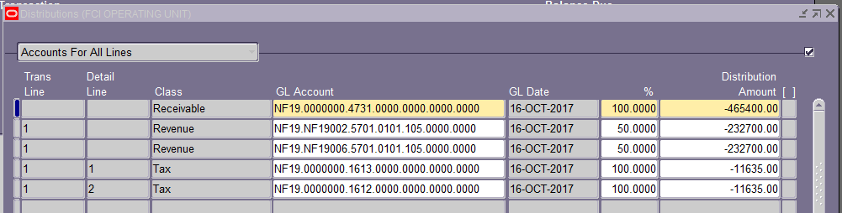

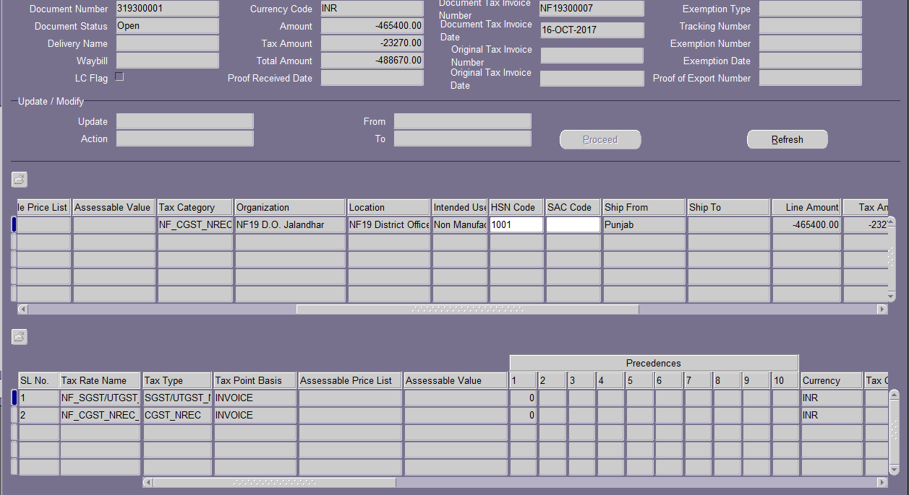

Debit Memo

DEBIT MEMO CREATION:-
Debit memos are raised to invoice the customer for extra charges.
GST Sequence on Credit Memo will be generated only in case GST is applied on the Credit Memo.

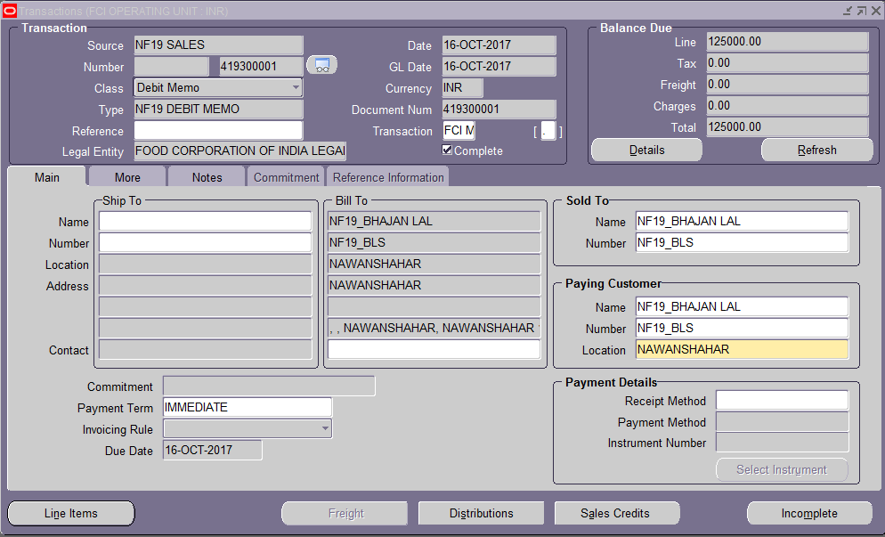
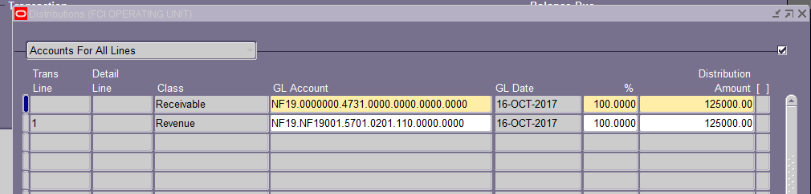

Cross reference
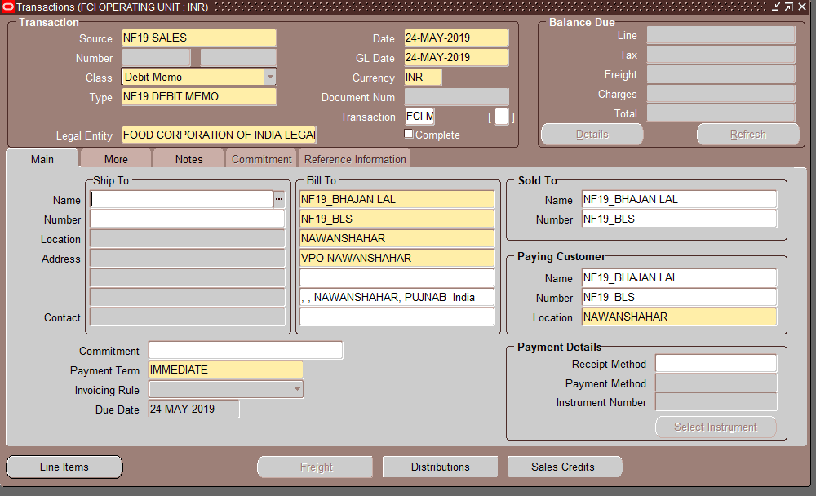

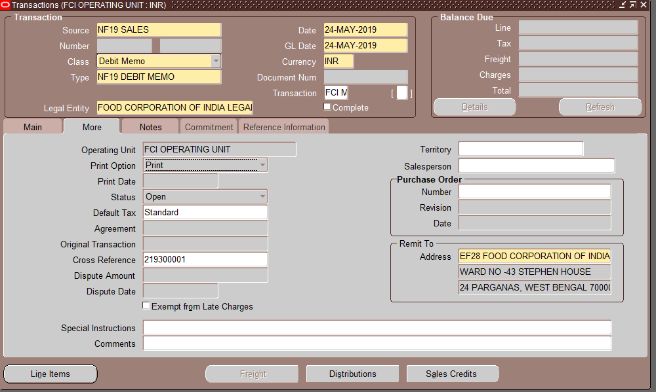

AR Validations
Transaction Form
- Only Recoverable tax categories will be available.
- Tax category lov must contain rates starting with first 2 characters of unit.
- Organization and Location LOV will contain self-unit only
- Intended Use default Non-Manufacturing and will be non-updatable.
- SAC Code should always start with 99 modification is needed
A personalization is placed on the SAC code field on India Tax details form to restrict user to enter the SAC code starting with 99.
  - Item Code should match with HSN or SAC
- If item code is selected in transaction than GST tax application is mandatory and vice versa.
- Restrict Access to Credit Transaction form – Credit memo auto application is restricted.
- Invoice level Rounding generation. In case rounding off is not generated then system will prompt an error and system, will not allow the invoice to complete.
- Place of Supply is mandatory in line DFF.
- If user has entered account- 4206 manually then system will not create auto rounding off.
- Following checks are placed on the AR Complete button (restricting the transaction completion)-
- If the transaction is not rounded.
- If any of the Distribution line doesn’t matches the Base Unit (Based on Transaction Type eg- NF19 for NF19 SALES transaction).
- If there’s any mismatch between the count of Item Lines and the Lines on which GST is applied or Organisation, Location, HSN Code is not filled.
- If tax rates and tax category are different.
- Complete Button Disable while on Line Item Form
- Tax tab at header level will be disabled
- Tax tab at line level will be disabled for transactions with gl date 01-nov-2017 onwards
- Tax CLASSIFICATION field will be disabled at transaction line level
- User will not be able to Incomplete any completed Transaction.
- Reference field will not be visible for Incomplete transactions.
- Cross Reference field under MOREtab is made mandatory for Debit Memo.
- Item selection criteria
  - 9999 can be selected for sale or non-sales entries.
  - Non Sales items will be more than equal to 2000.
  - Sales items will be less than 2000

AR Reports

FCI GST AR Tax Invoice/Bill of Supply

- Whenever a GSTIN registered supplier supplies any taxable goods or services, a tax invoice is issued.
- And for supplying non-taxable goods or services, a Bill of Supply is issued.
Therefore for ensuring GST compliance, FCI is required to issue the Tax Invoice/ Bill of Supply as the case be.
- If Taxes with non-zero amount are applied to the Transaction then Tax Invoice will be generated, otherwise Bill of Supply.

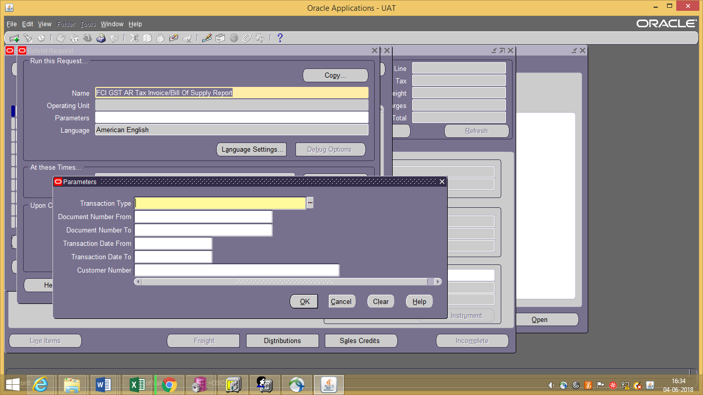

Report Parameters-

- Transaction Type (Mandatory) - List of AR Transaction Type
- Document Number From (Optional) - Document Sequence Value Range From
- Document Number To (Optional) - Document Sequence Value Range To
- Transaction Date From (Optional)- Transaction Date Range From
- Transaction Date To (Optional)- Transaction Date Range To
- Customer Number (Optional) - List of Values displaying the Customers.

Output of the report should be generated in PDF format.

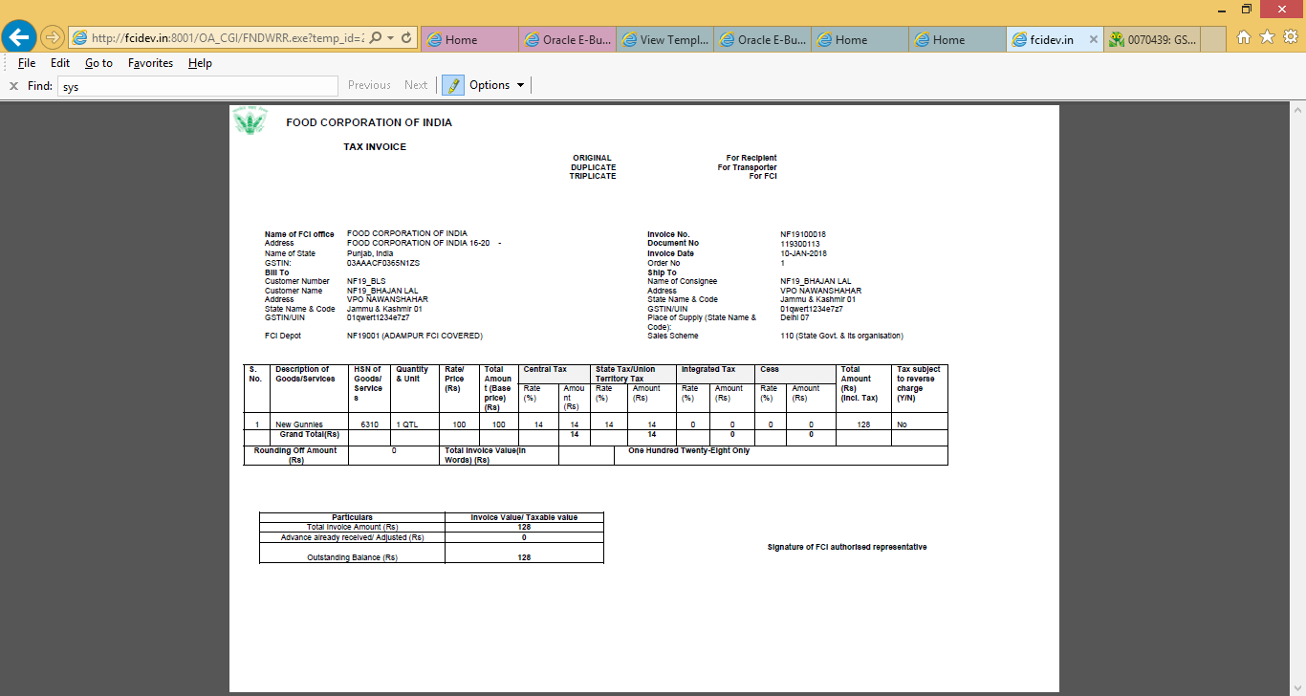

In case of Services, Triplicate Copy will not be available in report.
Also, the Unit of Measurement will be ’Others’.

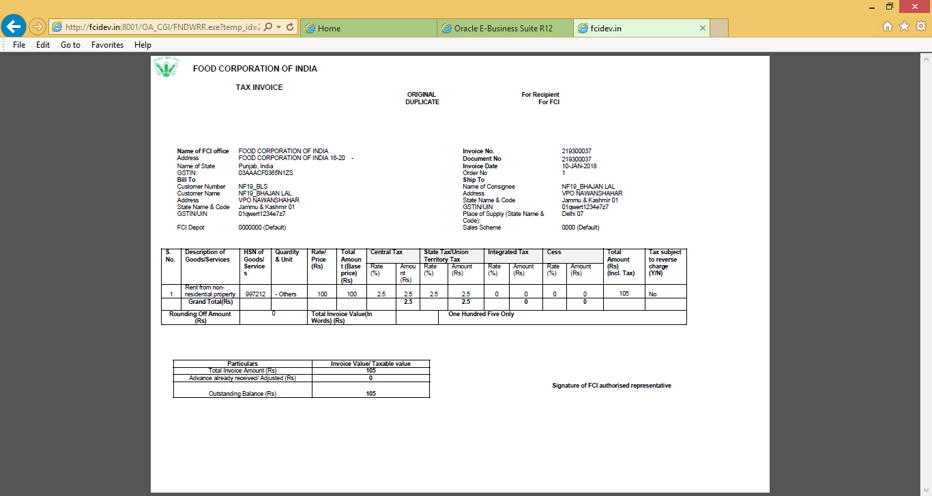

Bill of Supply will be generated, if 0 amount GST is applied to transaction.

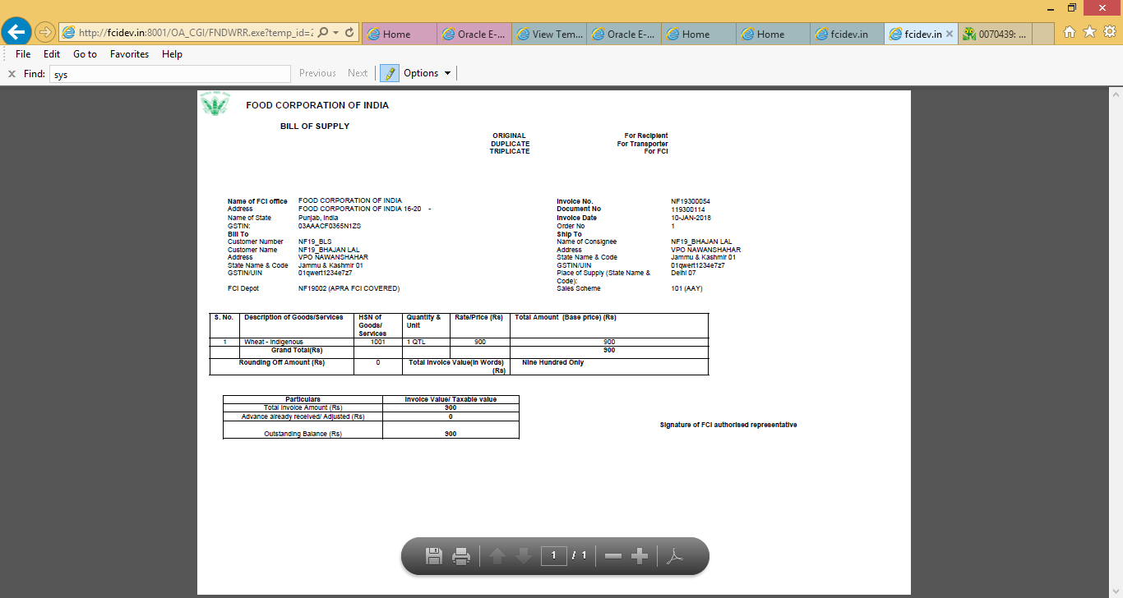

FCI GST AR Credit Note/Debit Note Report

- Whenever Credit Memo or Debit Memo is applied to Tax Invoice/ Bill of Supply a Credit Note/ Debit Note must be issued to the Customer.
Therefore for ensuring GST compliance, FCI is required to issue the Credit Note/ Debit note as the case be.
- Only the Credit Note where GST is applied and said CM is directly applied on a GST invoice will be picked in the report.
- Only the Debit Note where GST is applied and said DM is referred to a GST Invoice will be picked in the report (Based on transaction entered at Cross Reference field under More tab).
- Report Heading will be Credit Note if ‘CREDIT MEMO’ Transaction Type selected & will be Debit Note if ‘DEBIT MEMO’ type transaction Type selected
- Detail Section of the report will display only in case the CN/DN are applied to an GST Transaction otherwise message will be displayed- “Details are not displayed as Debit Note/Credit note is Un-applied or Applied to a Non GST transaction.

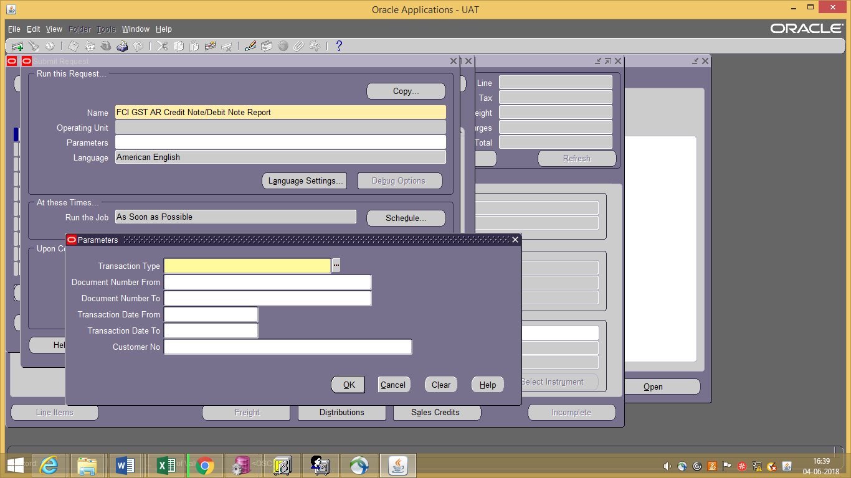
Report Parameters-

- Transaction Type (Mandatory) - List of AR Transaction Type
- Document Number From (Optional) - Document Sequence Value Range From
- Document Number To (Optional) - Document Sequence Value Range To
- Transaction Date From (Optional)- Transaction Date Range From
- Transaction Date To (Optional)- Transaction Date Range To
- Customer Number (Optional) - List of Values displaying the Customers.
Output of the report should be generated in PDF format.

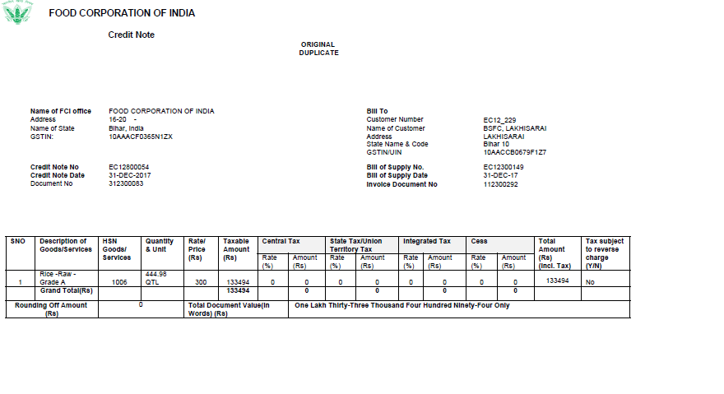
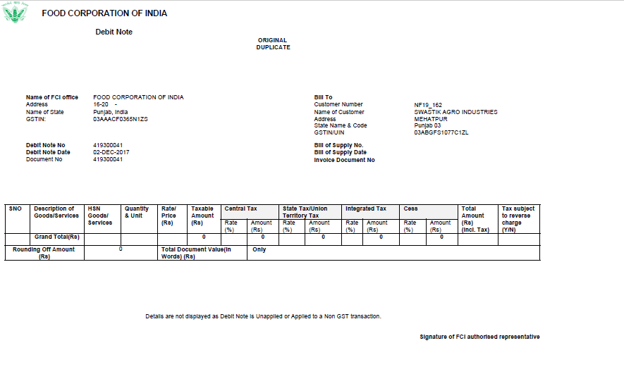

FCI GST AR Advance Receipt Voucher

- Advance received from Customer should be acknowledged by an Advance Receipt Voucher
FCI is required to issue Advance receipt voucher to customer whenever the Advance received includes GST.
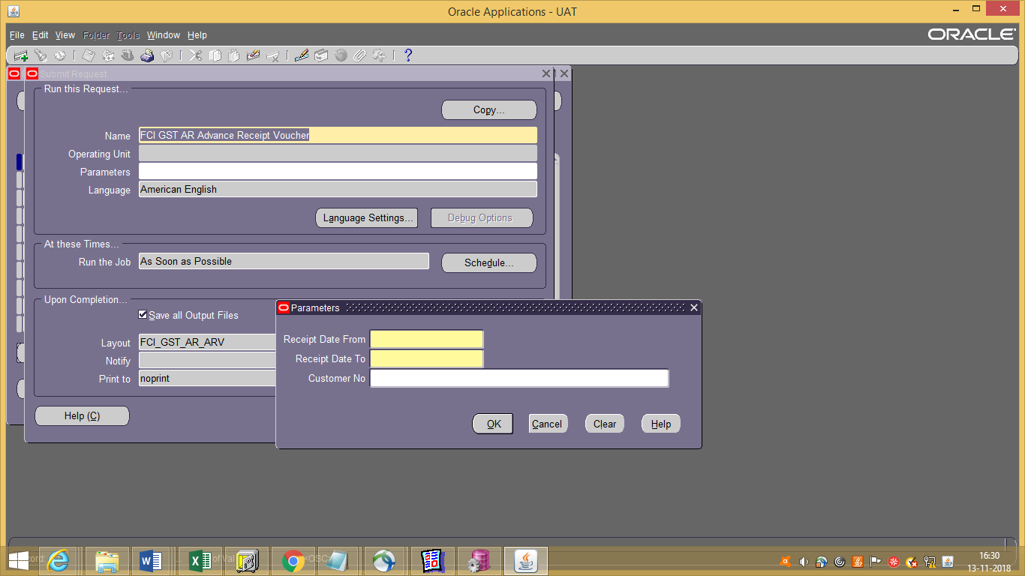

Report Parameters-

- Receipt GL Date From (Mandatory)- Date Range From
- Receipt GL Date To (Mandatory)- Date Range To
- Customer Name (Optional) - List of Value displaying the Customer

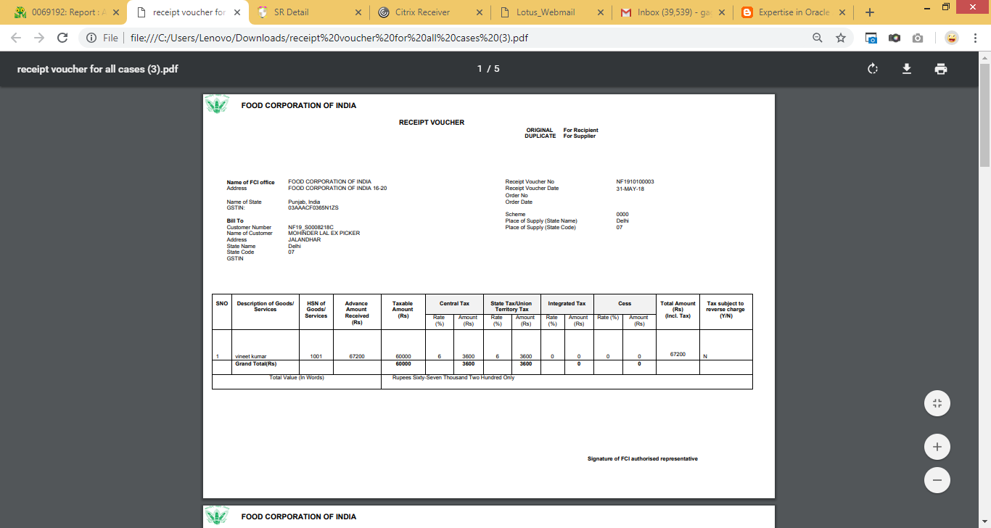

Note: Post implementation of CR 807, the UOM for below mentioned list of products will reflect as ‘Others’ OTH in GST reports:
0601, 0602, 0603, 0604, 0605, 0606, 0626, 0627, 1601, 1602, 1603, 1604, 1605, 1606, 1626, 1627

FCI GST Outward Supply Register Report:-
The Report Parameters for “FCI GST Outward Supply Register” will be as Follows:
- Region (GSTIN)- (Mandatory)- List of Values
- GL Date From (Mandatory)- GL Date From
- GL Date To (Mandatory)- GL Date To
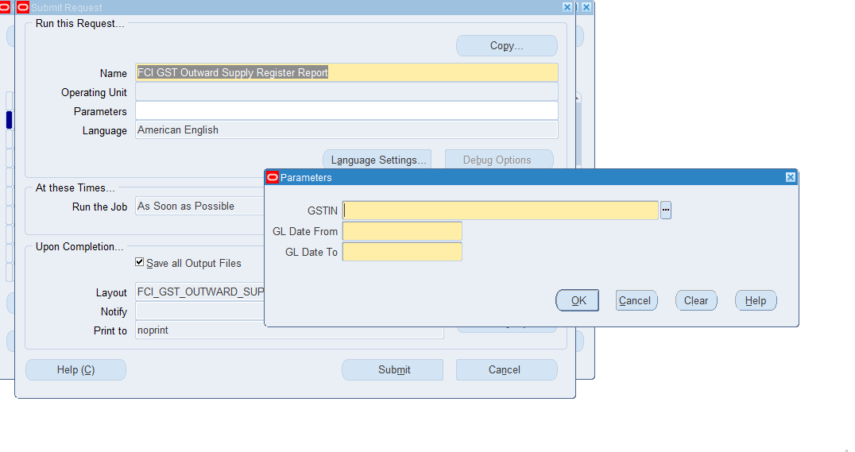
- Report will be generated for only those AR transactions, GL Journals where GST Sequence no is generated.
- Credit note will only be picked in the report post it is applied to any transaction.
- Report is assign in unit wise responsibility (eg NF11 GST USER,EE11 GST USER), FCI Support User and General user Responsibility(NF11 GENERAL LEDGER USER)

03- General Ledger
FCI currently undertakes the interstate stock transfer from one FCI office to other FCI office.
FCI would accordingly need to issue ‘Bill of Supply based on the time and place of supply for inter-state stock transfers in case of nil rated goods. Having said so , in case of intra state- stock transfers FCi would need to issue a delivery challan.
Asset transfers from one FCI office to another:-FCI currently undertake inter- state stock transfers of equipment’s from one FCI office to another. Inter-state stock transfer of Equipment/Assets from one FCI office to another would attract levy of GST at the applicable rates.
Manual Journal Entry – Paddy Mill-Paddy Out
Function Path: Normal General Ledger responsibility>> Journals >> Enter >> New Journal.
The Journal entry for paddy milling is required to capture the transactions of stocks conversions due to paddy milling i.e. conversion of paddy into rice. The quantitative transactions are to be captured through the journal entry as explained below and the paddy milling bills would be passed through Accounts Payable for payment action only.
Steps:
- To create a new manual journal entry, click on new journal in the find journals window.
- Journal Name: Leave the Journal name blank. It will automatically take the system date and time as Journal name.
- Period: Enter the Period, effective date. Adjusting periods are available at the end of each quarter and year beginning with ‘ADJ’
- Currency: Enter currency details. The currency will be ‘INR’ for the category ‘Paddy Mill-Paddy Out.
- Category: Enter the category as ‘Unit name (e.g. SB16, NC 14) Paddy Mill-Paddy Out ‘.
- Header Level DFF (Descriptive Flex field): For the category Paddy Mill-Paddy Out, Supplier details have to be captured. DFF is nothing but place to record additional information about the category of the Journal entry being passed. Click on the angular bracket of the DFF indicated as follows:
Screen shot of Journal Form: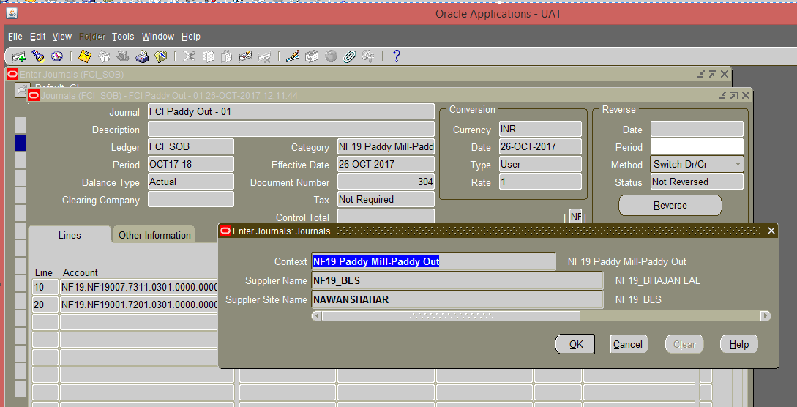
- Data entry in the Header Level DFF (Descriptive Flex field): On clicking the DFF symbol, fields to capture the Supplier Name and Supplier Site will appear. Both the fields are mandatory. This field is picked up from the Accounts Payable module and only the suppliers defined in the Accounts Payable Module will be picked up here.
For supplier site, user can select any site associated with the supplier selected in supplier DFF.
- For this category, user will also enter the GST tax related information in line level DFF. Following fields are mandatory at line level DFF leaving these fields blank will give an error as shown as described below: -
ERROR:Please fill line level DFF to capture GST information.JE Category: Paddy Mill-Paddy Out. All fields are mandatory except: Invoice/Challan No., Invoice/Challan Date, To GSTIN. And HSN code.
From GSTN: Enter the unit from which stock is transferred.
Place of supply: Enter the place where stock is supplied.
Tax Rate: Enter the tax rate for tax applicable.
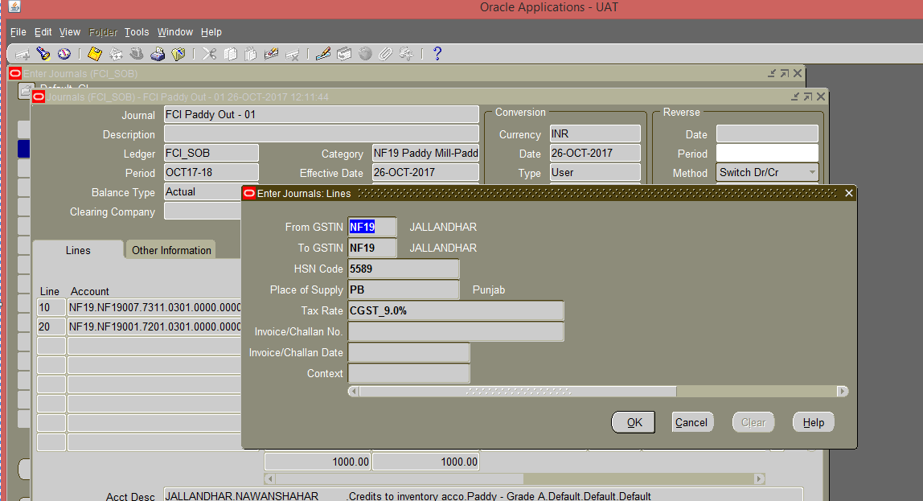

- Enter the JV in the lines and save the transaction. In the Line Number column of the Journal Entry, the numbering to be followed is in series of 10, i.e. numbering would be 10, 20, 30 and so on. The Journal Entry for Paddy Mill-Paddy Out would be:
Credit to Inventory Account (Paddy) Dr.
Transfer Out – Stocks Issued (paddy) Cr.
A check is implemented in the system, which will allow user to take only Paddy products with this category (0301, 0302) or default products. Also, user will be allowed to take only 7311 and 7204 as natural accounts.
- Click on ‘Approve’. The journal will be forwarded to the approver for approval. Post-approval the transaction will be available for posting.
- Post approval the GST Sequence generated can be viewed by-
Click on ToolsFCI GST SEQ
Document Sequencing at GL Level: - New form will be developed at GL level for custom document sequencing for GST purpose in addition to the existing document sequencing
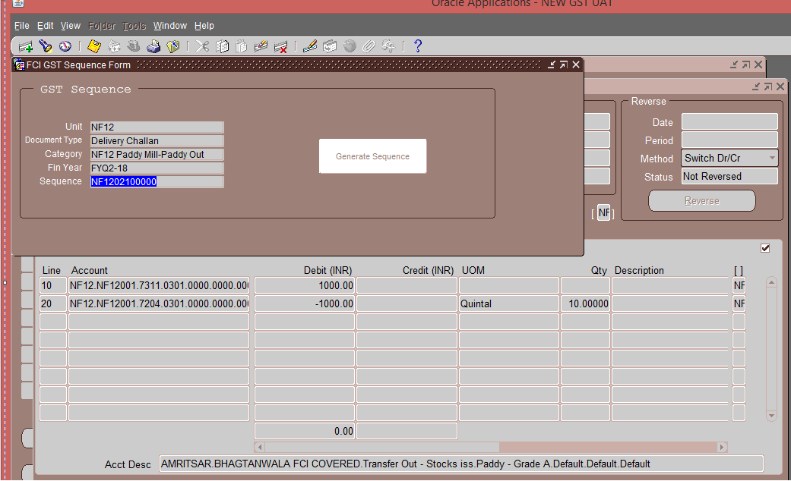
System will generate the GST sequence for journal category by below logic:
FCI GST GL Sequence Program is a scheduled program which will generate the GST sequence for Journals.

Manual Journal Entry-Paddy Mill Rice In
Function Path: Normal General Ledger responsibility>> Journals >> Enter >> New Journal.
The Journal entry for paddy milling is required to capture the transactions of stocks conversions due to paddy milling i.e. conversion of paddy into rice. The quantitative transactions are to be captured through the journal entry as explained below and the paddy milling bills would be passed through Accounts Payable for payment action only.
Steps:
- To create a new manual journal entry, click on new journal in the find journals window.
- Journal Name: Leave the Journal name blank. It will automatically take the system date and time as Journal name.
- Period: Enter the Period, effective date. Adjusting periods are available at the end of each quarter and year beginning with ‘ADJ’
- Currency: Enter currency details. The currency will be ‘INR’ for the category ‘Paddy Mill-Rice In.
- Category: Enter the category as ‘Unit name (e.g. SB16, NC 14) Paddy Mill-Rice In ‘.
- Header Level DFF (Descriptive Flex field): For the category Paddy Mill-Rice In, Supplier details have to be captured. DFF is nothing but place to record additional information about the category of the Journal entry being passed. Click on the angular bracket of the DFF indicated as follows:
Screen shot of Journal Form:
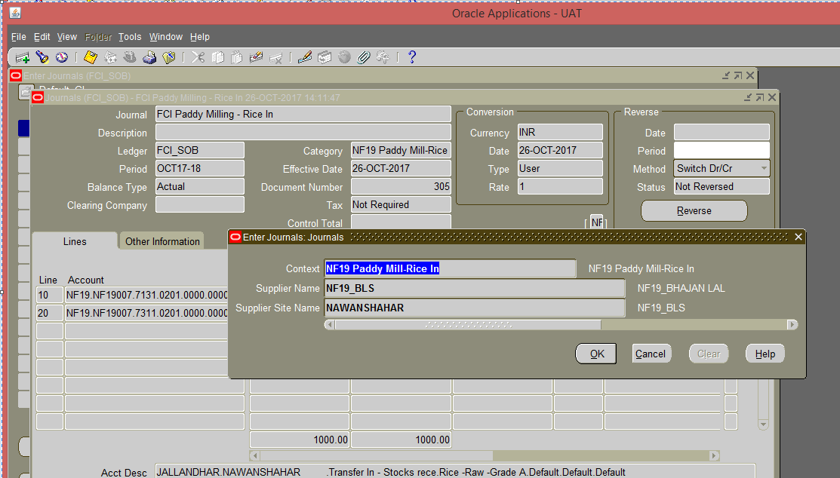
- Data entry in the Header Level DFF (Descriptive Flex field): On clicking the DFF symbol, fields to capture the Supplier Name and Supplier Site will appear. Both the fields are mandatory. This field is picked up from the Accounts Payable module and only the suppliers defined in the Accounts Payable Module will be picked up here.
For supplier site, user can select any site associated with the supplier selected in supplier DFF.
- For this category, user will also enter the GST tax related information in line level DFF. Following fields are mandatory at line level DFF leaving these fields blank will give an error as described below: -
ERROR: Please fill line level DFF to capture GST information.JE Category: Paddy Mill-Rice IN. All fields are mandatory except: From GSTIN AND HSN Code.
To GSTN: Enter the unit to which stock is transferred.
Place of supply: Enter the place where stock is supplied.
Tax Rate:Enter the tax rate for tax applicable.
Invoice/ challan No.: Invoice /challan No for corresponding Paddy-out journal entry
Invoice/Challan Date :Invoice/Challan Date for corresponding Paddy-out journal entry
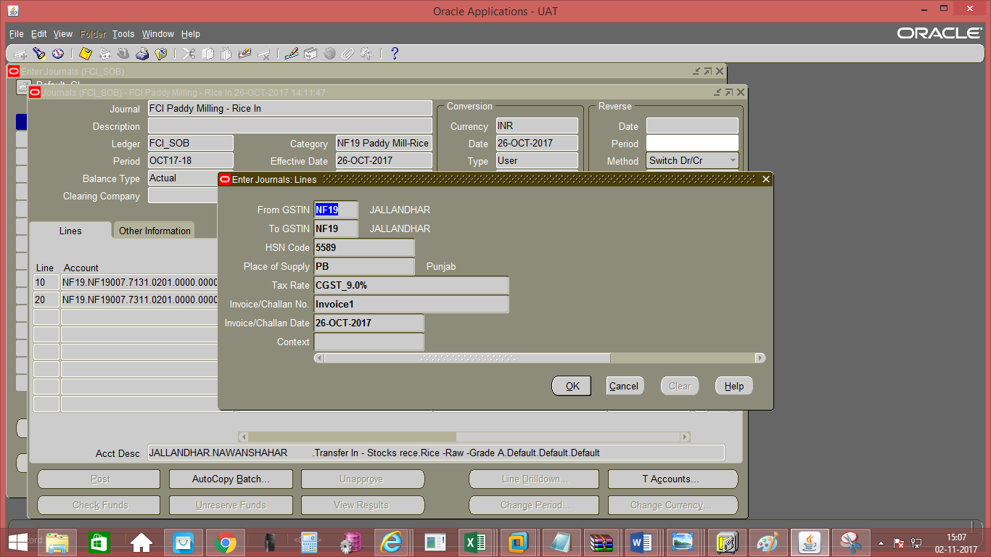

- Enter the JV in the lines and save the transaction. In the Line Number column of the Journal Entry, the numbering to be followed is in series of 10, i.e. numbering would be 10, 20, 30 and so on. The Journal Entry for Paddy Milling IN would be:
Credit to Inventory a/c (Rice) Cr.
Transfer IN – Stocks Received (Rice) Dr.
A check is implemented in the system, which will allow user to take only Rice products with this category (0201, 0202, 0203, 0204, 0205) or default products. Also, user will be allowed to take only 7311 and 7131 as natural accounts.

- Click on ‘Approve’. The journal will be forwarded to the approver for approval. Post-approval the transaction will be available for posting.
- Click on Post to post the transaction. This can also be done by JVs from Journals >> Post window
- Payment of Milling Charges will be done from the Accounts Payable module.

Manual Journal Entry-Interco IOM Railroad
This entry is passed by the unit sending the goods.
Function Path: Normal General Ledger responsibility>> Journals >> Enter >> New Journal.
Steps:
- To create a new manual journal entry, click on new journal in the find journals window.
- Journal Name: Leave the Journal name blank. It will automatically take the system date and time as Journal name.
- Period: Enter the Period, effective date. Adjusting periods are available at the end of each quarter and year beginning with ‘ADJ’
- Currency: Enter currency details. The currency will be ‘INR’.
- Category: Enter the category as ‘Unit name (e.g. SB16, NC 14) FCI IOM by RailRoad
- Enter the JV in the lines and save the transaction. In the Line Number column of the Journal Entry, the numbering to be followed is in series of 10, i.e. numbering would be 10, 20, and 30 and so on.
- Entering Quantity for Natural Accounts: It is possible to enter quantity for some of the Natural Accounts. The unit of measure (UOM) is ‘Quintal’. The Natural Accounts for which presently quantity is allowed are listed in Appendix 1.
- Header Level DFF (Descriptive Flex field): For the category FCI IOM by railroad, certain information needs to be captured in the header level DFF. DFF is nothing but place to record additional information about the category of the Journal entry being passed. Click on the angular bracket of the DFF indicated as follows to open the header level DFF:

Screen shot of Journal Form:
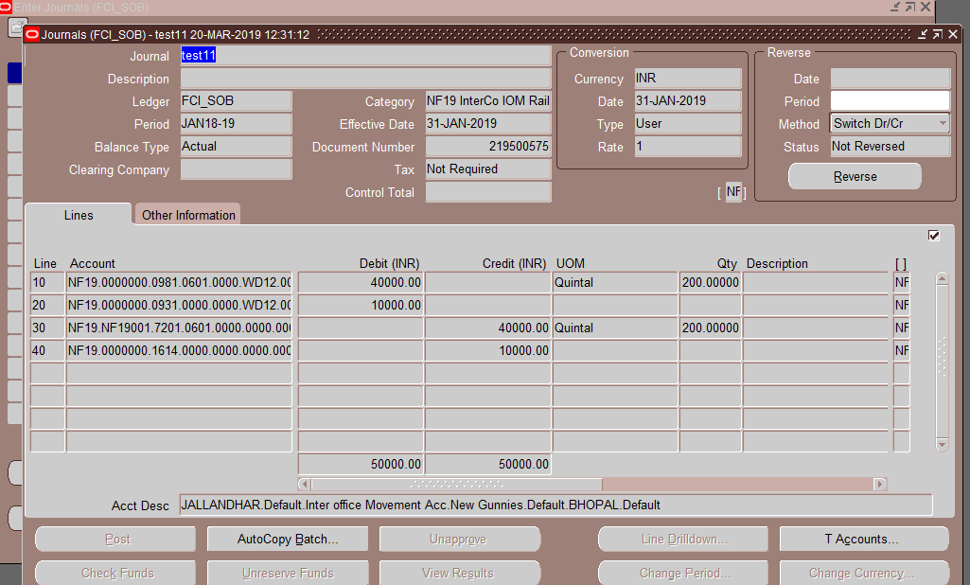
Data entry in the Header Level DFF (Descriptive Flex field): On clicking the DFF symbol, fields to capture the following fields will appear to capture the Railway Receipt number and the Railway receipt number quantity. User has to enter Receipt, receipt Quantity and To Account and Depot to which the IOM is to be sent.
Screen shot of Journal Form:
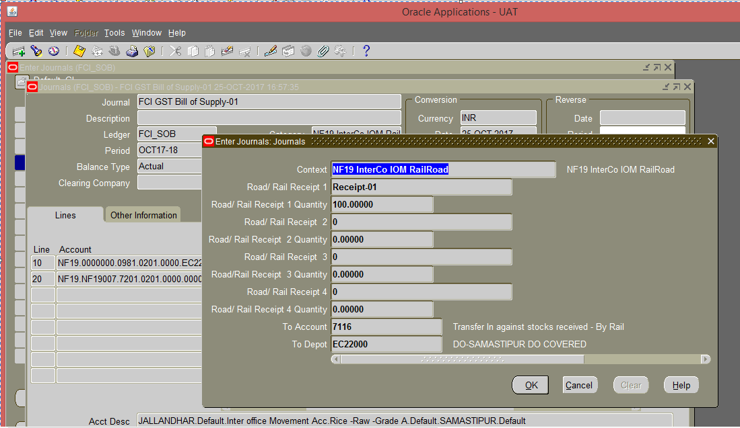

- For interco IOM Rail Road category following checks have been added.
  - Product can be same or default (0000) across all the lines.
  - Default product is allowed with CGST/IGST/SGST/UTGST liability accounts (1612, 1613, 1614, 0931) only.
  - Same depot for all or default depot (for account head 0981) can be used.
  - Exactly 1 line with account head 0981.
  - Intercompany segment cannot be default for line with account head ‘0981’.
  - Intercompany segment provided in line with account head 0981 should match with ‘To Depot ‘segment of descriptive field in case of Interco IOM Rail Road.
  - IOM Transfer Out category allows only account codes 7111, 7112 and from 7201 to 7210,7216,7611,7612,7616,7617,7621,7701,7702,7703,7709,7710,1612,1613,1614.
Screen shot of Journal Form:
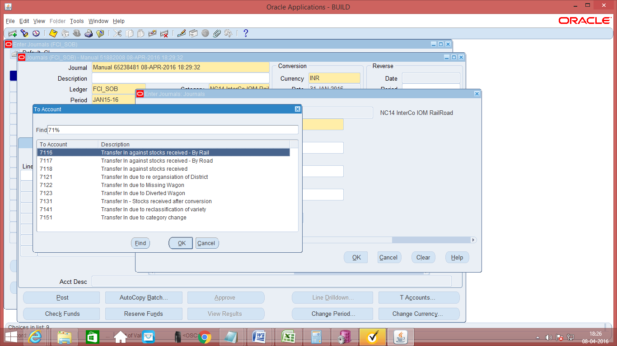

- Data entry in the Line Level DFF (Descriptive Flex field):
On clicking the DFF symbol, fields will appear to capture the Gunny bag number. Field value should be a whole number only. The DFF will be enabled only for food grains product. For other product like chemical, gunnies etc. the DFF will be disabled.
For this category, user will also enter the GST tax related information in line level DFF. Following fields are mandatory at line level DFF, leaving these fields blank will give an error as described below: -
ERROR: Please fill line level DFF to capture GST information.JE Category: IOM RailRoad . All fields are mandatory except: Invoice/Challan No., Invoice/Challan Date AND HSN Code.
From GSTN: Enter the unit from which stock is transferred.
To GSTN: Enter the unit to which stock is transferred.
Place of supply: Enter the place where stock is supplied.
Tax Rate: Enter the tax rate for tax applicable.
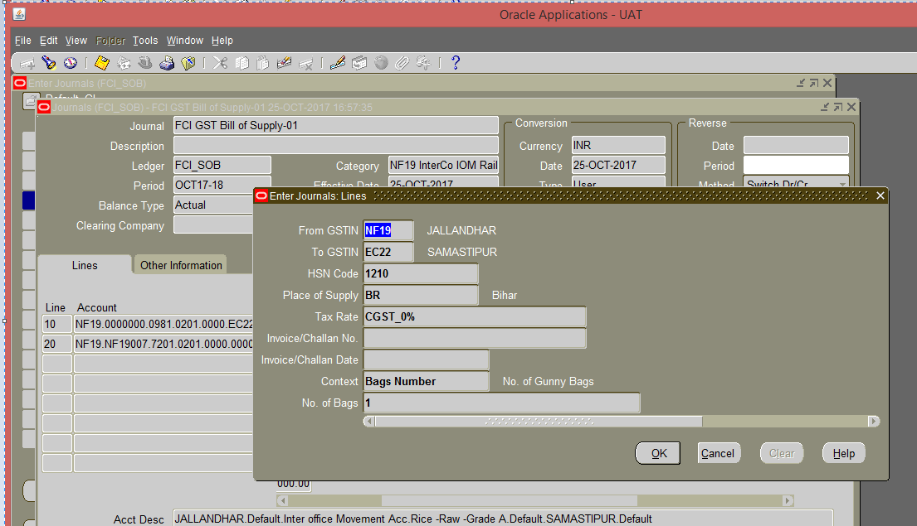

- Save your work.
- Click on ‘Approve’. The journal will be forwarded to the approver for approval. Post-approval the transaction will be available for posting.
- Post Approval
Click on ToolsFCI GST SEQ
A new form will appear, on this form the GST Sequence generated can be viewed.

Manual Journal Entry-Transfer In Against Stocks Received
The unit sending the goods passed the entry in InterCo IOM Rail/ Raid.
The entry in the category Transfer in against Stocks Received is passed by the unit received the goods. This entry also accounts for the transit gains and losses.
Function Path: Normal General Ledger responsibility>> Journals >> Enter >> New Journal.
Steps:
- To create a new manual journal entry, click on new journal in the find journals window.
- Journal Name: Leave the Journal name blank. It will automatically take the system date and time as Journal name.
- Period: Enter the Period, effective date. Adjusting periods are available at the end of each quarter and year beginning with ‘ADJ’
- Currency: Enter currency details. The currency will be ‘INR’.
- Category: Enter the category as ‘Unit name (eg SB16, NC 14) Trf IN Stocks Recvd’
- Enter the JV in the lines and save the transaction. In the Line Number column of the Journal Entry, the numbering to be followed is in series of 10, i.e. numbering would be 10, 20, and 30 and so on.
- Entering Quantity for Natural Accounts: It is possible to enter quantity for some of the Natural Accounts. The unit of measure (UOM) is ‘Quintal’. The Natural Accounts for which presently quantity is allowed are listed in Appendix 1.
- Header Level DFF (Descriptive Flex field): The category ‘TrfIn Stocks Recvd’ has a close relation with the category ‘InterCo IOM Rail/ Road’. The unit sending the goods passes the entry in InterCO IOM Rail/Road and when the goods are received by the receiving unit, it passes the enry in ‘TrfIn Stocks Recvd’. Hence in the DFF of the category ‘TrfIn Stocks Recvd’, reference has to be made to the entry passed by the sending unit while sending the goods. Hence the corresponding entry has to be reference in this DFF.
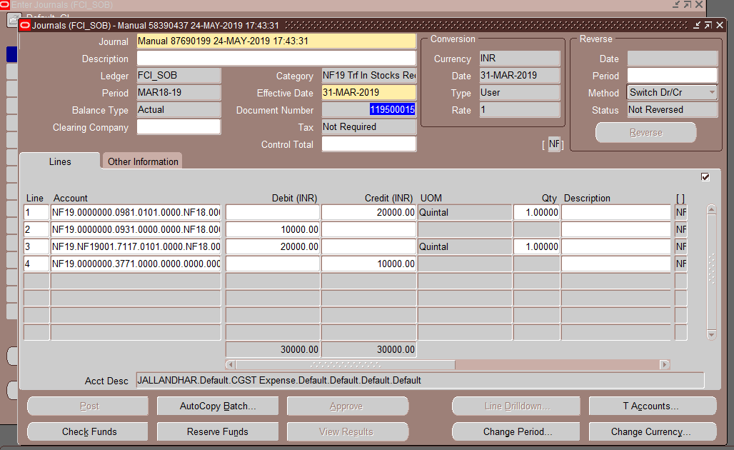

- Data entry in the Header Level DFF (Descriptive Flex field): On clicking the DFF symbol, fields to capture the following fields will appear to capture the Railway Receipt number and the Railway receipt number quantity. From account and Depot from which the stock has been received has to be also entered.
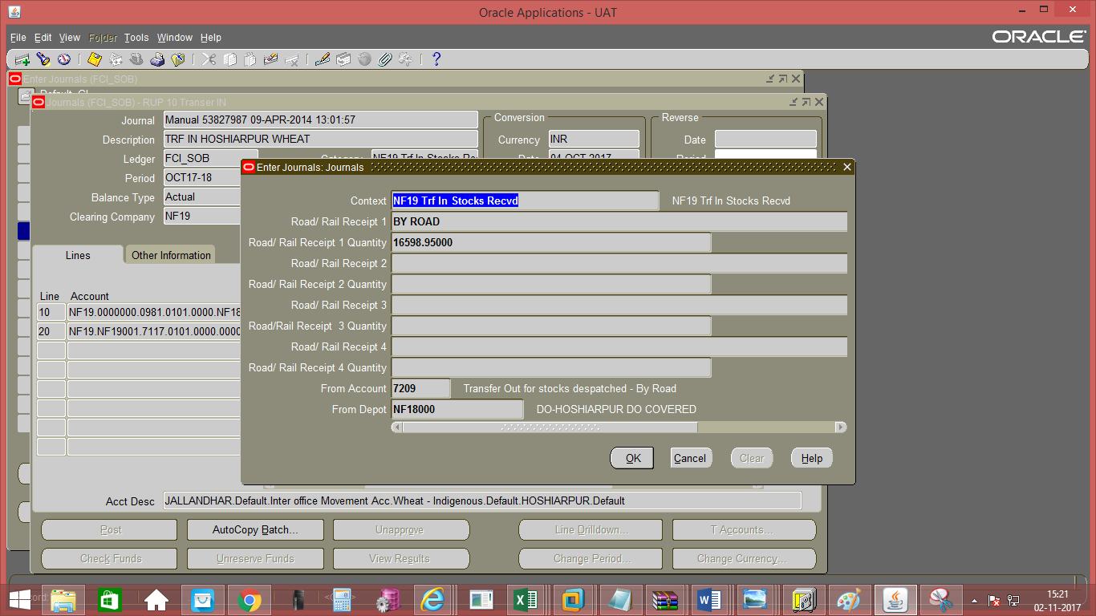

The following accounts are allowed in the DFF
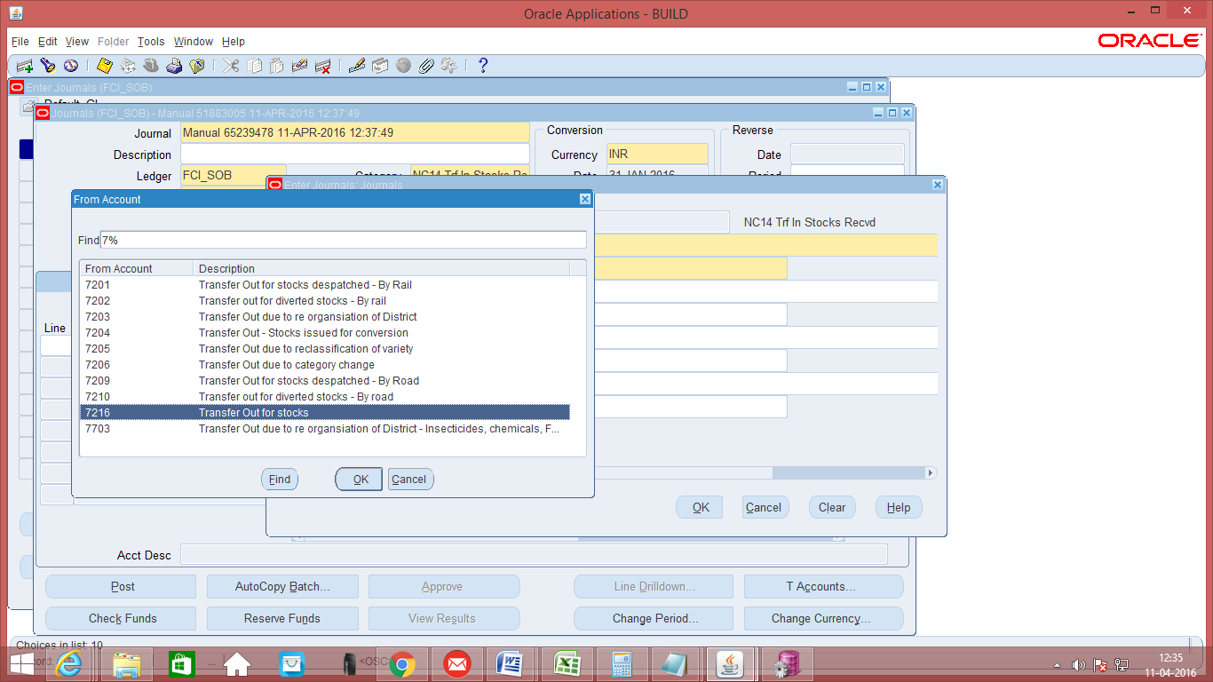

- The following checks have been added for Transfer in against stock received category.

- Product can be same or default (0000) across all lines.
- Default product is allowed with CGST/IGST/SGST/UTGST Expense accounts (3771,3773,3775, 0931) only.
- Same depot for all or default depot (for account head 0981) can be used.
- Exactly 1 line with account head 0981.
- Intercompany segment cannot be default for line with account head ‘0981’.
- Intercompany segment provided in line with account head 0981 should match with ‘From Depot’ segment of descriptive field in case of Transfer in stock received.
- For this category, user will also enter the GST tax related information in line level DFF. Following fields are mandatory at line level DFFleaving these fields blank will give an error as described below: -
ERROR: Please fill line level DFF to capture GST information for Plan-A.JE Category: TrfIn Stocks Recvd AND Unconn/Missing Wagon. All fields are mandatory.
From GSTN:Enter the unit from which stock is transferred.
To GSTN: Enter the unit to which stock is transferred.
HSN code: Enter the HSN code of the product transferred (4-8 Digit Numeric value only).
Place of supply: Enter the place where stock is supplied.
Tax Rate: Enter the tax rate for tax applicable.
Invoice/ challan No.: Invoice /challan received from other party against the entry.
Invoice/Challan Date : Invoice/Challan Date corresponding to the Invoice No/Challan No.
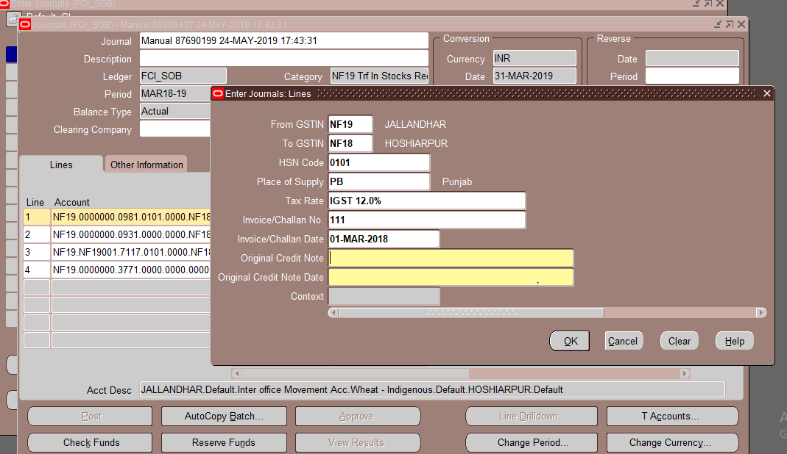
- Save your work.

Asset Transfer
- Asset Transfer: - Asset Transfer category to be split into two categories- Asset Transfer IN and Asset Transfer Out. Existing Asset Transfer category will remain effective for transactions entered for GL date 31-Oct-2017. For Transactions w.e.f. 01-Nov-2017, new category will be applicable.
- Asset Transfer OUT: - To capture the GST related data for Transfer Out, mandatory DFF will be provided at line level. For this category, user will enter the tax related information in the DFF. As per discussion with FCI, following fields are required at DFF: -
- From GSTIN (LOV from value set "FCI_Unit”)
- To GSTIN (LOV from value set "FCI_Unit”)
- HSN of the goods (Min-4 digit and Max-8 digit and numeric)
- Place of supply (LOV)
- Tax Rate (LOV)
- Assessable Value(WARNING:- If not required as per law compliance, the it will be better to not include this field, as we are going to exhaust no. of fields at DFF)
- Asset Transfer IN- : - To capture the GST related data for Asset Transfer-IN, mandatory DFF will be provided at line level. For this category, user will enter the tax related information in the DFF. As per discussion with FCI, following fields are required at DFF: -
- From GSTIN (LOV from value set "FCI_Unit”)- Not required for this category
- To GSTIN (LOV from value set "FCI_Unit”)
- HSN of the goods (Min-4 digit and Max-8 digit and numeric)
- Place of supply (LOV)
- Tax Rate (LOV)
- Invoice/ Challan No.
For this GL category, user will issue Tax invoice on the basis of taxability.
Transfer IN:-
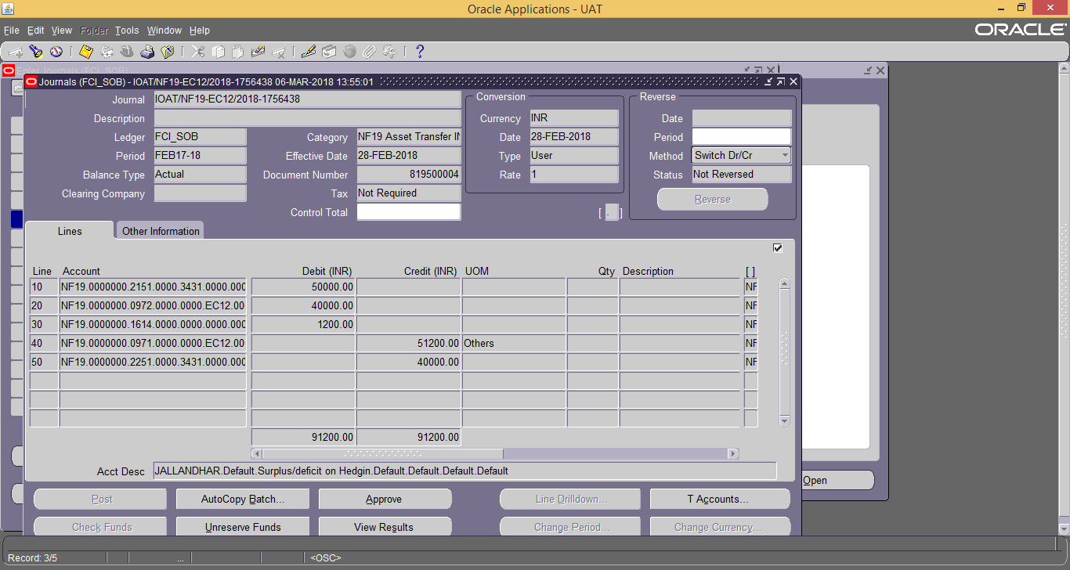
Check is implemented in Asset Transfer IN which will validate the single occurrence of Account 0971 & 0972 JE Line.
Quantity is enabled on 0971 Account Line with UOM as ‘Others’.
Transfer Out:-
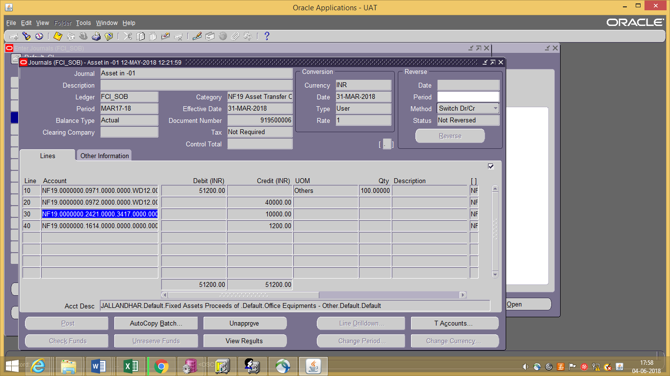

Check is implemented in Asset Transfer IN which will validate the single occurrence of Account 0971, 0972 & 2421 JE Line.
Quantity is enabled on 0971 Account Line with UOM as ‘Others’.

Unconn/Missing Wagon
Unconn/Missing Wagon:- Unconn/Missing Wagon is the new category which is introduced in GST Where consignment has been dispatched by the supplying branch and transfer out invoice has been raised but from the depot record of original consignee branch it is established that some wagons have not been received till the closing of accounts, such wagons are treated as ‘Missing Wagons’.
Under GST Regime, ‘Bill of supply’ or ‘Tax invoice’ would be issued by the supplying branch (e.g. Kolkata branch) for the supply of exempted or taxable goods respectively.
- To create a new manual journal entry, click on new journal in the find journals window.
- Journal Name: Leave the Journal name blank. It will automatically take the system date and time as Journal name.
- Period: Enter the Period, effective date. Adjusting periods are available at the end of each quarter and year beginning with ‘ADJ’
- Currency: Enter currency details. The currency will be ‘INR’.
- Category: Enter the category as ‘Unit name (eg SB16, WD12) Unconn/Missing Wagon’
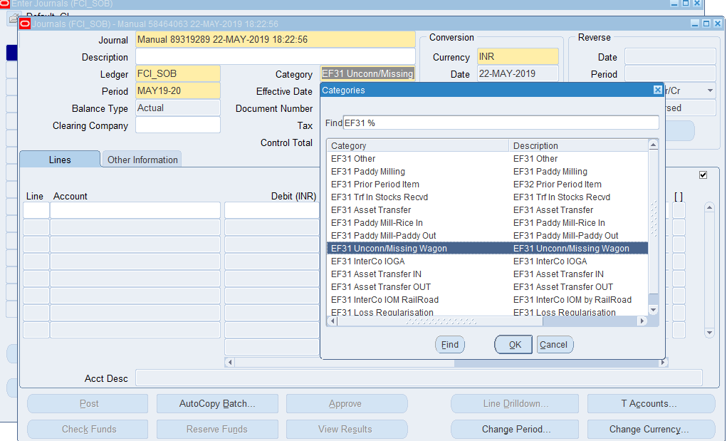

GL Reports

GST- Tax Invoice/ Bill of Supply/ Delivery Challan Reports

The tax Invoice/ Bill of Supply/ Delivery Challan reports are generated in GL for Transfer Out Categories: -
  - InterCo IOM RailRoad
  - Paddy Mill-Paddy Out
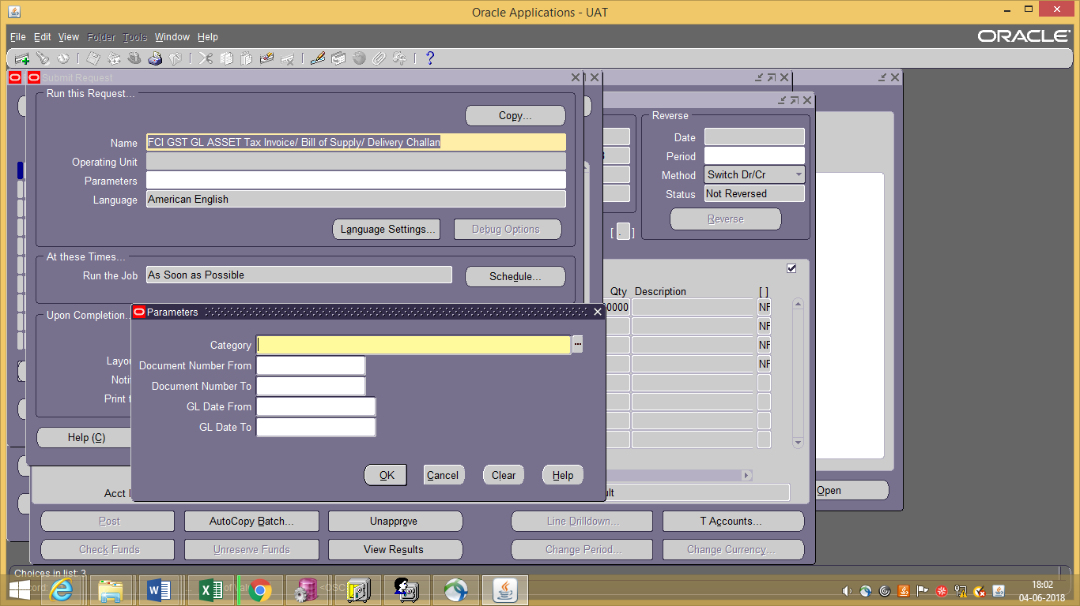
Report Parameters:
- Category (Mandatory) – Paddy Out, InterCo IOM RailRoad
- Document Number From (Optional) - Document Sequence Value Range From
- Document Number To (Optional) - Document Sequence Value Range To
- GL Date From (Optional)- Date Range From within GL period
- GL Date To (Optional)- Date Range To within GL period
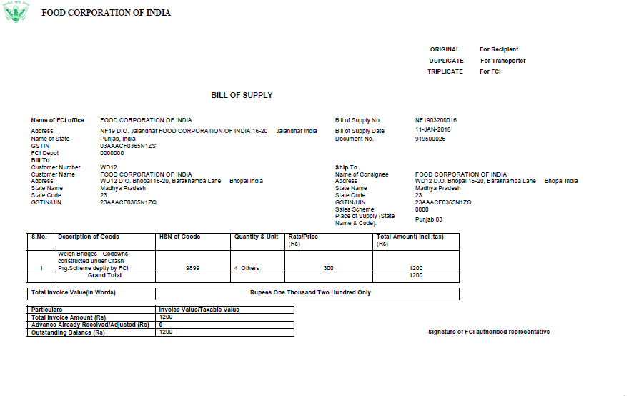

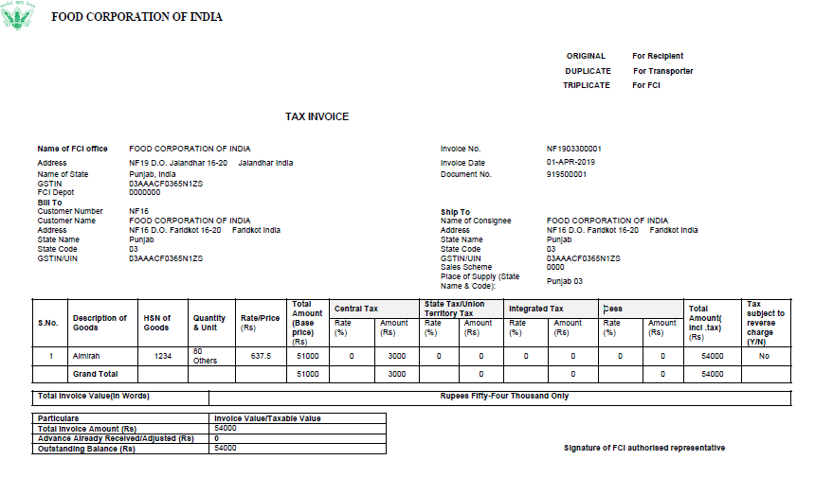

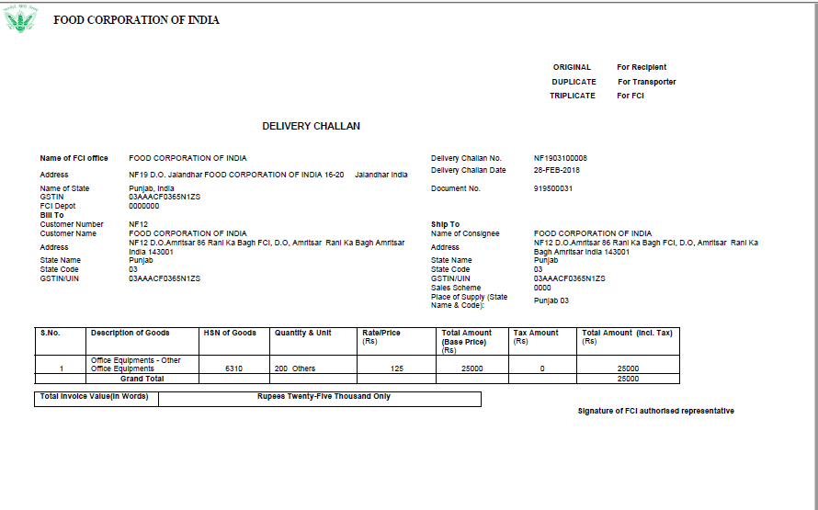

CR- 791: Modifications in format of GL GST Delivery Challan
In Delivery Challan-
- Instead of the column- Taxable Amount, Tax Amount column will be displayed with amount 0.

In Delivery Challan, Bill of Supply, Tax Invoice-
- Column Labels- Description of Goods/Services, HSN Goods/SAC of Servicesare changed to Description of Goods, HSN of Goods respectively.
- Columns- Customer Name&Name of Consignee willdisplay FOOD CORPORATION OF INDIA incase of IOM.

FCI GST Job Work Register Report
This report covers the details of the job work being outsourced to the vendors/suppliers. It includes all the mandatory information related to a job work, which will be required to be GST complaint and this report is also used for ITC-04 .
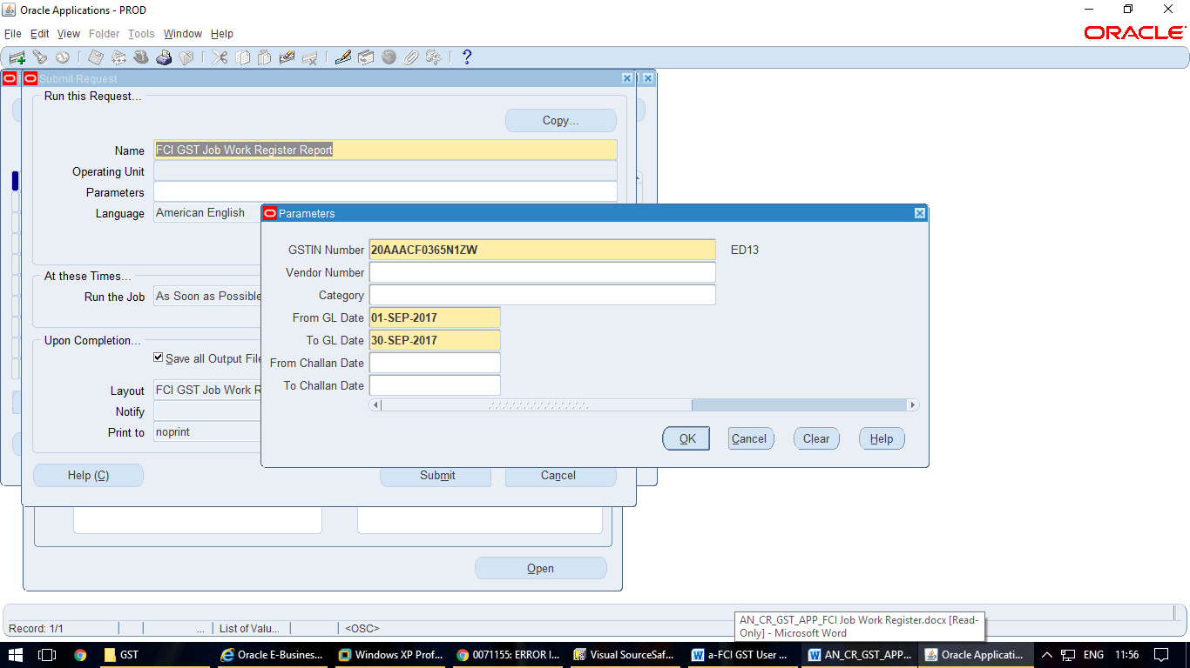
Following Journal Categories are covered under the report:
Paddy Mill-Rice In
Paddy Mill-Paddy Out

Report Parameters:
GSTIN (Mandatory) – GSTIN Number for the FCI Region
Vendor Num (Non Mandatory) - Supplier to whom job work is assigned.
Category (Non Mandatory) – Paddy Out/Rice In, if left blank, report will fetch the data for both categories
GL Date From (Mandatory)- Date Range From within GL period
GL Date To (Mandatory)- Date Range To within GL period
Challan Date From (Non Mandatory)- Date Range From against Paddy Out
Challan Date To (Non Mandatory)- Date Range To against Paddy Out

- The report has two sections, one for Paddy-Out journal lines and second for Rice-In journal lines. The fields for Paddy-Out journal remain blank if the line corresponds to Rice-In journal and vise-versa.
- In case of Paddy Out journals, the net amount displayed for each line in the report is Cr-Dr value for that line.
- In case of Rice In journals, the net amount displayed for each line in the report is Dr-Cr value for that line.
- Only lines with specific accounts are shown in the report:
- For Rice-In Journal, lines with account 7131 only
- For Paddy-Out Journal, lines with account 7204 only
- If user enters multiple lines for above mentioned accounts in one journal, then all such lines are displayed in the report.
- The report brings data for posted journals only.
- In addition to this report, following additional checks have been applied on journal entry form:
For Rice-In Journal, user will be allowed to take only 7311 and 7131 as natural accounts.
For Paddy-Out Journal, user will be allowed to take only 7311 and 7204 as natural accounts.

Report should be generated in Excel format.

FCI GST GL ITC Report
This report covers the details of all the Journals which are applicable for input tax credits. The report brings journal lines data that are of journal sources ‘Manual’, ‘Financials India’ and ‘AutoCopy’havinglines with account codes 2923, 2924, 2925 and 2926. Report can be run on Unit hierarchy basis too.
Note:
- The report brings data only if that particular journal is posted and having Effective date on or after ’01-Nov-2017’.
- The ‘GL Date From’ and ‘GL Date To’ parameters should be in the date range of same month (or Say Period). The cross month dates parameters value in above two input parameters will compell program to get completed with Error. The message will be reflected in the Log file.
Parameter’s Screenshot:-

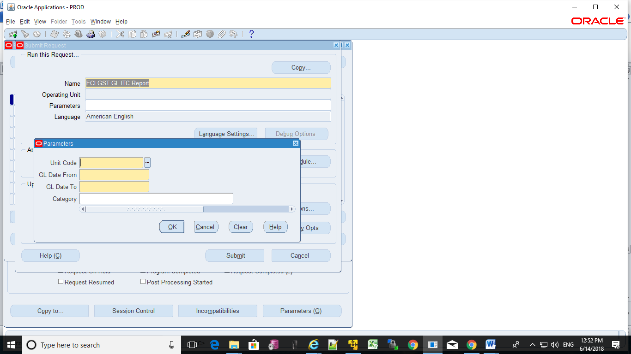

Report Parameters-

- Unit Code (Mandatory) – It fetches the LOV of all the Units Lists.
- GL Date From (Mandatory) – It is starting date range of Journal’s Effective date.
- GL Date To (Mandatory) - It is ending date range of Journal’s Effective date.
- Category (Optional) - It fetches the LOV of Journal Categories Lists pertaining to that particular Unit (First Four Characters of Responsibility Name)
Output of the report should be generated in Excel format.

- Sample Output

GST- Asset Tax Invoice/ Bill of Supply/ Delivery Challan Reports

The tax Invoice/ Bill of Supply/ Delivery Challan reports are generated in GL for Asset Transfer OUT Categories: -
Asset Transfer- Out: - In case of Asset Transfer- Out, following will be issued
Delivery Challan- Delivery Challan is issued in case transfer within GSTIN transfer.
Bill of Supply- Bill of Supply is issued in case transfer is GST exempt & Inter State.
Tax Invoice- Tax Invoice is issued in case transfer is for taxable goods & Interstate.

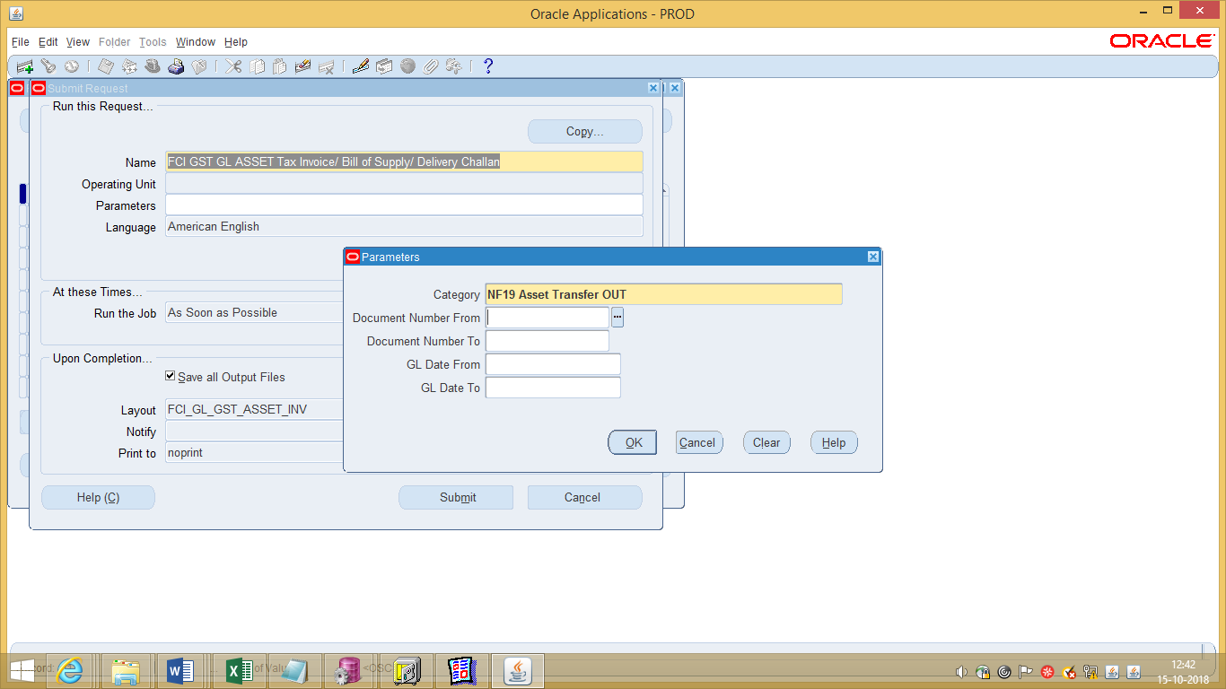
Report Parameters:
- Category (Mandatory) – Asset Transfer OUT
- Document Number From (Optional) - Document Sequence Value Range From
- Document Number To (Optional) - Document Sequence Value Range To
- GL Date From (Optional)- Date Range From within GL period
- GL Date To (Optional)- Date Range To within GL period
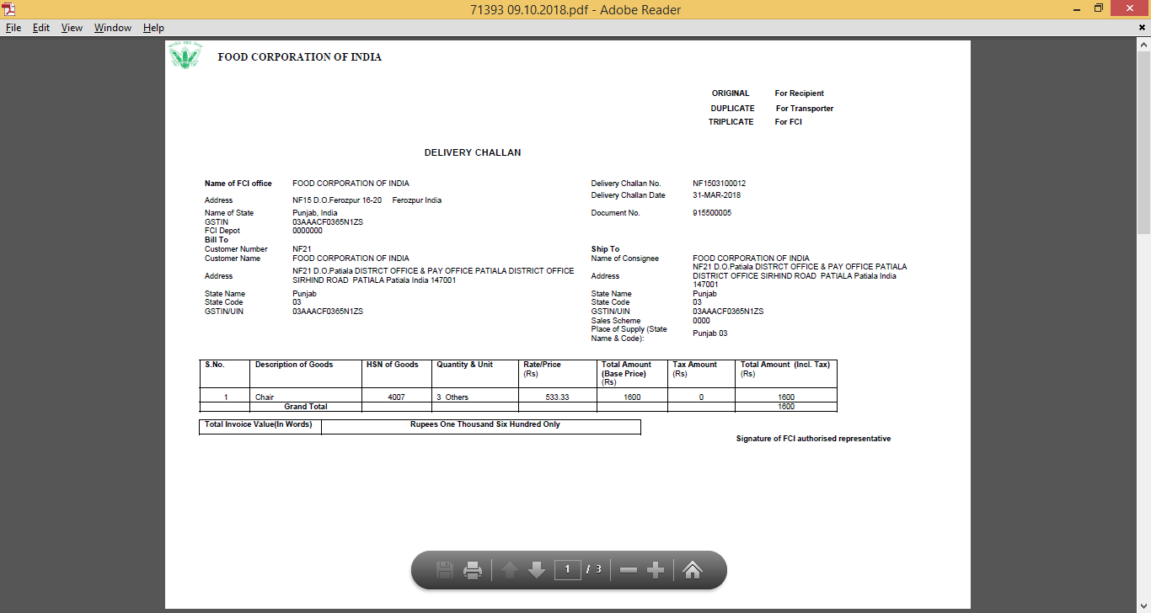

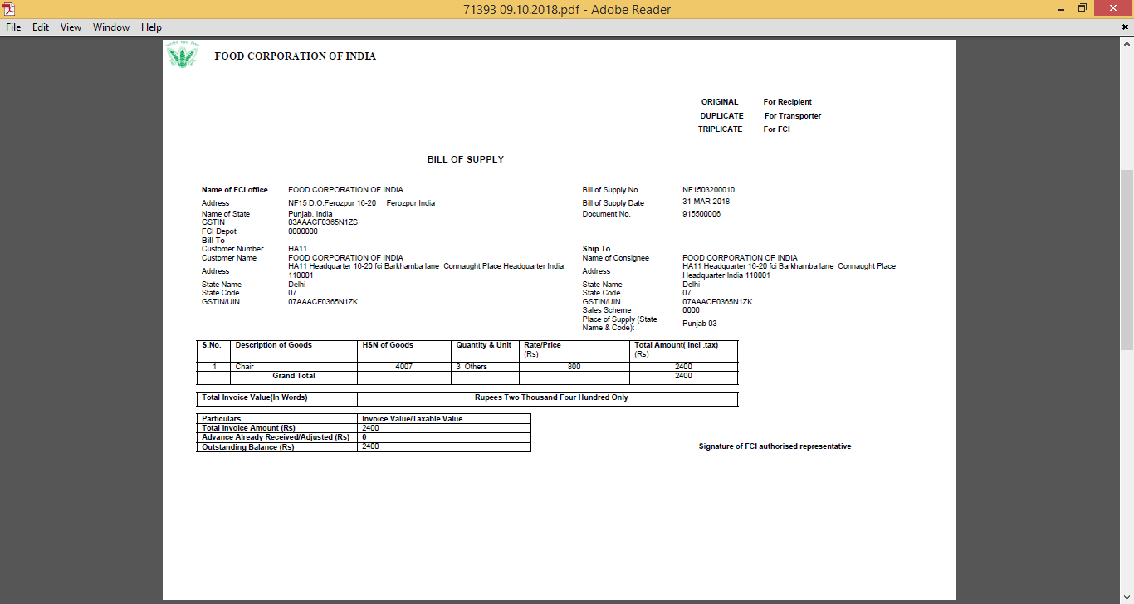

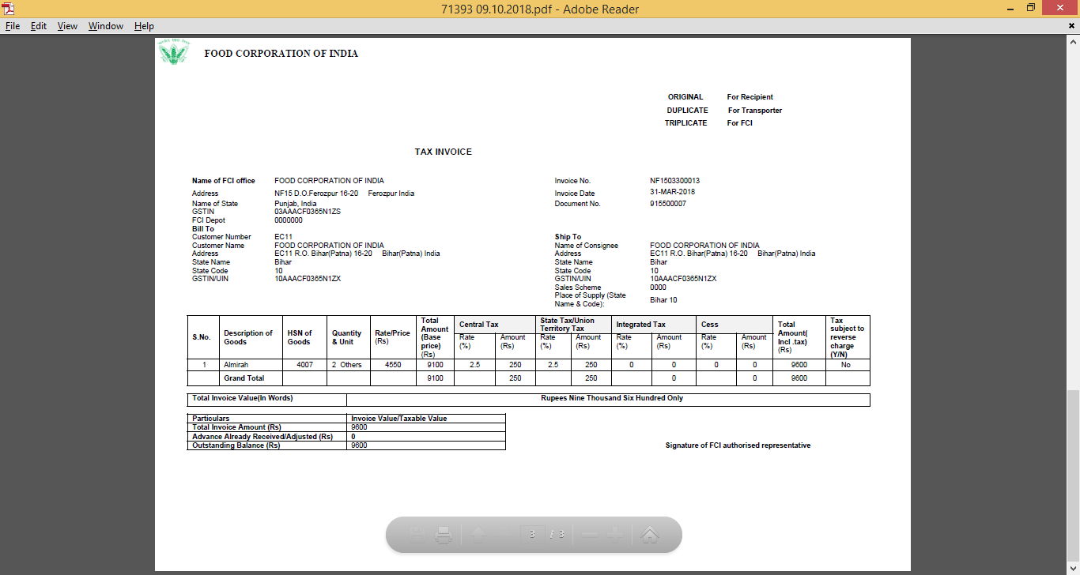

GL Reversal – Credit Note Report

- This report is required for following categories: -
- Interco IOM RailRoad
- Asset Transfer- Out

- Interco IOM RailRoad: - In case of Interco IOM Railroad, GL Credit Note will be issued in following JE reversals-
  - Bill of Supply(i.e transfer is inter-GSTINfor exempted goods and services)
  - Tax Invoice(i.e inter-GSTIN and for taxable goods and services)

- Asset Transfer- Out: - In case of Asset Transfer Out, GL Credit Note will be issued in following JE reversals-
  - Tax Invoice- (i.e inter-GSTINand for taxable goods)
  - Bill of Supply- (i.e inter-GSTINfor exempted goods)

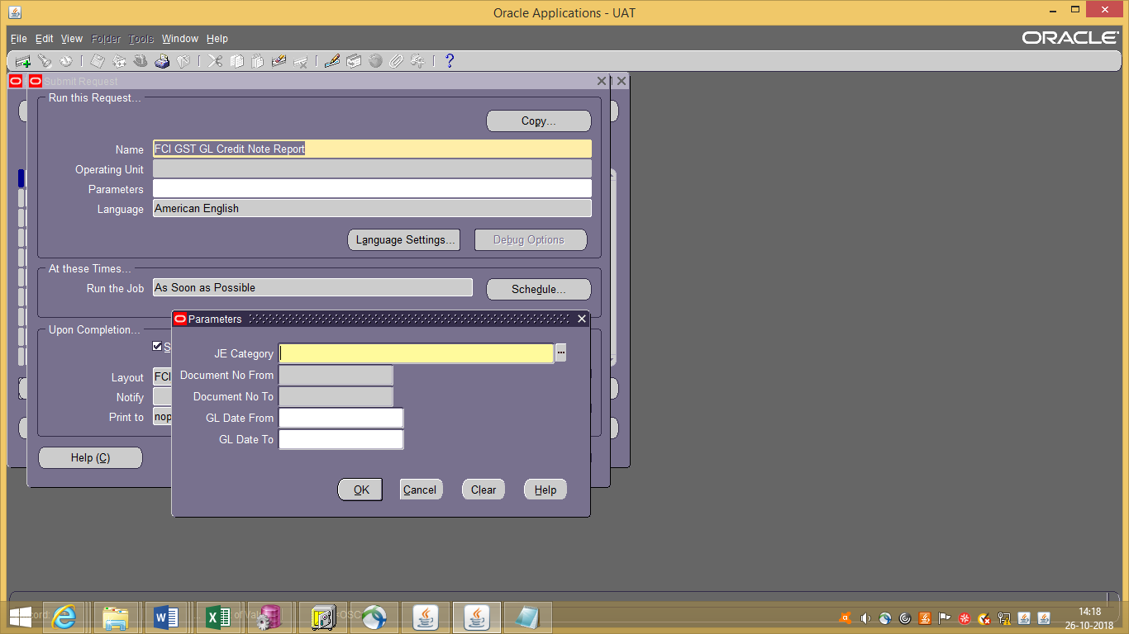
Report Parameters
- JE Category (Mandatory) - List of Values depending upon the responsibility.
- Oracle Document Number From (Optional)
- Oracle Document Number To (Optional)
- GL Date From (Optional)- Date Range From
- GL Date To (Optional)- Date Range To
Journal Reversal :-
- Original Credit Note
- Original Credit Note Date
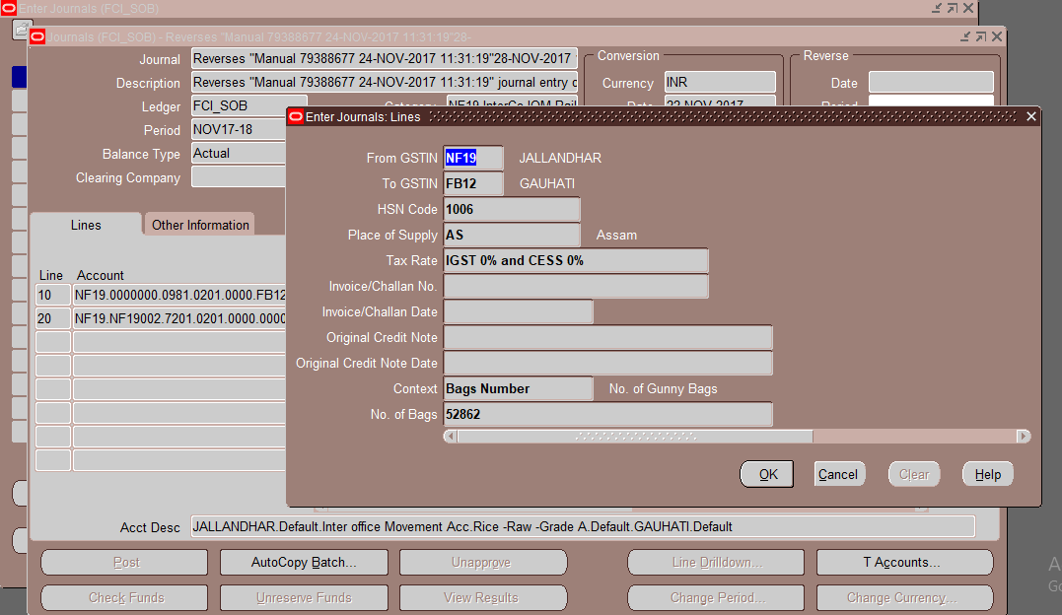
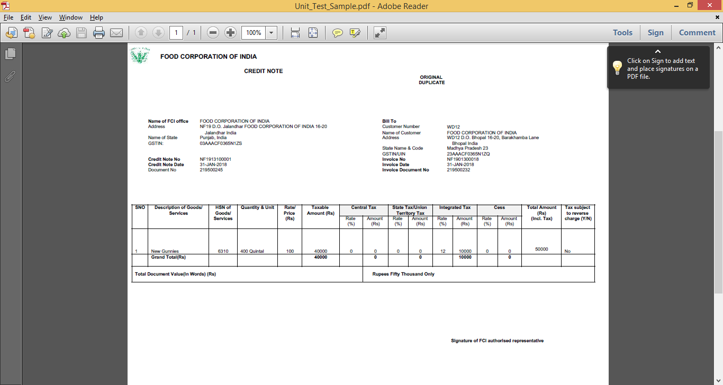
Note: Post implementation of CR 807, the UOM for below mentioned list of products will reflect as ‘Others’ OTH in GST reports:0601, 0602, 0603, 0604, 0605, 0606, 0626, 0627, 1601, 1602, 1603, 1604, 1605, 1606, 1626, 1627

04-GST Reports (GSTR1 and GSTR2)
Under GST Regime, monthly, quarterly and annual reports are needed to be submitted on GSTN Network. For GST compliance, some reports will be needed from FAP SYSTEM (in specific format provided by ASP/GSP).
- GSP has provided sub-templates for GSTR1 and GSTR2 submission. Following are the sub templates:
  - GSTR1 Business to Business
  - GSTR1 Credit and Debit Note
  - GSTR1 Voucher
  - GSTR2 Business to Business Reverse Charge
  - GSTR2 Credit and Debit Note
  - GSTR1 Document Summary
  - GSTR2 Voucher

FCI GSTR2 Voucher
Input Parameters:
- GSTIN
- FROM DATE- GL Date in case of AP and GL Default Effective Date in case of GL
- TO DATE- GL Date in case of AP and GL Default Effective Date in case of GL
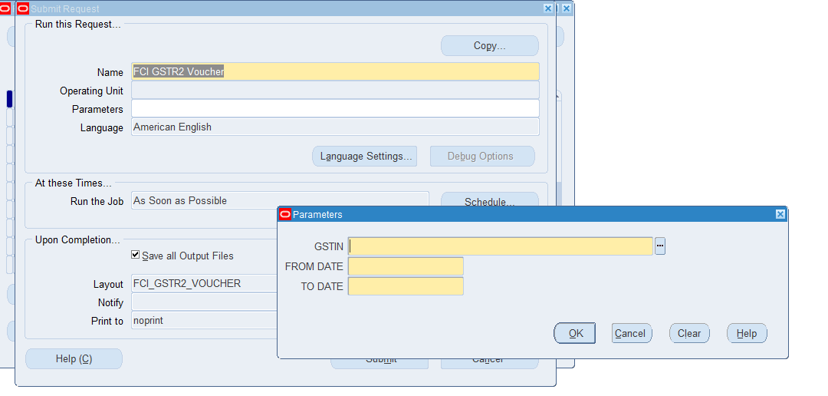
- Report will pick data for Payments (RCM Applicable) and Application of these Invoices on Prepayment.
- Report will be fetch data basis the date parameter.
- Report is assign in unit wise responsibility (eg NF11 GST USER,EE11 GST USER) and FCI Support User
- User need to check manually the report and then upload ASP/GSP Portal
Note: Prepayments where NON-RCM tax if applied will not be picked in this report.

FCI GSTR2 Credit Debit Note
Input Parameter
- GSTIN
- FROM DATE :-(GL Date in case of AP and GL Default Effective Date in case of GL)
- TO DATE:- (GL Date in case of AP and GL Default Effective Date in case of GL)
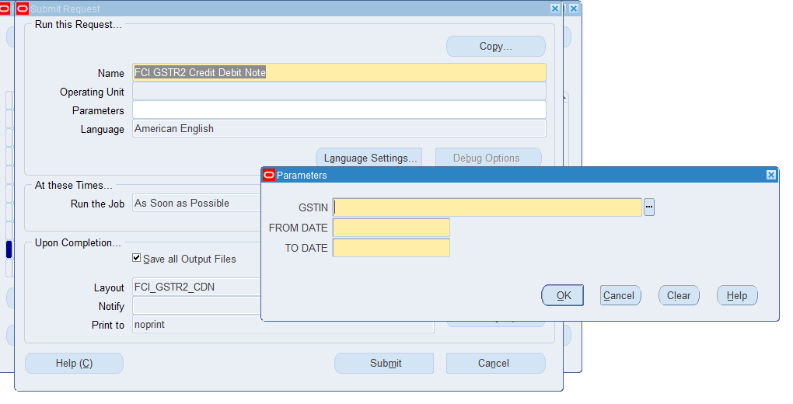
1. “GSTR2-CDN” report which will have information for Credit and Debit memo type of transactions.
- Credit/Debit notes that are applied, complete and GST Tax applied will be picked in this report.
- Report will fetch data basis the date parameter
- Report is assign in unit wise responsibility (eg NF11 GST USER,EE11 GST USER) and FCI Support User .
- User need to check manually the report and then upload ASP/GSP Portal

FCI GSTR2 B2B RCM
Input Parameter
- GSTIN
- FROM DATE :-(GL Date in case of AP and GL Default Effective Date in case of GL)
- TO DATE:- (GL Date in case of AP and GL Default Effective Date in case of GL)
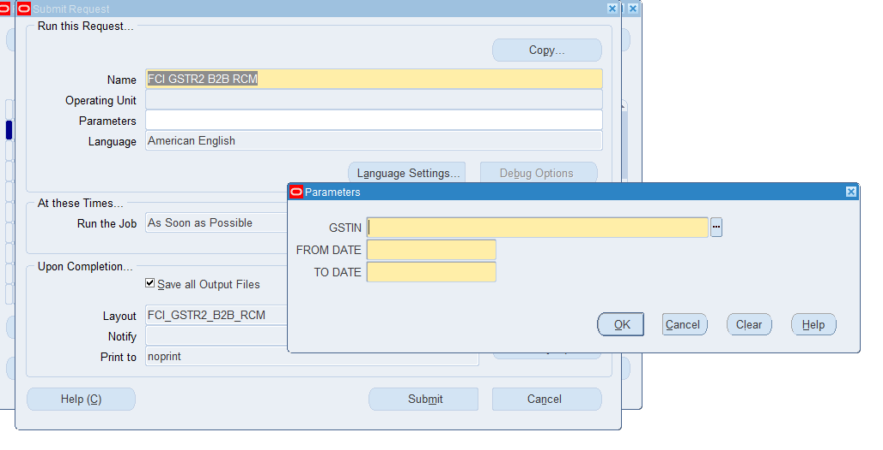

- All AP invoices where GST tax (Both RCM and NON –RCM GST) applied will be brought in this report.
- Moreover GL Transfer In and Asset In data will be brought in report.
- Report will be fetch data basis the date parameter.
- Report is assign in unit wise responsibility (eg NF11 GST USER,EE11 GST USER) and FCI Support User.
- User need to check manually the report and then upload ASP/GSP Portal

FCI GSTR1 Business To Business
Input Parameter
- GSTIN
- FROM DATE :-(GL Date in case of AR and GL Default Effective Date in case of GL)
- TO DATE:- (GL Date in case of AR and GL Default Effective Date in case of GL)

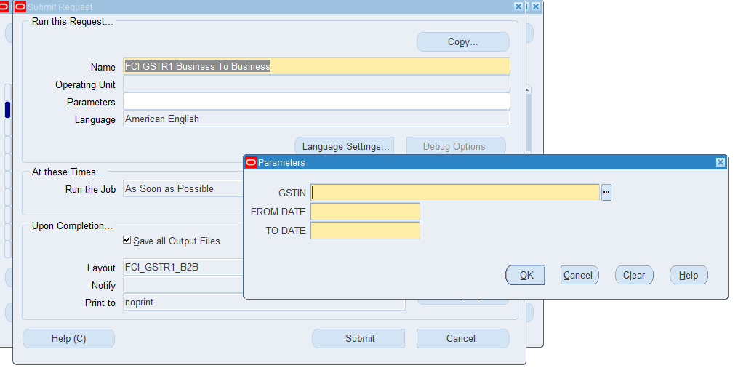

- AR Transaction with complete status.
- “IOM railroad, Asset Transfer Out” category Journals will be considered in this report.
- Report is assign in unit wise responsibility (eg NF11 GST USER,EE11 GST USER) and FCI Support User .
- User need to check manually the report and then upload ASP/GSP Portal

FCI GSTR1 Credit/Debit Note
Input Parameter
- GSTIN
- FROM DATE :-(GL Date in case of AR and GL Default Effective Date in case of GL)
- TO DATE:- (GL Date in case of AR and GL Default Effective Date in case of GL)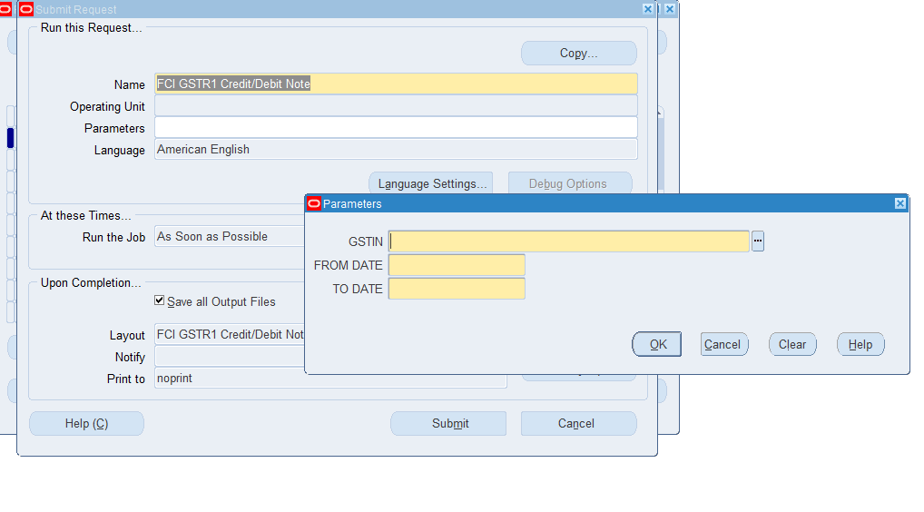
- Only applied and completed Credit and Debit Note will be picked for GSP.
- In General Ledger reversal of Interco IOM Rail Road and Asset Transfer- Out Journal will be treated as Credit Note.
- Report is assign in unit wise responsibility (eg NF11 GST USER,EE11 GST USER) and FCI Support User
- User need to check manually the report and then upload ASP/GSP Portal

FCI GSTR Delivery Challan Summary Report
Input Parameters:
- GSTIN
- From Date:- GL Default Effective Date
- To Date:- GL Default Effective Date

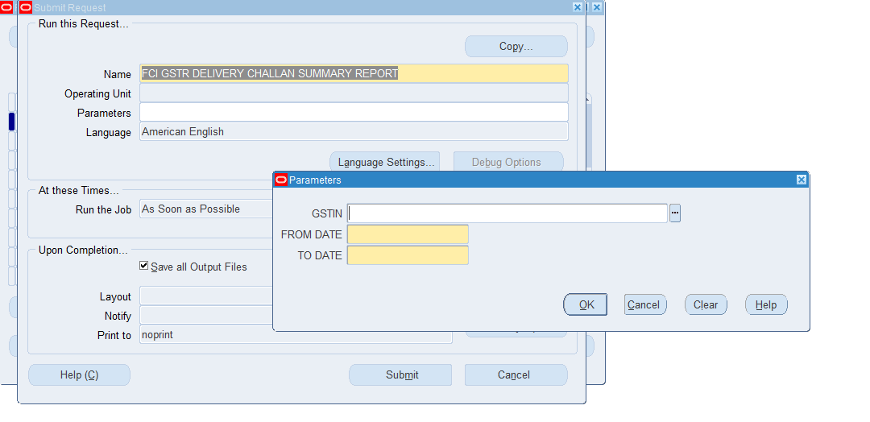
- The GSTR1 Document Summary Report will bring data for Delivery Chalan only as other transaction types (Outward, Inward etc.) will be created and submitted by ASP/GSP.
- For Delivery Chalan following GL Categories will be considered:
- Paddy Milling Out
- Transfer Out Asset where DC chalan sequence is generated
- IOM Transfer Out Asset where DC chalan sequence is generated
- Document Summary will be created on the Date parameter(From date and To date).
- Report is assign in unit wise responsibility (eg NF11 GST USER,EE11 GST USER) and FCI Support User

FCI GST Sequence Summary Report
This report brings applicable Sequence status documents on which GST tax is applied.
Report Parameters-
Unit :
GST Document Type:
GL Period:

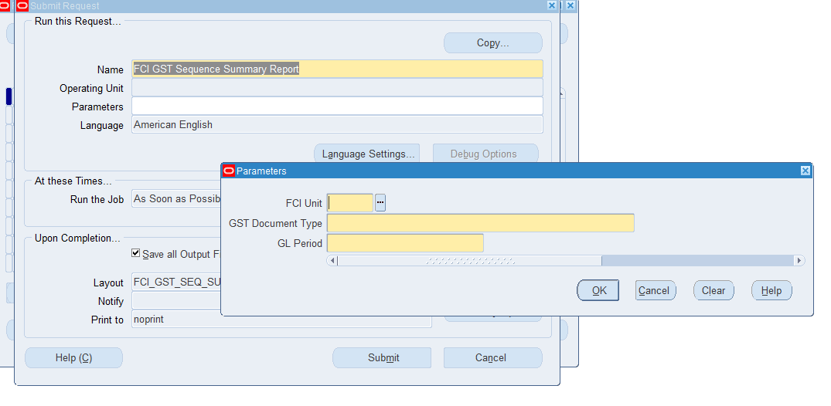
- Report is assign in FCI Support User responsibility.

Annexure-A Scheduled Programs

India- Period Ending Process

- It’s a standard program which will generate the Reverse Charge Sequencing for AP documents.
- It will create the GST accounting of Reverse Charge AP documents in GL with source as Financials India and category as AP Validate.
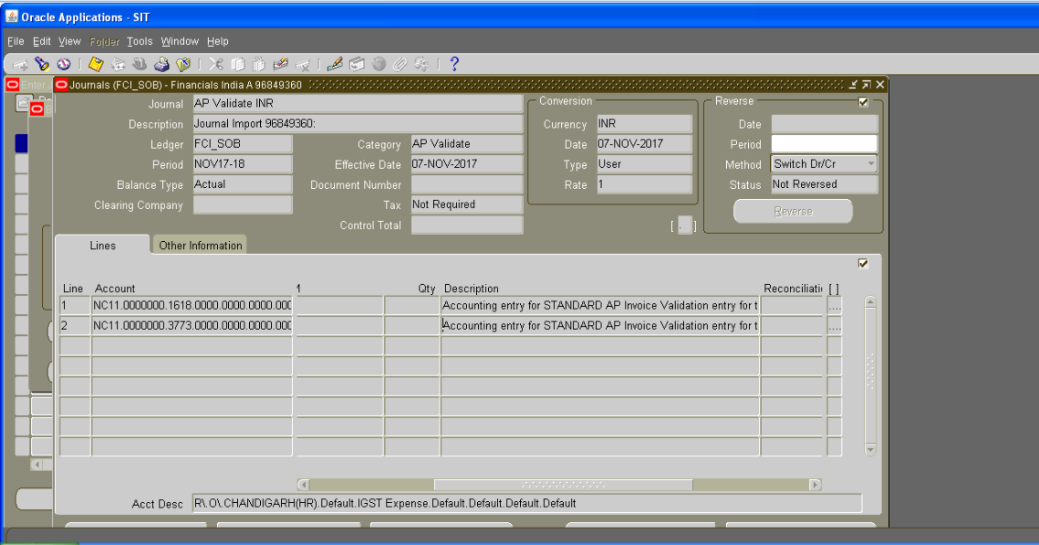

- Program Parameters
  - Operating Unit FCI Operating Unit (Code-103)
  - Tax Regime Should be India GST
  - Registration Number If left blank, it will run for all First Party Registrations. Otherwise can be run for specific First Party.
  - Period Name Accounting Period
  - Running Mode Should be Final
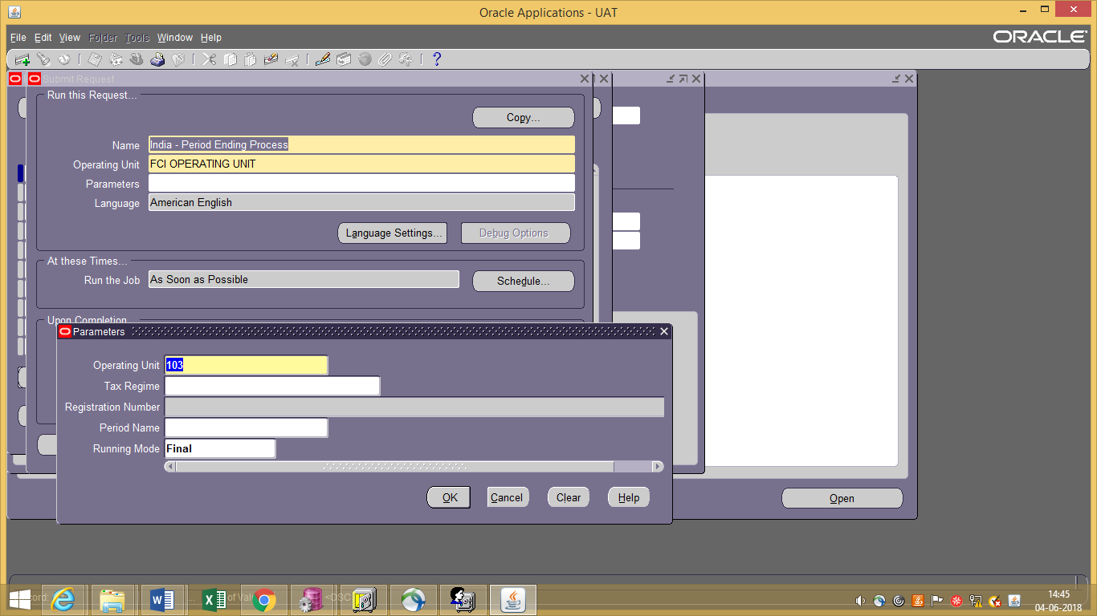

- Program is scheduled daily once a day to run for all custom Open periods, for all First Party Registrations.

FCI AP GST Payment Sequence Generator

- It’s a custom program which will generate Payment Voucher Sequence for applicable AP documents.

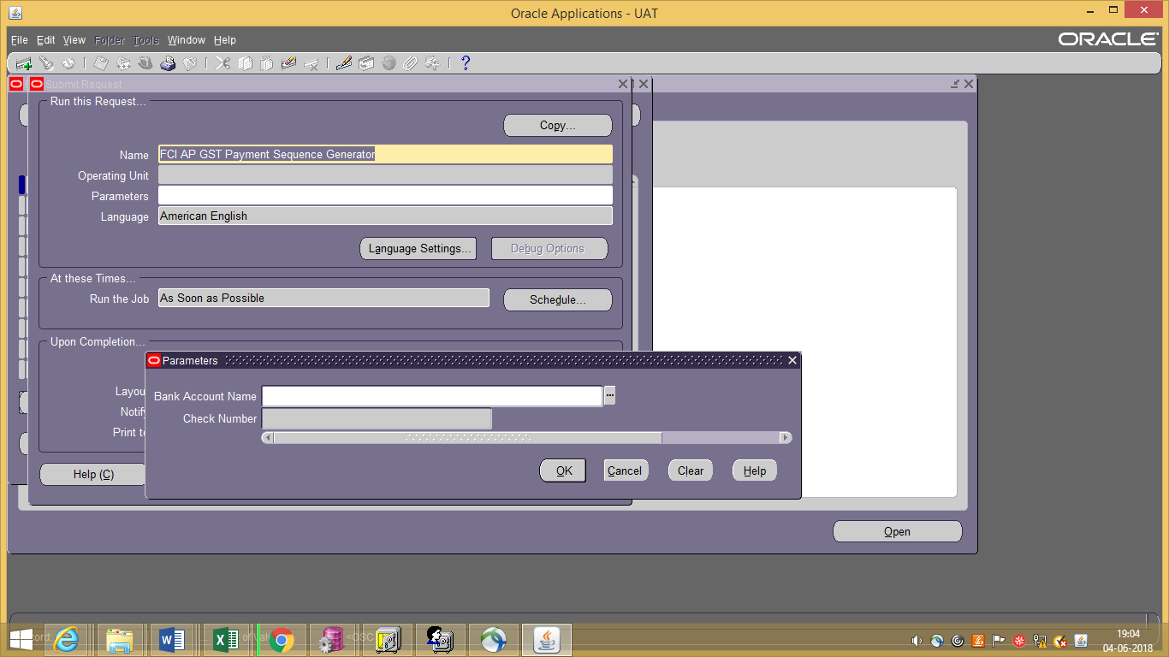
- Program Parameters
  - Bank Account Name FCI Internal Bank used for making Payment
  - Check Number Check Number used for Payment
- Program is scheduled daily once a day to run for all applicable Reverse Charge Invoice Payments, for all Units.

FCI Customer Third Party Registration

- It’s a custom program which will register corresponding Customer as third party on Supplier’s Third Party Registration.
- The Customer registered will also be mapped with applicable Item Category based on which GST will be defaulted in AR Transactions (for exempted items).
- Program is scheduled daily once a day to run for all newly registered Suppliers.

FCI GL GST Generate Sequence Program

- It’s a custom program which will generate the GST sequence for approved Journals under GL Categories- Paddy OUT, InterCo IOM RailRoad, Asset Transfer OUT. Additionally Credit Note sequences will be generated for reversal JE’s under InterCo IOM RailRoad& Asset Transfer OUT.
- Program Parameters
  - Category Journal Category
  - Period GL Period
- Program is scheduled to run every 6 hours.
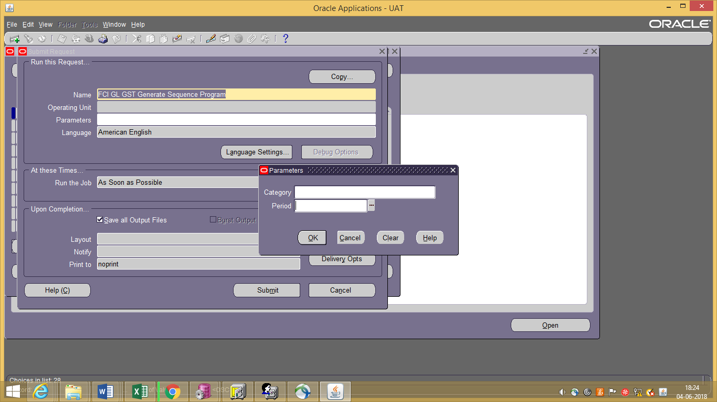
Annexure-BDocument Sequencing

GOODS AND SERVICES INCLUSION IN GENERAL LEDGER (AS PER PLAN B)
(This has been referenced under General Ledger User guide – Sr. No. 42).
To capture GST related information for Journal entries with GL Date less than or equal to 31-OCT-2017, please refer this section.
Introduction of a new category and new DFF fields at JE Line Level.
For some of the journal categories, new DFF fields are provided at JE Line Level and user will enter the details in DFF for each line.
Journal Categories where DFF is required: -
- IOM Within Same Unit
- InterCo IOGA
- InterCo IOM RailRoad
- Paddy Milling
- Trf In Stocks Recvd
- Unconn/Missing Wagon
- Transfer of Assets (New category)
Following are the new DFF fields (exempted & taxable) in manual Journal Entry:
- From GSTIN (LOV from value set "FCI_Unit”)
- To GSTIN (LOV from value set "FCI_Unit”)
- HSN of the goods
- Place of supply (LOV)
- Tax Rate (LOV)
- Future
- Invoice/Challan No.
- Invoice/Challan Date
Note:Fields : Invoice/Challan No. and Invoice/Challan Date are introduced in Plan A and the mentioned fields will be eligible for entry in Gl after 31-Oct-2017.
Below mentioned are the steps to create a Journal:
Function Path: Normal General Ledger responsibility>> Journals >> Enter >> New Journal.
1. Category: TrfIn Stocks Recvd
1. To create a new manual journal entry, click on new journal in the find journals window.
2. Journal Name: Leave the Journal name blank. It will automatically take the system date and time as Journal name.
3. Period: Enter the Period, effective date. Adjusting periods are available at the end of each quarter and year beginning with ‘ADJ’
4. Currency: Enter currency details. The currency will be ‘INR’.
5. Category: Enter the category as ‘Unit name (eg SB16, WD12) Trf IN Stocks Recvd’

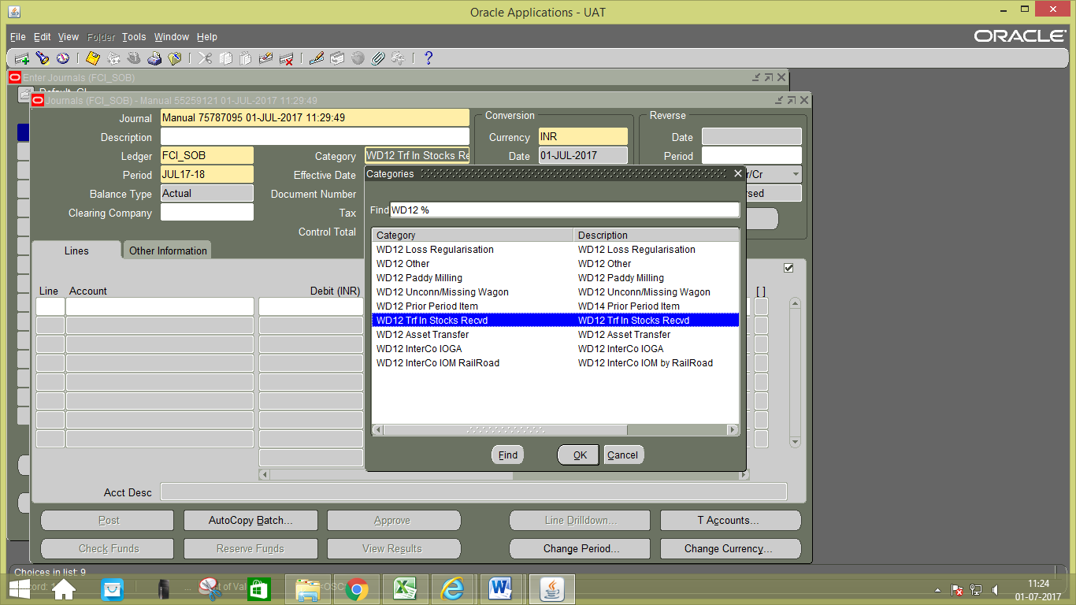

- Data entry in the Header Level DFF (Descriptive Flex field): On clicking the DFF symbol, fields to capture the following fields will appear to capture the Railway Receipt number and the Railway receipt number quantity. From account and Depot from which the stock has been received has to be also entered.
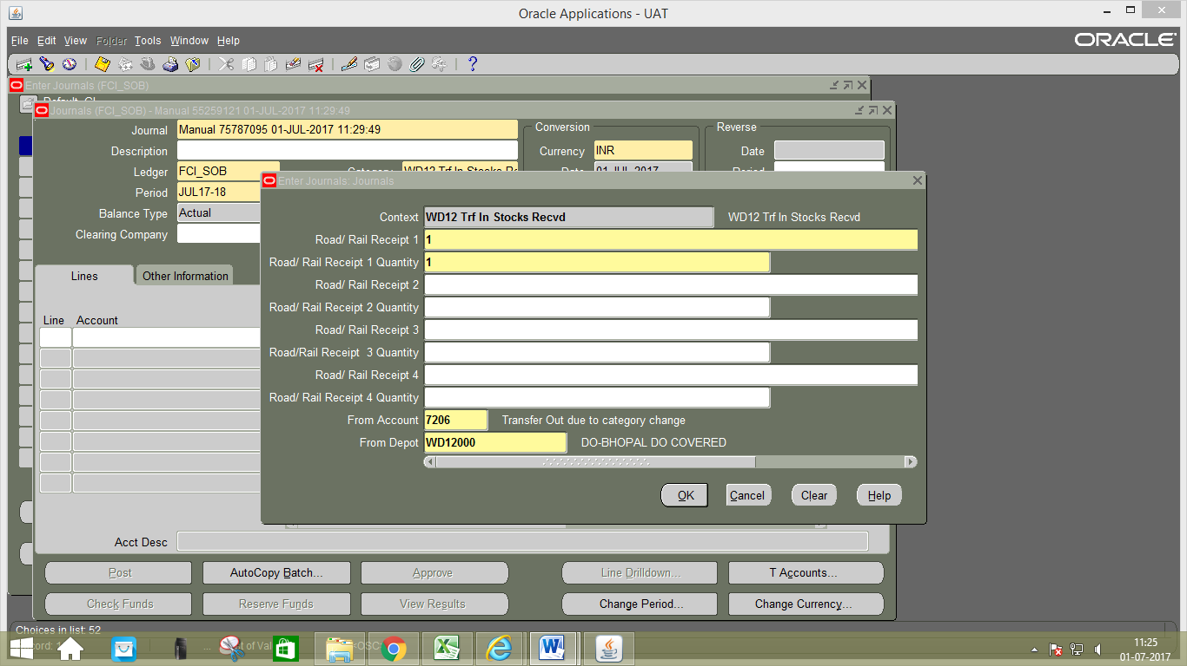
- Data entry in the Line Level: Enter the JV in the lines.In the Line Number column of the Journal Entry, the numbering to be followed is in series of 10, i.e. numbering would be 10, 20, and 30 and so on.
- Line Level DFF (Descriptive Flex field): New DFF fields are provided at JE Line Level and user will enter the details in DFF for each line. Otherwise system will prompt an error message and would not allow user to proceed unless details in DFF are filled.
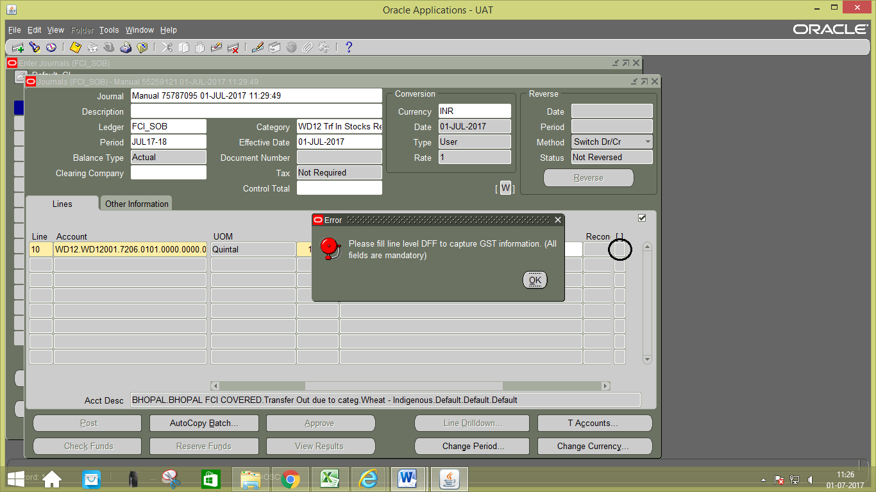
Fill the details in DFF at line, click on OK.
From GSTN: Enter the unit from which stock is transferred.
To GSTN: Enter the unit to which stock is transferred.
HSN code: Enter the HSN code of the product transferred.
Place of supply: Enter the place where stock is supplied.
Future: It is mentioned for future use.
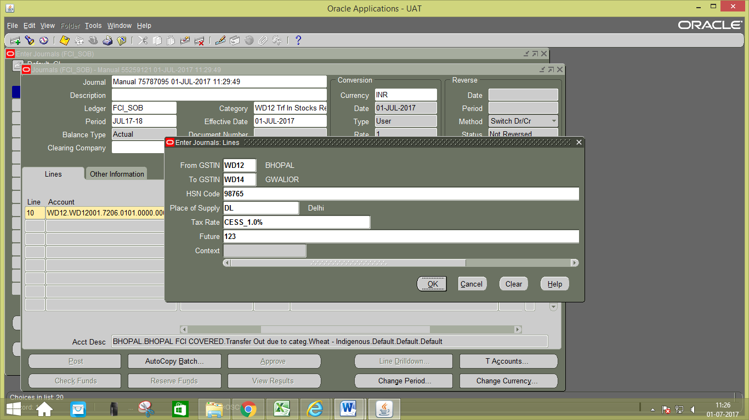

Fill the details in DFF at line 2.
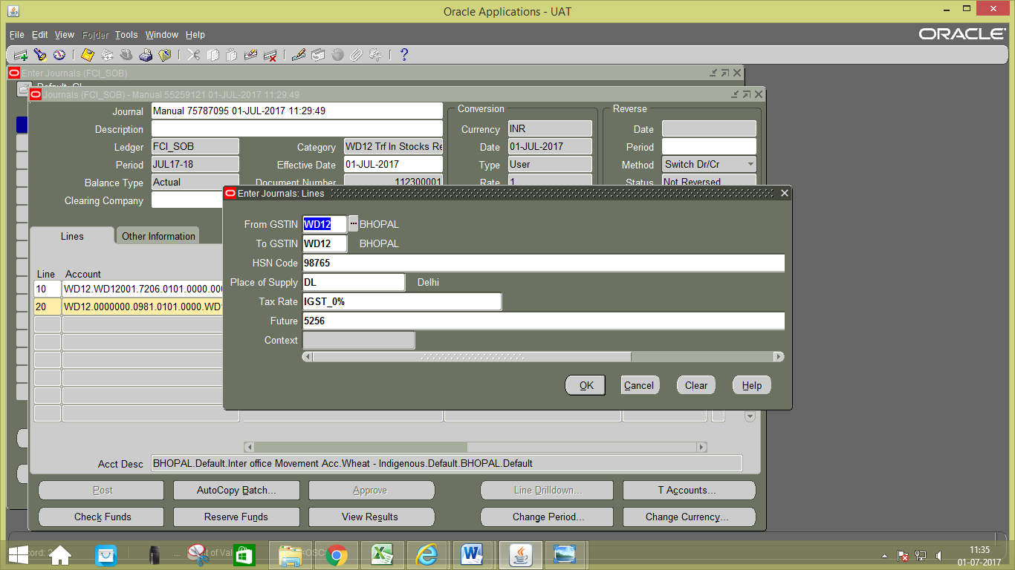

- Save you work.
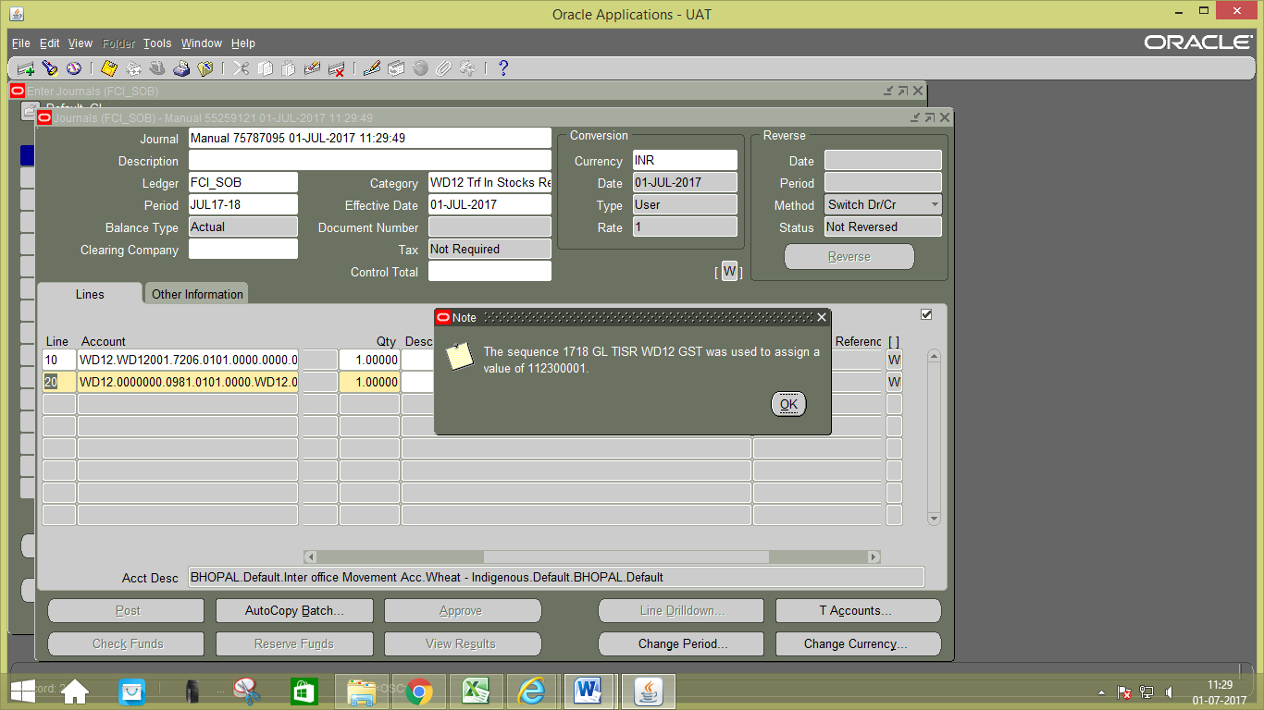

2. Category: Transfer of Assets.
Transfer of Assets is the new category which is introduced in GST.
- To create a new manual journal entry, click on new journal in the find journals window.
- Journal Name: Leave the Journal name blank. It will automatically take the system date and time as Journal name.
- Period: Enter the Period, effective date. Adjusting periods are available at the end of each quarter and year beginning with ‘ADJ’
- Currency: Enter currency details. The currency will be ‘INR’.
- Category: Enter the category as ‘Unit name (eg SB16, WD12) Asset Transfer’
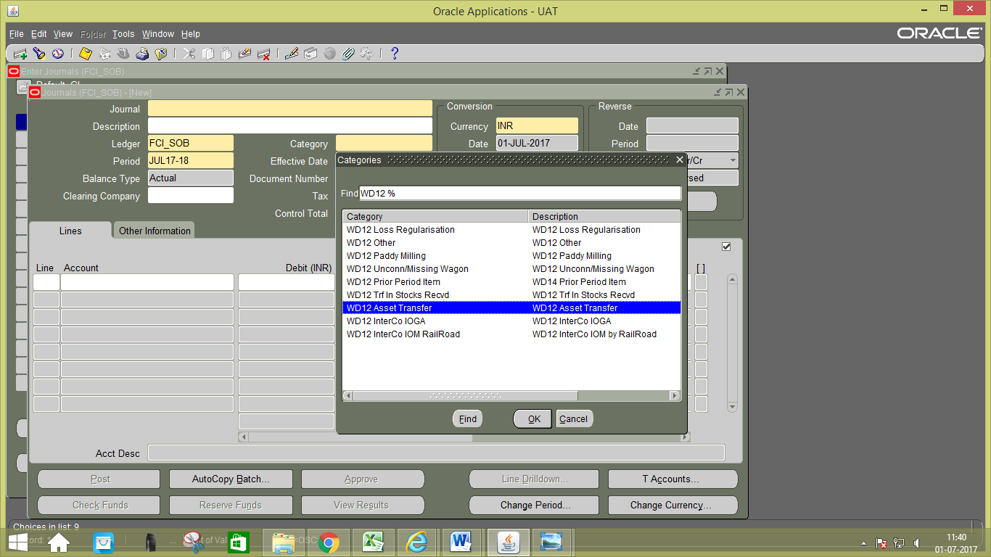
- Data entry in the Line Level: Enter the JV in the lines.In the Line Number column of the Journal Entry, the numbering to be followed is in series of 10, i.e. numbering would be 10, 20, and 30 and so on.
- Line Level DFF (Descriptive Flex field): Entering details in DFF is mandatory for each line. Otherwise system will prompt an error message and would not allow user to proceed unless details in DFF are filled.
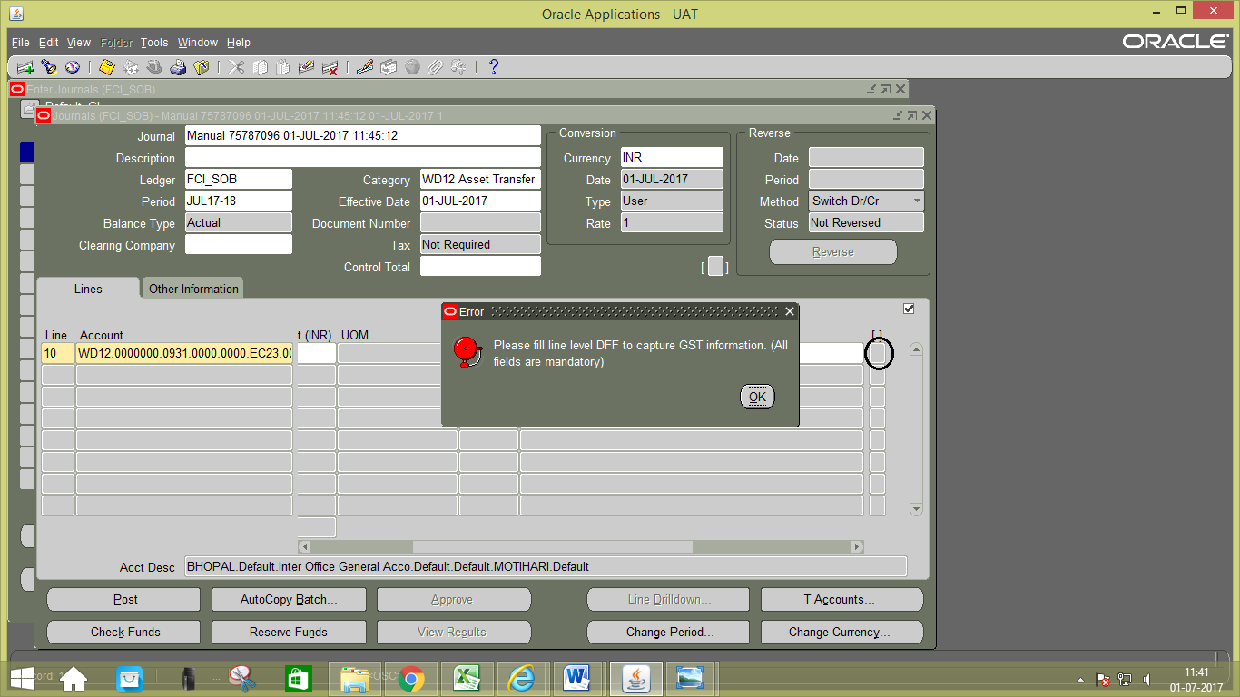
Fill the details in DFF at line1, click on OK.
From GSTN: Enter the unit from which asset is transferred.
To GSTN: Enter the unit to which asset is transferred.
HSN code: Enter the HSN code of the product transferred.
Place of supply: Enter the place where asset is supplied.
Future: It is mentioned for future use.
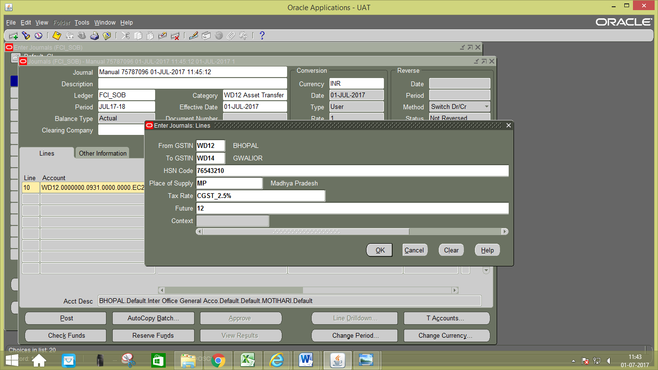

Fill the details in DFF at line 2, click on OK.
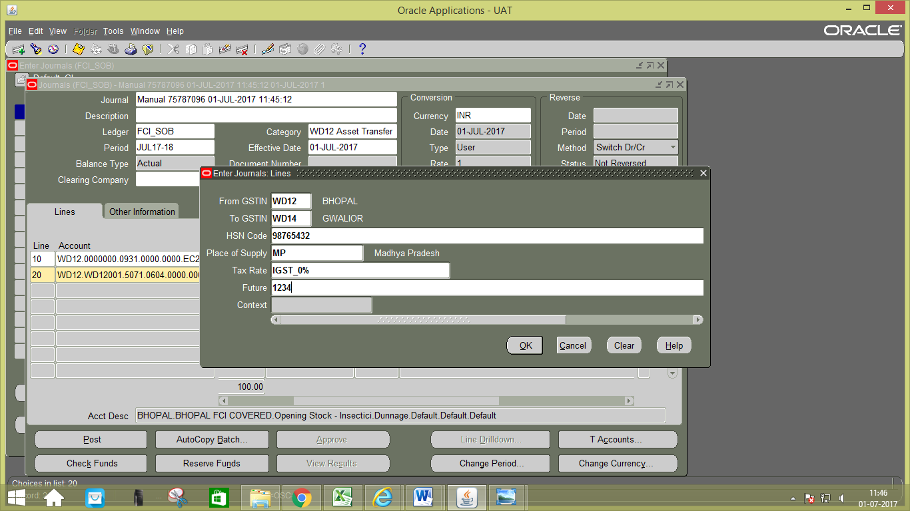

- Save your work.
